DEPARTMENT OF COMPUTER SCIENCE & ENGINEERING
#22

CONTENTS
FROM THE DESK OF THE H.O.D

- From the Desk of the HOD
- Vision and Mission of the Department
- Staff List
- International Journal Publications
- Faculty Development Program
- Student Achievements

EDITOR:
Dr. M. Radhika Mani
Professor and Head of CSE Dept.

ADVISOR’S:
Mrs. K. Lakshmi Viveka Mrs .P. Srilakshmi

STUDENT COORDINATORS:
M Uhakash Goud (IV CSE-B) Ch Subhas (IV CSE-A)

It’s immense pleasure to present this semi-annual newsletter “CYBERWAVES” Computer Science and Engineering department is the dynamic and vibrant department with the blend of young and experienced Faculty. Department is actively involved in academic as well as research work in current areas of Computer Science and Engineering and multi-disciplinary streams. The department has well equipped labs with the state of art software and hardware. The faculty members are constantly publishing technical papers in national and international journals and conferences. The department is fortunate to have dedicated teachers, devoted students, and committed supporting staff and expert technical staff. Specially, I congratulate my students to participate various extra-curricular activities, research work and competitive exams. My best wishes to all for their bright carrier and successful life.
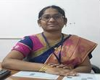
Dr. M. Radhika Mani
Professor and Head of Computer Science and Engineering Dept. hod_cse@pragati.ac.in

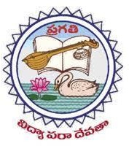

DEPARTMENT OF COMPUTER SCIENCE & ENGINEERING

The Vision of the CSE Department:
To emerge as a center of technical expertise in the field of computer science and engineering by producing globally competent professionals with technical & research capabilities, ethical values and team spirit.
The Mission of the CSE Department:
DM1: To produce competent software professionals.

DM2: To induce application oriented and research capabilities in students for the betterment of society.

DM3: To inculcate ethics and human values in students to adapt to the dynamism in the field of computing technology.

Staff List:

S.No. | Name of the Faculty Member | Designation | Date of Joining
1 | Dr M.Radhika Mani | Professor & HOD | 6/4/2013
2 | Dr.Y.Jayababu | Professor | 6/12/2001
3 | Dr.Y. Venkata Ram Kumar | Professor | 11/1/2012
4 | Dr.A.Radha Krishna | Associate Professor | 17/05/2018
5 | Dr. S Rao Chintalapudi | Associate Professor | 15/05/2017
6 | Mr. Rajesh M V | Associate Professor | 20/04/2011
7 | Mr.Raja Kumar Medapati | Associate Professor | 11/10/2006
8 | Mrs.Sreepada Sarada | Associate Professor | 4/1/2014
9 | Mrs.Lakshmi Viveka Kesanapalli | Assistant Professor | 22/09/2008
10 | Mrs.Kumari Gorle | Assistant Professor | 6/1/2011
11 | Mr.Chandra Sekhar Koppireddy | Assistant Professor | 20/05/2013
12 | Mrs.G Suryakala Eswari | Assistant Professor | 20/05/2013
13 | Mr.Manas Kumar Yogi | Assistant Professor | 16/06/2014
14 | Mr.G. Vijaya Kumar | Assistant Professor | 6/9/2015
15 | Mrs.Darapu Uma | Assistant Professor | 6/4/2015
16 | Mrs P V Komali | Assistant Professor | 1/6/2012
17 | Ms.Allampilli Harini | Assistant Professor | 6/5/2018

18 | Mrs.R L M Tayaru Gollapalli | Assistant Professor | 23/07/2018
19 | Mrs.Srilakshmi Puli | Assistant Professor | 6/1/2019
20 | Mr.Merla S V V Ramesh | Assistant Professor | 6/7/2019
21 | Mrs.Divya Karri | Assistant Professor | 13/06/2019
22 | Mrs.Tutta Naga Venkata Durga | Assistant Professor | 6/3/2019
23 | Mrs.Sama Surya Sri | Assistant Professor | 6/12/2019
24 | Mr.Kondapalli V V Subba Rao | Assistant Professor | 6/5/2019
25 | Ms.Morampudi Uma Devi | Assistant Professor | 7/8/2019
26 | Mr.Janardhana Rao Addanki | Assistant Professor | 6/10/2019
27 | Mrs.Kopparthi Harika | Assistant Professor | 6/10/2019
28 | Mrs.Teeparthi Tejasvi | Assistant Professor | 7/10/2019
29 | Mrs.S Malleswari Akshintala | Assistant Professor | 6/6/2019
30 | Mrs.T. Deepthi | Assistant Professor | 6/6/2019
31 | Mrs.Lakkamsani Yamuna | Assistant Professor | 6/1/2016
32 | Mr.Geeta Vijaya Kumar | Assistant Professor | 12/2/2015
33 | Mr.Yerramsetti Srinivasa Rao | Assistant Professor | 7/8/2019
34 | Mr.Pennada Siva Satya Prasad | Assistant Professor | 23/07/2019
35 | Ms.Kakarla Ganga Devi Bhavani | Assistant Professor | 6/6/2019
36 | Mr.Satish Kumar Koduri | Assistant Professor | 7/1/2019
37 | Mr.Srikanth Kosaraju | Assistant Professor | 4/3/2017
38 | Mrs.Oleti Parvathi | Assistant Professor | 6/3/2019
39 | Mrs.Chittajallu Veena Raga Malika | Assistant Professor | 6/3/2019
40 | Mrs.Kodiyala Devi Sireesha | Assistant Professor | 6/3/2019
41 | Mr.Ummidisetti Veera Ramesh | Assistant Professor | 6/1/2019
42 | Mrs.Tirumalanedi Satya Aruna | Assistant Professor | 6/3/2019
43 | Mrs.Appana Naga Lakshmi | Assistant Professor | 6/1/2019
44 | Mrs.T Durga | Assistant Professor | 4/12/2020
45 | Mr.G Uma Mahesh | Assistant Professor | 2/11/20
Visiting Faculty
46 | Mr.N.Venkata Pradeep | Visiting Faculty | 09-07-2018

Faculty Activities:

S No | Event | Internal | External | Total
 | Paper Publications | 00 | 29 | 29
 | Faculty FDPs (ATAL) | 00 | 05 | 05
 | Books / Book Chapters | 00 | 03 | 03
Total |  | 00 | 37 | 37

4. Paper Publications

Academic Year 2020-2021 International Journal Publications

SNo | Details
1 | Mr Y Manas Kumar "Balancing Data Utility and Data Privacy using Synthetic Data for Cyber Physical Systems Balancing Data Utility and Data Privacy using Synthetic Data for Cyber Physical Systems" Journal of Computer Technology & Applications, STM Journals Nov 14, 2021, ISSN: 2229
2 | Mr Y Manas Kumar "Risk mitigation measures during adoption of ML techniques for additive manufacturing quality control and data security", International Journal of Circuit, Computing and Networking 2021;2(2):36
3 | Mr Y Manas Kumar "Impact analysis of using ML techniques on imbalanced datasets for leveraging security of industrial IoT", International Journal of Circuit, Computing and Networking ;Nov 24 2021,E
4 | Mr Y Manas Kumar “The Spectrums of AI: Novel Perspectives, Current Trends, Future Directions" 1st International Conference on EMMA”
5 | Mr Y Manas Kumar "Application of Virtual Reality Technologies to Enhance Cultural Perspective in Modern Society", THE 3RD INTERNATIONAL CONFERENCE ON VIRTUAL REALITY 15
6 | Mr Y Manas Kumar "Novel Perspectives of Security and Privacy Challenges in Virtual Reality Technologies", THE 3RD INTERNATIONAL CONFERENCE ON VIRTUAL REALITY HARRAN UNIVERSITY SANLIURFA TURKEY,Dec 31, 2021, ISBN: 978
7 | Mr Y Manas Kumar "Eliminating Bias in Predictive Policing tools for increasing Degree of Justice",The Journal of Applied Computer Science & Artificial Intelligence ,Dec 31, 2021. ISSN:2582
8 | Mr Y Manas Kumar "IMPACT OF CLOUD COMPUTING PRINCIPLES IN EDUCATIONAL SYSTEM: TRENDS, PRACTICES AND FUTURE DIRECTIONS", International Research Journal of Modernization in Engineering Technology and Science
9 | Mr Y Manas Kumar Proof-of-Minimum Privacy Leak Consensus Strategy in Blockchain", Issue Vol. 9 No. 1 (2022): E-Commerce for Future & Trends, Published on 22-4-2022, Journal DOI no.: 10.37591/ ECFT.
10 | Mr Y Manas Kumar "Applying XAI for Smart city Security and Privacy: Novel Perspectives", AICTE Sponsored International Conference On Role of AI and Sustainable Engineering In Driving Smart Cities (ICRASES
11 | Mr Y Manas Kumar "Sustainable Smart city with Green IoV: Challenges, Opportunities, Future directions", AICTE Sponsored International Conference On Role of AI and Sustainable Engineering In Driving Smart Cities (ICRASES
12 | Mr Y Manas Kumar "Using AI for Urban Planning in Smart Cities: Current Trends, Future Directions", AICTE Sponsored International Conference On Role of AI and Sustainable Engineering In Driving Smart Cities (ICRASES
13 | Mr Y Manas Kumar "Green AI for Smart Cities Sustainability: Novel Perspectives", AICTE Sponsored International Conference On Role of AI and Sustainable Engineering In Driving Smart Cities (ICRASES
14 | Mr Y Manas Kumar "Privacy Aspects in Smart Cities: Concerns and Challenges", AICTE Sponsored International Conference On Role of AI and Sustainable Engineering In Driving Smart Cities (ICRASES
15 | Manas Kumar Yogi, "Assessment of smart agriculture in developing countries: Principles, current trends, future directions,” International Journal of Circuit, Computing and Networking 2021; 2(1):01-05,E-ISSN: 2707-5931,P-ISSN: 2707-5923
16 | P Srilakshmi, K Lakshmi Viveka, T Tejasvi,” Face Recognition Footage on Google Map using Open CV”, Advances and Applications in Mathematical Sciences, Vol. 20, Issue 11, 2529-2534, September 2021, (ISSN 0974-6803).
17 | Darapu Uma, A Harini, G R L M Tayaru,” The Most Trending Articles Every Year Using Natural Language Processing (NLP) Technique”, Advances and Applications in Mathematical Sciences, Vol. 20, Issue 11, 2825-2829, September 2021, (ISSN 0974-6803).
18 | Y Manas Kumar, A.S. Chakravarthy, “Spectrum of Research Challenges in Design Optimizations in Cyber Physical Systems”, Advances and Applications in Mathematical Sciences, Vol. 20, Issue 11, 2585-2594, September 2021, (ISSN 0974-6803).
19 | K.Chandra Sekhar, G Vijay Kumar,” Design of Natural Language Processing Based Web Page with Browser Pad”, Advances and Applications in Mathematical Sciences, Vol. 20, Issue 11, 2767-2773, September 2021, (ISSN 0974-6803).
20 | G Surya Kala Eswari , Dr M Radhika Mani,” An innovative Approach for Representation of Shape Signature by using Probability Distribution Function,” Advances and Applications in Mathematical Sciences, Vol. 20, Issue 11, 2721-2725, September 2021, (ISSN 0974-6803).
21 | Rajesh M V, Dr. S Rao Chintalapudi, “A Review on Applications of Machine Learning in E – Commerce”, Advances and Applications in Mathematical Sciences, Vol. 20, Issue 11, 2831-2841, September 2021, (ISSN 0974-6803).
22 | Lakshmi Viveka K, Dr. S Rao Chintalapudi, “A Survey on Machine Learning Applications in Healthcare”, Advances and Applications in Mathematical Sciences, Vol. 20, Issue 11, 2819-2824, September 2021, (ISSN 0974-6803).
23 | M S V V Ramesh, “Unintentional Outflow of Confidential Data Severe Security Organizations in Digital Area”, Advances and Applications in Mathematical Sciences, Vol. 20, Issue 11, 2689-2692, September 2021, (ISSN 0974-6803).
24 | Dr. S Rao Chintalapudi, K Chandra Sekhar, G Vijay Kumar, “A Machine Learning Approach for Crop Yield Prediction in Agriculture”, Advances and Applications in Mathematical Sciences, Vol. 20, Issue 11, 2803-2810, September 2021, (ISSN 0974-6803).
25 | G Kumari, Dr M Radhika Mani, “A Novel Approach for Extraction of Dominant Representation Points of the Image”, Advances and Applications in Mathematical Sciences, Vol. 20, Issue 11, October 2021-Inpress, (ISSN 0974-6803
26 | P Siva Satya Prasad, K V V Subba Rao, “Detection Weeds in the Field Using Image Processing,” Advances and Applications in Mathematical Sciences, Vol. 20, Issue 11, 2671-2676, September 2021, (ISSN 0974-6803).
27 | G Kumari, Dr M Radhika Mani, “A Novel Approach for Extraction of Dominant Representation Points of the Image”, Advances and Applications in Mathematical Sciences, Vol. 20, Issue 11, October 2021-Inpress, (ISSN 0974-6803).
28 | A Janardhan Rao , K Srikanth ,” Fake News Articles to Identify as a Supervised Learning Technique,” Advances and Applications in Mathematical Sciences, Vol. 20, Issue 11, 2721-2725, October 2021-In press, (ISSN 0974-6803).
29 | Dr A Radha Krishna , U V Ramesh ,” A Survey of Usability Factors of Information Systems,” Advances and Applications in Mathematical Sciences, Vol. 20, Issue 11, 2653-2660, September 2021, (ISSN 0974-6803).

4.1Books/Book-Chapters etc.

SNo | Books/Book-Chapters etc. Details
1 | “Research Challenges in Cryptocurrency Transaction Networks” , Publisher: The Bhopal School of Social Sciences · Nov 8, A Book Chapter in the Edited Book titled "Cryptocurrency : A Bright Future or a Fad ".ISBN:978-93-91410-11-7.
2 | "NOVEL METHOD FOR PRIVATE DATA RELEASE IN CYBER-PHYSICAL SYSTEMSNOVEL METHOD FOR PRIVATE DATA RELEASE IN CYBER-PHYSICAL SYSTEMS", Advances in Computer Science and Information Technology (ISBN: 978-93-91768-28-7), Feb 1, 2022.
3 | "Beyond the Pandemic: Survival of the Human Race and Challenges", Book Title: Handbook of Research on Lifestyle Sustainability and Management Solutions Using AI, Big Data Analytics, and Visualization Copyright: © 2022, IGI Global Publishers, DOI: 10.4018/978-1-7998-8786-7.ch017.
4 | "Privacy Preserving Mechanism by Application of Constrained Nonlinear Optimization Methods in Cyber-Physical System", Wiley Publications, Published on 27-3-2022, https://doi.org/10.1002/9781119812555.ch7.
5 | "Application of Exact Barrier-Penalty Function for Developing Privacy Mechanisms in Cyber-Physical Systems", Published on Apr 20, 2022 , Publishers-Chapman and Hall/CRC, eBook ISBN: 9781003206088.DOI-https://doi.org/10.1201/9781003206088.

5.Faculty FDPs (ATAL)

S. No | Faculty Name | Discipline | Name of the FDP | Duration | Organized by
 | P.Srilakshmi | CSE | Sensor Technology in Life style Enrichment | 02-08-2021 to 06-08-2021 | ATAL
 | T.Tejaswi | CSE | Sensor Technology in Life style Enrichment | 02-08-2021 to 06-08-2021 | ATAL
 | G.UmaMahesh | CSE | “IPR Awareness and Patent Prosecution” | 13th - 17th July 2021. | OIST

6.Student Achievements:

Participation Events:

S. No. | Event | Internal | External | Total
 | Workshop (APSSDC) | 20 | 00 | 20
 | JAM | 30 | 00 | 30
 | Project idea in APSSDC | 00 | 01 | 01
 | Webinar-CSI | 170 | 135 | 305
 | Quiz | 02 | 00 | 02
 | Essay Writing | 18 | 00 | 38
Total Participants |  | 632 | 135 | 767
6.1 Workshop

S. NO | Academic Year | Name of the workshop/seminar organized | Dates | Duration | Name of the APSSDC Mentor | No of Students Participated
2 | 2020-21 | Cyber Security | 20-09-2021 to 25-09-2021 | 6 Days | Mr. Rama krishna | 20

Cyber Security

S. No. | Roll No | Name |  | Event Conducted By | Event Name | Date
1 | 20A35A0501 | Ryali Poojitha |  | APSSDC | Basics of Cyber Security | 20-09-2021 to 25-09-2021
2 | 20A35A0507 | Sunkara Bhuvaneswari |  | APSSDC | Basics of Cyber Security | 20-09-2021 to 25-09-2021
3 | 19A31A0583 | Merigi Nushitha |  | APSSDC | Basics of Cyber Security | 20-09-2021 to 25-09-2021
4 | 20A35A0511 | Puvvala Sai Krishna |  | APSSDC | Basics of Cyber Security | 20-09-2021 to 25-09-2021
5 | 19A31B0529 | Pithani Niharika |  | APSSDC | Basics of Cyber Security | 20-09-2021 to 25-09-2021
6 | 19A31A0571 | Gadilli Lahari |  | APSSDC | Basics of Cyber Security | 20-09-2021 to 25-09-2021
7 | 20A35A0509 | Manam Suryanarayana |  | APSSDC | Basics of Cyber Security | 20-09-2021 to 25-09-2021
8 | 19A31B0558 | Putta Gowtham Sagar |  | APSSDC | Basics of Cyber Security | 20-09-2021 to 25-09-2021
9 | 19A31B0557 |  | Puramsetti Ravi Kiran | APSSDC | Basics of Cyber Security | 20-09-2021 to 25-09-2021
10 | 19A31B0513 |  | Grandhi Hardha Nandini | APSSDC | Basics of Cyber Security | 20-09-2021 to 25-09-2021
11 | 19A31B0526 |  | Oduri Devi Sri Naga Jyothi | APSSDC | Basics of Cyber Security | 20-09-2021 to 25-09-2021
12 | 19A31A05A9 |  | G.Satya Sudarshan Reddy | APSSDC | Basics of Cyber Security | 20-09-2021 to 25-09-2021
13 | 19A31A0568 |  | B.Sailohitha | APSSDC | Basics of Cyber Security | 20-09-2021 to 25-09-2021
14 | 19A31A05C1 |  | Patchipala Venkata Sairam | APSSDC | Basics of Cyber Security | 20-09-2021 to 25-09-2021
15 | 19A31A05B0 |  | Gopalapurapu Bhargav Sanjay | APSSDC | Basics of Cyber Security | 20-09-2021 to 25-09-2021
16 | 19A31B0519 |  | K TejaSri | APSSDC | Basics of Cyber Security | 20-09-2021 to 25-09-2021
17 | 20A35A0504 |  | M Leela Sai | APSSDC | Basics of Cyber Security | 20-09-2021 to 25-09-2021
18 | 20A35B0506 |  | M Srikanth | APSSDC | Basics of Cyber Security | 20-09-2021 to 25-09-2021
19 | 20A35B0505 |  | K S Sowmithra | APSSDC | Basics of Cyber Security | 20-09-2021 to 25-09-2021
20 | 19A31A0549 |  | K Vamsi Kiran | APSSDC | Basics of Cyber Security | 20-09-2021 to 25-09-2021

6. 2. Project idea in APSSDC

S.No | Name of the student | Roll Number | Area | Level | Conducted by
1 | Mr. K. S.J. Siva Rama Krishna | 18A31A05A7 | Cyber Security | State Level | APSSDC

6.3 Webinar-CSI

Date: 25-09-2021
Time: 10:00am to 11:00am
The Webinar Report on SALESFORCE - ADMINS

The International Webinar on “Salesforce – Admins” was organised by the department of Computer Science and Engineering in association with Computer Society of India on 25th September 2021 in Microsoft Teams App from 10:00am to 11:00am, Pragati Engineering College (A).
The event was started by Dr. M. Radhika Mani, Head of the CSE Department. She welcomed the resource person Mrs. Keerthana Prathi, Assistant Consultant, TCS, San Francisco, USA, and Alumni of CSE Department.

The event preceded by Mr. G. Vijaya Kumar, Assistant Professor of CSE department introducing the resource person by addressing the technical achievements of the resource person.
The Principal of Pragati Engineering College, Dr. S. Sambhu Prasad expressed his gratitude to the resource person. He also congratulated the Head of the Department and all the faculty of CSE department for conducting this webinar for the benefits of student community.

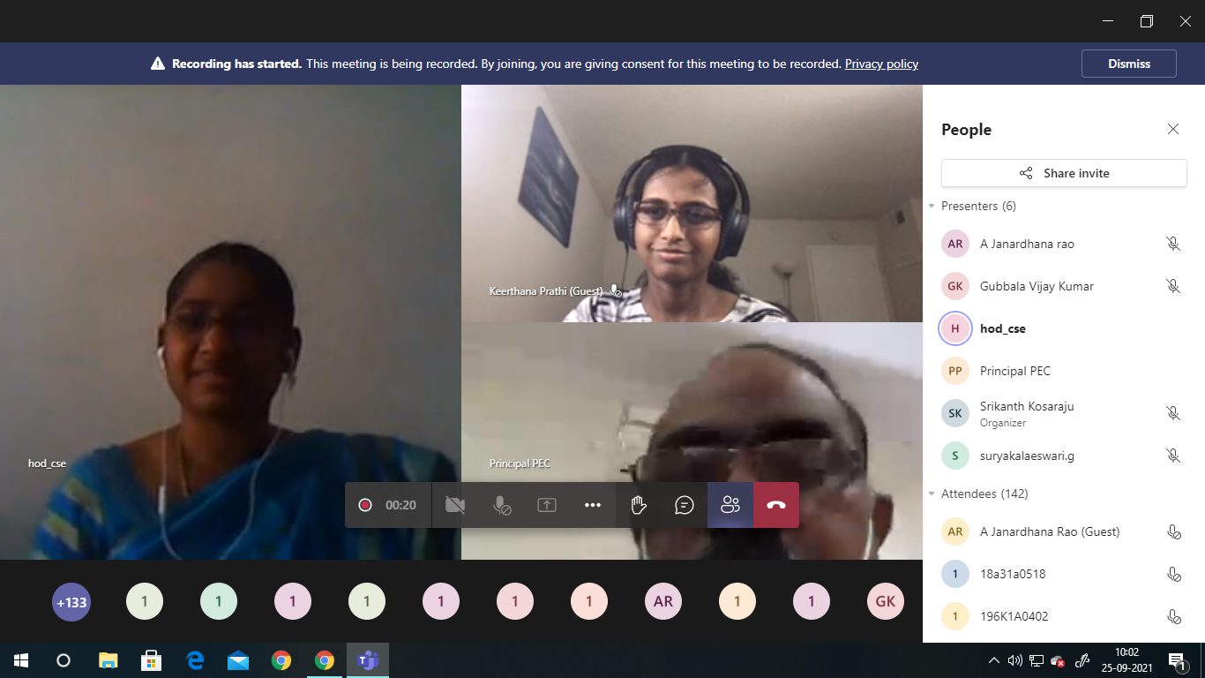

The resource person started the session by explaining the introduction of Salesforce (a cloud based Customer Relationship Management) and the key highlights of Salesforce CRM.

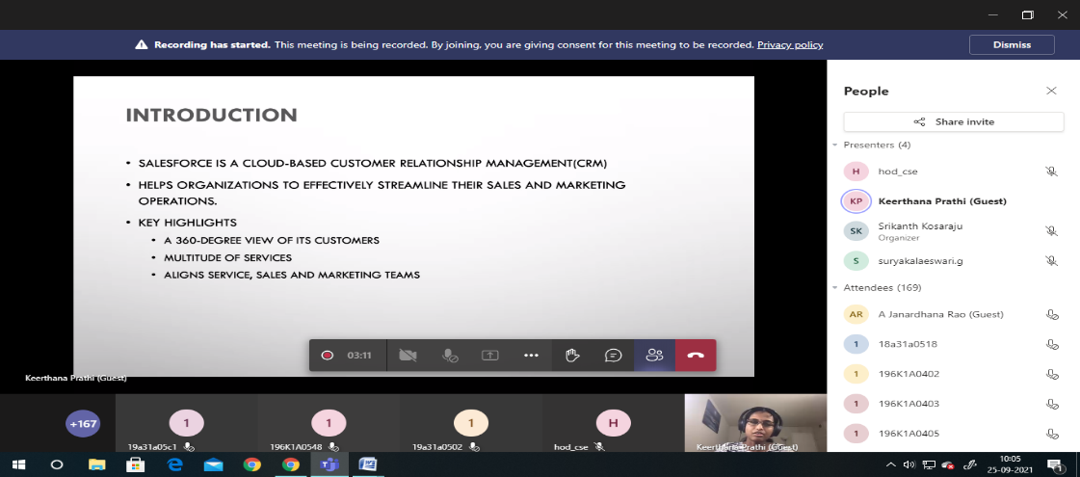
Next, the popular clouds of Salesforce like Service, Sales, Marketing, Commerce, Community, etc were discussed briefly.
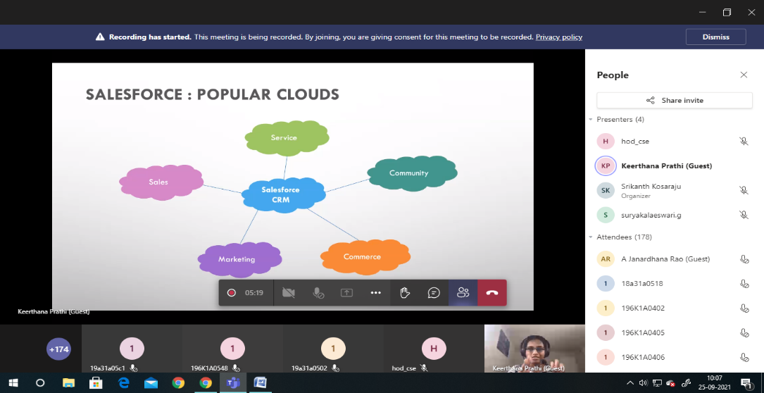
A consumer’s customer journey was also presented with help of visualisation and a real time example. This journey describes how an unknown consumer turns into a known customer. This journey consists of the involvement of various clouds like Sales, Community, etc.
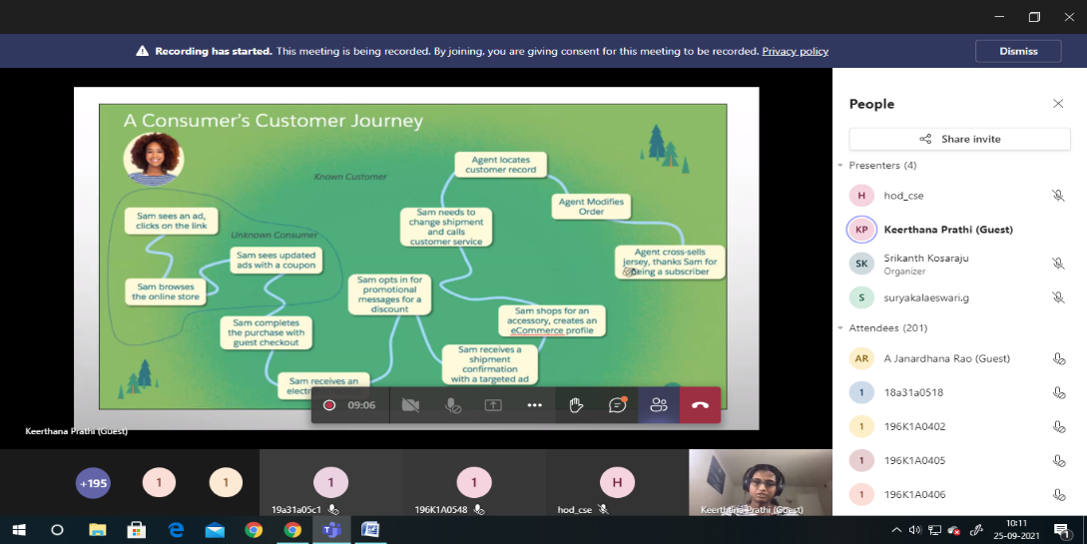

The important sections of Salesforce CRM were demonstrated next. The previous interfaces like Home, Object Manager and their functionalities were explained clearly. Also interfaces regarding Users, Data are also elaborated. She illustrated about the creation of a profile, customizing the cloud page, and Administration interface where we can create different users and assign different roles to them according to their work. She also briefed about the Consumer portal in which a dashboard can be maintained to know the progress of the particular customer

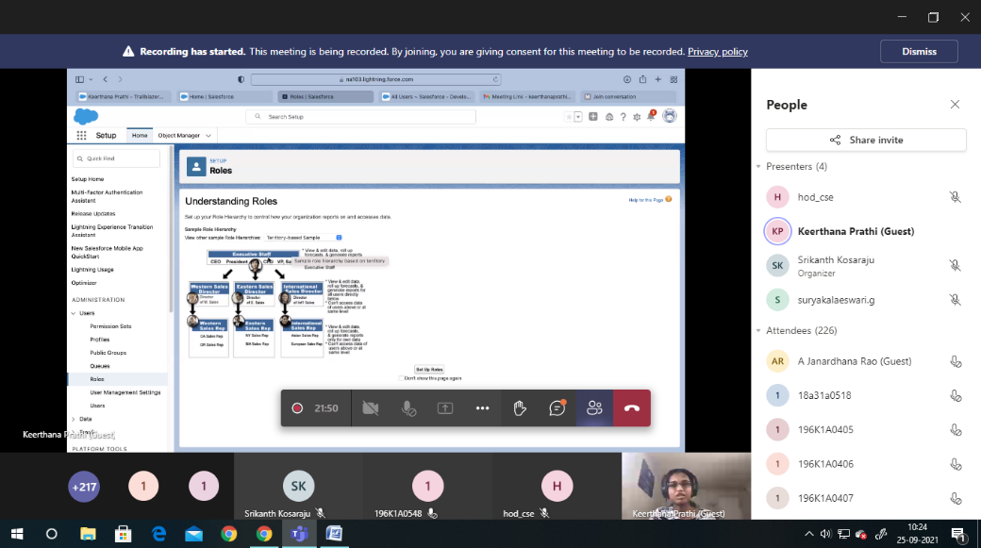

The App Launcher interface which facilitates customised application development was also discussed. The App Launcher consists of the list of available apps. We can either choose one among them or we can also build and deploy our own application.

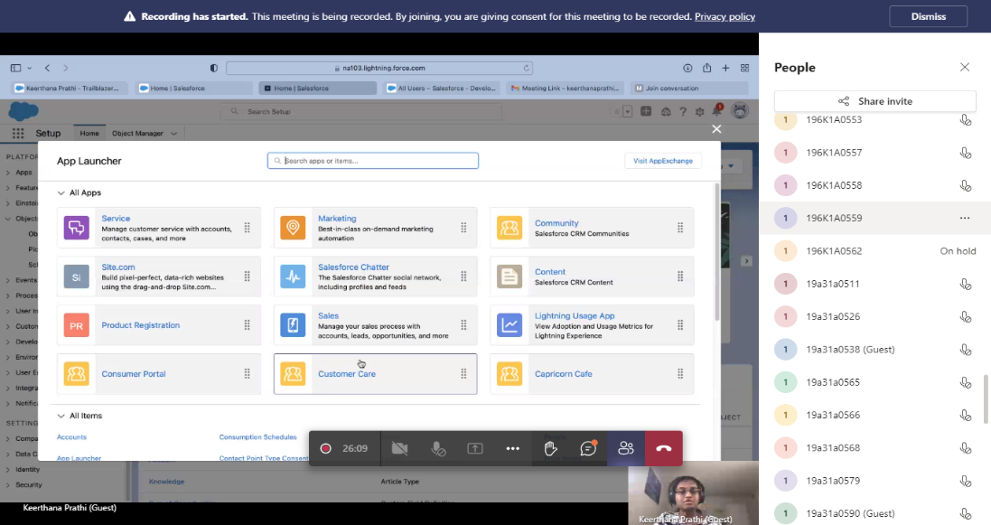
Furthermore, the advantages of Salesforce like User friendliness, Affordable nature of Salesforce supporting charge per usage, Collaboration, App Exchange, Integration APIs and AI that enhances user experience were discussed concisely.
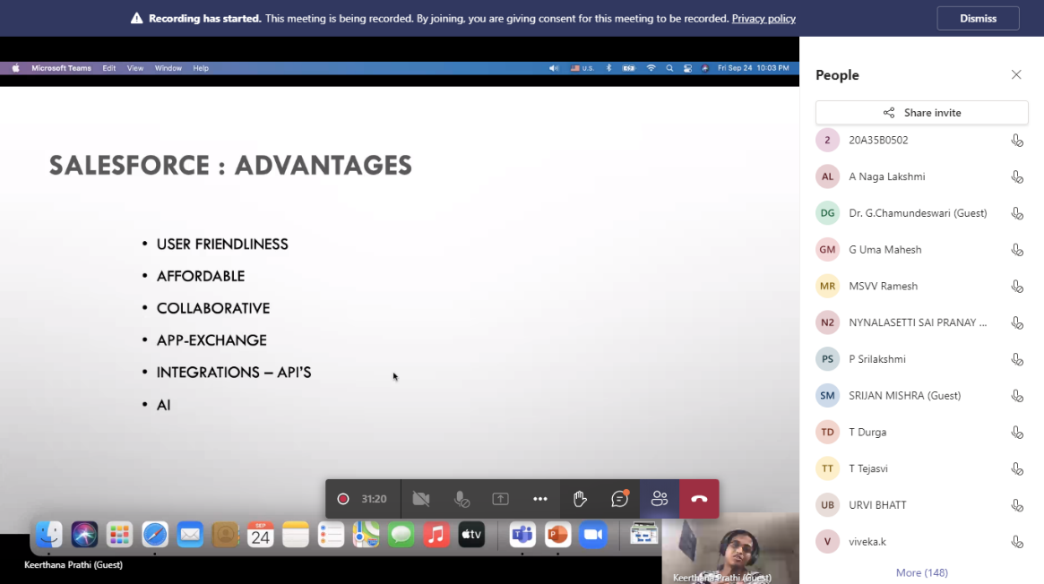
The aspects of Salesforce Tech Stack comprising of Apex (Object Oriented Programming Language that manages the backend), Visual Force (Mark up Language that manages the Frontend) and SOQL (Salesforce Query Language) were presented.
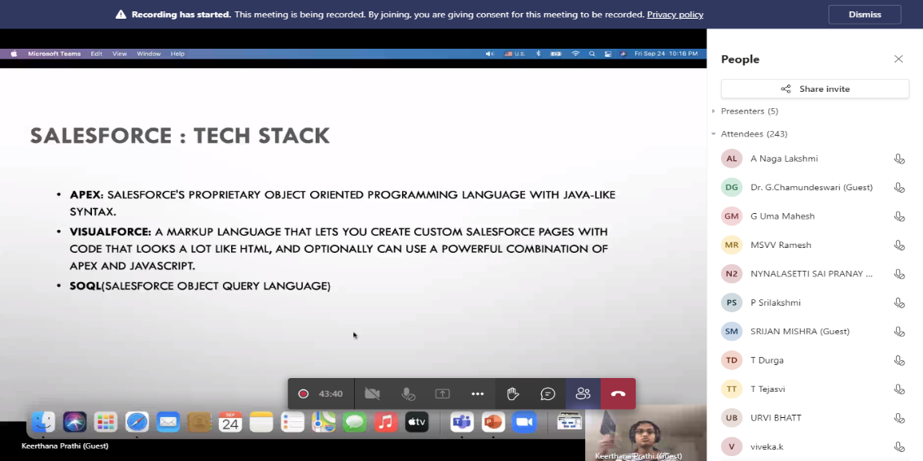

Various Learning and Career Options were provided and the training features through Salesforce Trailhead were also highlighted by the resource person. The recommended roles like Salesforce Administrators and Developers were also discussed.

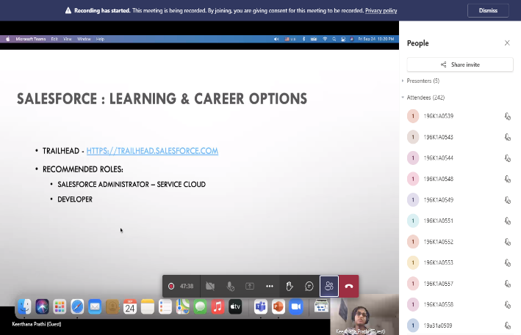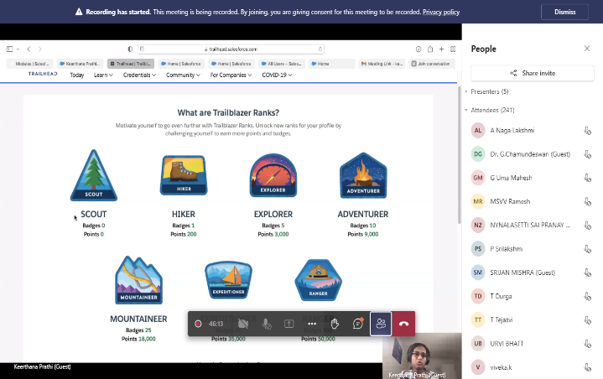

The webinar ended with a query session where the participants asked queries regarding the various features of Salesforce. It was an honor for Pragati to be a part of such potentially useful webinar.
Totally 305 participants attended the webinar.

S.No. | Name of the Participant | Department | Name of the College | State | Country
1 | Suyog Sanjay Kumbhar | Cse | Vivekananda Education Society Polytechnic | Maharashtra | India
2 | Sachin Jaiswal | Cse | Vivekanand Education Society's Polytechnic | Maharashtra | India
3 | Dr.P.C.SENTHIL MAHESH | CSE | Annamacharya Institute Of Technology And Sciences | Andhra Pradesh | India
4 | Vishnu Sasidharan | Cse | A.V.C College Of Engineering | Tamil Nadu | India
5 | Khushal. Patel | CSE | Vivekanand Education Society's Polytechnic | Maharashtra | India
6 | Jayashree Jaishankar | Cse | Avc College Of Engineering | Tamil Nadu | India
7 | Mounika Ravi | Cse | Avc College Of Engineering | Tamil Nadu | India
8 | Sneha.V | CSE | AVC COLLEGE OF ENGINEERING | Tamil Nadu | India
9 | Bharti Kumari | Cse | Brainware University | Bihar | India
10 | Ankan Das | Cse | Brainware University | West Bengal | India
11 | Sagar Khanra | Cse | Brainware University | West Bengal | India
12 | Serful Sk | Cse | Brainware University | West Bengal | India
13 | Shubham Das | Cse | Brainware University | West Bengal | India
14 | Sourav Maity | Cse | Brainware University | West Bengal | India
15 | Asif Iqbal | Cse | Brainware University | West Bengal | India
16 | Fatema Shakir | Cse | Brainware University | Madhya Pradesh | India
17 | Subhasish Dutta | Cse | Brainware University | West Bengal | India
18 | Suvankar Saha | CSE | Brainware University | West Bengal | India
19 | Arpita Dey | Cse | Brainware University | West Bengal | India
20 | Bhavik Kadu Ingle | Cse | Plitms College Of Engineering Buldhana | Maharashtra | India
21 | Avishek Chatterjee | Cse | Brainware University | West Bengal | India
22 | Anjana. R | CSE | A. V. C College Of Engineering | Tamil Nadu | India
23 | E.Srividhya | Cse | Sathyabama Institute Of Science And Technology | Tamil Nadu | India
24 | Fernandes K J | CSE | Christ Collage Of Engineeeing | Kerala | India
25 | Shri Mahaalakshmi S J | Cse | A.V.C. College Of Engineering | Tamilnadu | India
26 | Vivek Dinesh | Cse | Christ College Of Engineering | Kerala | India
27 | N Ayyanathan | Computer Applications | Bsacist, Chennai | Tamil Nadu | India
28 | Dharshini.S | CSE | A.V.C.College Of Engineering | Tamilnadu | India
29 | Parth Goel | Cse | Devang Patel Institute Of Advance Technology And Research | Gujarat | India
30 | Rishav Ghosh | Cse | Brainware University | West Bengal | India
31 | Reshmi Paul | CSE | Brainware University | Tripura | India
32 | Albert Joseph Paul | Cse | Christ College Of Engineering | Kerala | India
33 | Nirzor Sen | Cse | Brainware University | West Bengal | India
34 | Manindita Deb | Cse | Brainware University | Tripura | India
35 | Santhoshini.B | CSE | AVC COLLEGE OF ENGINEERING MAYILADUTHURAI | Tamil Nadu | India
36 | Dr Dweepna Garg | Cse | Depstar, Charusat | Gujarat | India
37 | Dr.C.KOTTEESWARAN | CSE | Sri Indu College Of Engineering & Yerhio7 | Tamilnadu | India
38 | Tejaswini Ulemale | Cse | D Y Patil College Of Engineering Akurdi | Maharashtra | India
39 | Rupam Bar | Cse | Brainware University | West Bengal | India
40 | Argha Chowdhury | Cse | Brainware University | West Bengal | India
41 | Md Irfan Mallick | Cse | Brainware University | West Bengal | India
42 | M Glory | Cse | Cmr Engineering College | Telangana | India
43 | M. Anuyakumari | Cse | Cmr Engeenering College | Telangana | India
44 | Kishore. R | CSE | A. V. C College Of Engineering | Tamilnadu | India
45 | Jayanthiradhakrishnan1976@Gmail.Com | Cse | Sathyabama Institute Of Science And Technology | Tamilnadu | India
46 | Muthazhagan B | IT | Kings Engineering College | Tamil Nadu | India
47 | Navyatha | CSE | CMR ENGINEERING COLLEGE | Telangana | India
48 | J.Sanjana | Cse | Cmr Engineering College | Telangana | India
49 | Udhayakumar L | IT | DMI College Of Engineering | Tamil Nadu | India
50 | A.Punitha | Cse | Cmr Engineering College | Telangana | India
51 | Nilesh Satyavijay Pohokar | Me | Prof. Ram Meghe Institute Of Technology And Research, Badnera | Maharashtra | India
52 | Dipankar Mandal | Cse | Brainware University | West Bengal | India
53 | Sahi Imran Mallick | Cse | Brainware University | West Bengal | India
54 | Srijan Mishra | Cse | Brainware University | Bihar | India
55 | Dharani Muthareddy | Cse | Pragati Engineering College | Andhra Pradesh | India
56 | Sidhvi Nuvvula | Cse | Pragati Engineering College | Andhra Pradesh | India
57 | Balaji Varre | Cse | Pragati Engineering College | Andhra Pradesh | India
58 | Karthik Kavala | CSE | Pragati Engineering College, Surampalem | Andhrapradesh | India
59 | Lalitha Kiranmai Kancharla | Cse | Pragati Engineering College | Andhra Pradesh | India
60 | Yasaswini Sivakoti | CSE | Pragati Engineering College, Surampalem | Andhrapradesh | India
61 | G Harsha Nandini | Cse | Pragati Engineering College | Andhra Pradesh | India
62 | Pithani Niharika | Cse | Pragati Engineering College | Andhra Pradesh | India
63 | Shaik. Basherunnisha | CSE | Pragati Engineering College,Surampalem | Andhra Pradesh | India
64 | Dr. A. Radha Krishna | Cse | Pragati Engineering College, Surampalem. | Andhra Pradesh | India
65 | Tokada Divya Sudha | Cse | Pragati Engineering College | Andhra Pradesh | India
66 | Saikumar Arigela | Cse | Pragati Engineering College | Ap | India
67 | Md Jafar Sadiqe | IT | Pragati Engineering College | Andhra Pradesh | India
68 | Mutyala Vanitha | Cse- Ai & Ml | Pragati Engineering College | Andhra Pradesh | India
69 | Bhuvana Naga Priya | Cse- Ai & Ml | Pragati Engineering College | Andhrapradesh | India
70 | A.Navya Sri Alekhya | Cse- Ai & Ml | Pragati Engineering College | Andhra Pradesh | India
71 | Vudathu Venkata Naga Anjana Pravallika | Cse | Pragati Engineering College | Andhra Pradesh | India
72 | Anaparthi Vineela | Cse Ai&Ml | Pragati Engineering College | Andhra Pradesh | India
73 | I.Jaya Krishna | CSE | Pragati Engineering College | Andhra Pradesh | India
74 | Surya Mouli Bogavarapu | Cse | Pragati Engineering College | Andhra Pradesh | India
75 | Godavarthi Srujana | Cse Ai&Ml | Pragati Engineering College | Andhra Pradesh | India
76 | Ritu Sukhdev Surushe | Cse | Pankaj Ladhhad Institute Of Technology And Management Studies | Maharashtra | India
77 | Issarapu Gangadhar | Cse | Pragati Engineering College | Andhra Pradesh | India
78 | Kotha Varshika Kumari | Cse-Ai&Ml | Pragati Engineering College | Andhra Pradesh | India
79 | Gadilli Lahari | CSE | Pragati Engineering College | Andhra Pradesh | India
80 | Nallamilli Aisshwarya | Cse | Pragati Engineering College | Andhra  Pradesh | India
81 | Pamula Sai Durga | CSE | Pragati Engineering College | Andhra Pradesh | India
82 | Ch V K Harika | Cse | Pragati Engineering | Andhra Pradesh | India
83 | Hemasri Palika | Cse | Pragati Engineering College | Andhra Pradesh | India
84 | Dr VENKATA KRISHNA V | IT | Vasavi College Of Engineering Hyderabad | Telangana | India
85 | Priyanka Himmatrao Kale | Cse | Plit,Ms Buldhana | Maharashtra | India
86 | Gowthami.Gedda | Cse | Pragati Engineering College | Andhra Pradesh | India
87 | Dr. N. K. Kameswara Rao | Cse | Sagi Rama Krishnam Raju Engineering College | Andhrapradesh | India
88 | Purli Bhagya Kiran | Ece | Pragati Engineering College | Andhra Pradesh | India
89 | Bommisetti Harshita | Cse | Pragati Engineering College | Andhra Pradesh | India
90 | Kurukuri Haritha | Cse | Pragati Engineering College | Andhra Pradesh | India
91 | V.Sri Navya | Cse | Pragati Engineering College | Andhra Pradesh | India
92 | Vishal Madupuri | Cse | Pragati Engineering College | Andhraâ Pradesh | India
93 | Parag S Nashikkar | Cse | Vivekanand Education Society's Polytechnic College | Maharashtra | India
94 | Vuddagiri Murali Gupta | Cse | Pragati Engineering College | Andhra Pradesh | India
95 | Alluri Lalitha Sri Madhuri | Cse | Pragati Engineering College | Andhra Pradesh | India
96 | Kanakala Divya Harshini | Cse | Pragati Engineering College | Andhra Pradesh | India
97 | Nakka Vineela | Cse | Pragati Engineering College | Andhrapradesh | India
98 | Adurthy Geethika Sree Alekhya | Cse | Pragati Engineering Collage | Andhra Pradesh | India
99 | Vegisetti Surya Satish | CSE | Pragati Engineering College | Andhra Pradesh | India
100 | Mounika Geddam | Cse | Pragati Engineering College | Andhra Pradesh | India
101 | Dadi Satya | Cse | Pragati Engineering College | Andhrapradesh | India
102 | Mallireddi Durga Prasad | CSE | Pragati Engineering College | Andhra Pradesh | India
103 | Rayaprolu Baladinakar | Cse | Giet(A),Rajamahendravaram | Andhra Pradesh | India
104 | K.Sriharsha | CSE | Pragati | Andra Pradesh | India
105 | Vanaparthi Prabhu Ram | Ece | Pragati Engineering College | Andhra Pradesh | India
106 | M.Lakshmi Prasanna | Cse | Pragati Engineering College | Andhra Pradesh | India
107 | N.Sekhar | Cse | Pragati | Andra Pradesh | India
108 | Durga Thokala | Cse | Pragati Engineering College | Andhrapradesh | India
109 | Kanuri Durga Prasad | ECE | Pragati Engineering Collage | Andhra Pradesh | India
110 | Sai Harshith Reddy | Cse | Malla Reddy College Of Engineering | Telangana | India
111 | Papa Rajkumar | Cse | Mallareddy Collage Of Engineering | Telangana | India
112 | Rahul Kosuri | Cse | Malla Reddy College Of Engineering | Telangana | India
113 | Nallavalli Vamshi Krishna | CSE | Mallareddy College Of Engineering | Telangana | India
114 | Moses Stanley Jaladi | Cse | Mrce | Telangana | India
115 | M.Maneesha | Cse | Malla Reddy College Of Engineering | Telangana | India
116 | G Rakesh Reddy | Cse | Malla Reddy College Of Engineering | Telangana | India
117 | L Saikiran Goud | Cse | Mallareddy College Of Engineering | Telangana | India
118 | Vasam Gouthami | Cse | Mallareddy College Of Engineering | Telangana | India
119 | Paladugu Dinakar Prasad | Cse | Malla Reddy College Of Engineering | Telangana | India
120 | A.Vyshnavi | IT | MRCE | Telangana | INDIA
121 | Ramala Naga Lakshmi | Cse | Mallareddy College Of Engineering | Telangana | India
122 | Vishwanath Vaishnavi | Cse | Mallareddy College Of Engineering | Telangana | India
123 | Sai Baba Kancherla | Cse | Malla Reddy College Of Engineering | Telangana | India
124 | Subhasish Dutta | Cse | Brainware University | West Bengal | India
125 | Syeda Aliya Mehnaaz | CSE | Mallareddy College Of Engineering | Telangana | India
126 | K.Naga Sathya Vathi | Cse | Mrce | Telangana | India
127 | M.L Sowmya Sree | Cse | Mallareddy College Of Engineering(Mrce) | Telangana | India
128 | Anusha Gattu | CSE | Malla Reddy College Of Engineering | Telangana | India
129 | Bhavana | CSE | Bhavana Minnu | Telangana | India
130 | Annam Sai Vamshi | Cse | Malla Reddy College Of Engineering | Telangana | India
131 | Kuruva Siva Ganesh | Cse | Malla Reddy College Of Engineering | Andhra Pradesh | India
132 | Ankadala Satyajeet Naidu | Cse | Malla Reddy College Of Engineering | Telangana | India
133 | Kotha Naga Sri Lakshmi | Cse (Al&Ml) | Pragati Engineering College | Andhra Pradesh | India
134 | Chindada Nandini | Cse | Pragati Engineering College | Andhra Pradesh | India
135 | Jyoshna Reddy | ITE | Malla Reddy Clg Of Engineering | Telangana | India
136 | Premkumar Chithaluru | CSE | KL University, Vaddeswaram | Andhra Pradesh | India
137 | Dhanushram.S | Cse | Avc College Of Engineering | Tamilnadu | India
138 | A. Naga Lakshmi | Cse | Pragati Engineering College | Andhra Pradesh | India
139 | Kone Ramlalsuresh | It | Pragathi | Andhra Pradesh | India
140 | Shezal Philip | Cse | Malla Reddy College Of Engineering | Telangana | India
141 | T. Poojitha | Cse | Mallareddy College Of Engineering | Telangana | India
142 | Ajaykummaar | CSE | Mallareddy College Of Engineerinng | Telangana | India
143 | A Ramesh | Eee | Ideal Institute Of Technology, Kakinada | Andhra Pradesh | India
144 | Madaka Jagadeesh | Eee | Ideal Institute Of Technology | Andhra Pradesh | India
145 | Jayalakshmi Swarnamukhi Nekkanti | Cse | Pragati Engineering College | Andhra Pradesh | India
146 | Surya Prabha | Cse | Pragati Engineering College | Andhra Pradesh | India
147 | Chatrathi Sri Divya Gowri | CSE | Pragati Engineering College | Andhrapradesh | India
148 | Mounica Bhavani | Cse | Pragati Engineering College | Andhra Pradesh | India
149 | Chitturi Geethika | Cse | Pragati Engineering College | Andhrapradesh | India
150 | Ryali Poojitha | Cse | Pragati Engineering College | Andhra Pradesh | India
151 | T. Sri Venkateswari | Cse | Pragati Engineering College | Andhra Pradesh | India
152 | Vasamsetti Venkat | CSE | Pragati Engineering College Surampalem | Andhra Pradesh | India
153 | K.Bulli Raju | Cse | Pragati Engineering College | Ap | India
154 | Kadari Anjali | Cse | Pragati Engineering College | Andhra Pradesh | India
155 | Nakka Devisri | Cse | Pragati Engineering College | Andhrapradesh | India
156 | Medavarapu Tejaswi | Cse | Pragati Engineering College | Andhra Pradesh | India
157 | Druvitha Pinisetti | Cse | Pragati Engineering College | Andhra Pradesh | India
158 | K.Vyshnavi Durga Keerthana | CSE | Pragati Engineering College | Ap | India
159 | Romith Kumar Jain | CSE | Pragati Engineering College | Andhra Pradesh | India
160 | Pilli Bhavana Priya | Cse | Pragati Engineering College | Andhra Pradesh | India
161 | Anusha Adabala | Cse | Pragati Engineering College | Andhra Pradesh | India
162 | Siddanati Suresh | Cse | Pragati Engineering College | Andhra Pradesh | India
163 | Palisetti Mounika Devi | Cse | Pragati Engineering College | Andhra Pradesh | India
164 | Yandamuri Deepthi Lochana | Cse | Pragati Engineering College | Andhra Pradesh | India
165 | Kamadi .Jyothi Manasa | Cse | Pragati Engineering College | Andhra Pradesh | India
166 | Surarapu Jyotsna Sree | Cse | Pragati Engineering College | Andhra Pradesh | India
167 | Pola Charan Adabala | Cse | Pragati Engineering College | Andhra Pradesh | India
168 | G.Bhavya Sri | CSE | Pragati Engineering College | Andhra Pradhesh | India
169 | Sekhar Nakkina | CSE | Pragati Engineering College | Andhra Pradesh | India
170 | Navya Satya Manisri Samanasa | Cse | Pragati Engineering College | Andhra Pradesh | India
171 | Ramkumar Akula | Cse | Pragati Engineering College | Andhra Pradesh | India
172 | Kola Venkatesh | Cse | Pragati Engineering College | Andhrapradesh | India
173 | Amjuri Durga Ram Prasad | Cse | Pragati Engineering College | Andhra Pradesh | India
174 | Sanjana Jain | Cse | Pragati Engineering College | Andhra Pradesh | India
175 | Dhavalagiri Veera Arun Pandyan | Cse | Pragati Engineering College | Andhra Pradesh | India
176 | Gubbala Kavya Sri | CSE | Pragati Engineering College | Andhra Pradesh | India
177 | D.Niranjana Swarna Sindhu | Cse | Pragati Engineering College | Andhra Pradesh | India
178 | Rajeev Vishal Juthuga | Cse | Pragati Engineering College | Andhra Pradesh | India
179 | Ravi Kiran | Cse | Pragati Engineering College | Andhra Pradesh | India
180 | Sri Vignatha Neram | Cse | Pragati Enginnering College | Andhra Pradesh | India
181 | Mothukuri Sunil | Cse | Pragati Enginnering College | Andhra Pradesh | India
182 | Aparna Matha | Cse | Pragati Engineering College | Andhra Pradesh | India
183 | Putta Gowtham Sagar | Cse | Pragati Engineering College | Andhra Pradesh | India
184 | Sidhu | CSE | Pragati | Ap | India
185 | Boyidi Sai Kiran | Cse | Pragati Engineering College | Andhra Pradesh | India
186 | Aishwarya Tankasala | Cse | Pragati Engineering College | Andhra Pradesh | India
187 | Kothem Venkatesh | CSE | Pragati Engineering College | Andhra Pradesh | India
188 | D.Nagendra | Cse | Pragati Engineering College | Andhra Pradesh | India
189 | K.Satwik | CSE | Pragati Engineering College | Andhra Pradesh | India
190 | Sravya Meher | Cse | Pragati Engineering College | Andhrapradesh | India
191 | K.Satya Sowmithra | CSE | Pragati Engineering College | Andhra Pradesh | India
192 | Pattabhi Keerthana | CSE | Pragati Engineering College | Andhrapradesh | India
193 | N.Satya Surya | Cse | Pragati Engineering College | Andra Pradesh | India
194 | Pavani Sai Mutyala | Cse | Pragati Engineering College | Andhra Pradesh | India
195 | Maddula Kavya Sri Lakshmi Manisri Priyanka | CSE | Pragati Engineering College | Andhrapradesh | India
196 | B.Nandakishore | Cse | Pragati Eng Clg | Andhra Pradesh | India
197 | Deepika Anjali Vallu | Cse | Pragati Engineering College | Andhra Pradesh | India
198 | Sunkara Lakshmi Sri Nitya | Cse | Pragati Engineering College | Andhra Pradesh | India
199 | Sreelekha | IT | Mallareddy Collage Of Engineering | Telangana | India
200 | K.Jahnavi | Ece | Ideal Engineering College | Andhra Pradesh | India
201 | Gayatri Srilakshmi | Ece | Ideal Institute Of Technology Kakinada | Andhra Pradesh | India
202 | Nandamuri. Padma Sri | ECE | Ideal Institute Of Technology | ANDHRA PRADESH | INDIA
203 | Merigi Nushitha | Cse | Pragati Engineering College | Andhra Pradesh | India
204 | Siva Nandini Magapu | Cse | Pragati Engineering College | Andhra Pradesh | India
205 | B.N.Ch.S.S Hima Madhuri | Cse | Pragati Engineering College | Andhra Pradesh | India
206 | B.Sailohitha | CSE | Pragati Engineering College | Andhra Pradesh | India
207 | Manam Suryanarayana | Cse | Pragati Engineering College | Andhrapradesh | India
208 | K Surya Teja | Cse | Pragati Engineering College | Andhra Pradesh | India
209 | Vimala | CSE | Ideal Institute Of Technology | Andhra Pradesh | India
210 | P Durgapavani | Cse | Pragati Engineering College | Andhra Pradesh | India
211 | Sai Krishna Puvvala | Cse | Pragati Engineering College | Andhra Pradesh | India
212 | Nagireddy Veera Siva Sai Sowmya Likitha | CSE | Pragati Engineering College | Andhra Pradesh | India
213 | Priyajit Ray | Cse | University Of Calcutta | West Bengal | India
214 | Mamidala Chandini Ramalakshmi | CSE | Pragati Engineering College | Andhra Pradesh | India
215 | Chandini Varalakshmi Mallidi | Cse | Pragati Engineering College | Andhra Pradesh | India
216 | Leela Sai | Cse | Pragati Engineering College | Andhra Pradesh | India
217 | Sunkara Bhuvaneswari | Cse | Pragati Engineering College | Andhra Pradesh | India
218 | Vereedhi Rama Naga Anjani | Cse | Pragati Engineering College | Andhra Pradesh | India
219 | G.Girish Kumar | CSE | Pragati Engineering College | Andhra Pradesh | India
220 | Kasturi Swetha Sri Anjani | Cse | Pragati Engineering College | Andhra Pradesh | India
221 | L Swathi | Cse | Bhoj Reddy Engineering College For Women | Telangana | India
222 | S S S Charishma | Cse | Pragati Engineering College | Andhra Pradesh | India
223 | Mudiki Jeevan Sandhya | CSE | Pragati | Andhra Pradesh | India
224 | Bhanu Prakash Balagam | CSE | Pragati Engineering College | Andhra Pradesh | India
225 | Sangeetha Chandanapally | Cse | Guru Nanak Institute Of Technology | Telangana | India
226 | Supriya Kumari | CSE | Advanced Institute Of Technology | Haryana | India
227 | Dommeti Vikas | Cse | Srinivasa Institute Of Engineering And Technology | Andhra Pradesh | India
228 | Gollamudi.Ashita | Cse | Pragati Engineering College | Andhra Pradesh | India
229 | M.Urjitha Bala | CSE | Pragati Engineering College | Andhra Pradesh | India
230 | Yasarapu Vijayalakshmi | Cse | Ideal Institute Of Technology | Andhra Pradesh | India
231 | Rishitha Yelleti | Cse | Pragati Engineering College | Andhra Pradesh | India
232 | Kurumalla Sri Satya Sai Tulasi | Ece | Pragati Engineering College | Andhra Pradesh | India
233 | Poojitha | ECE | Ideal Institute And Technology | Andhra Pradesh | India
234 | Karnasula. Lakshmi Tulasi | Cse | Pragati Engineering College | Andhra Pradesh | India
235 | Lokesh Sharma | Qa Dept | Sunarc Technologies | Rajasthan | India
236 | Ramya Gubbala | Cse | Ideal Institute Of Technology | Andhra Pradesh | India
237 | MERNEDI .Santha Sri | ECE | IDEAL Institute Of Technology Kakinada | Andhra Pradesh | India
238 | P.Lalitha | CSE | Pragati Engineering | Andhrapradesh | India
239 | Dendukuri Mahitha | Cse | Sagi Rama Krishnam Raju Engineering College | Andhra Pradesh | India
240 | G.Sowmya | ECE | IDEAL INSTITUTE OF TECHNOLOGY | Andhra Pradesh | India
241 | Vivek Kumar Verma | It | Government Girls Polytechnic | Uttar Pradesh | India
242 | Chinthawar Prathiksha | Cse | Mallareddy College Of Engineering | Telangana | India
243 | G.Satya Sudarshan Reddy | Cse | Pragati Engineering College | Andra Pradesh | India
244 | Dharmada. Yuva Nandini | ECE | Ideal Institute Of Technology | Andhra Pradhesh | India
245 | Shaik Umar Farooq | Cse | Pragati | Andhra Pradesh | India
246 | Addanki Janardhanarao | Cse | Pragati Engineering College | Andhra Pradesh | India
247 | S.Sindhura | ECE | Ideal Institute Of Technology | Andhra Pradesh | India
248 | Reddy Srilatha | Ece | Ideal Institute Of Technology | Andra Pradesh | India
249 | Erupilla.Pavitranjali | CSE | Pragati Engeering College | Ap | India
250 | K V V Subbarao | Cse | Pragati Engineering College | Andhra Pradesh | India
251 | Dr. PANDURANGA VITAL TERLAPU | CSE | AITAM | Andra Pradesh | India
252 | Pithani Neelima Devi | Cse | Ideal Institute Of Technology | Andrapradesh | India
253 | Gandepalli Sai Bhargavi | Cse | Pragati Engineering College | Andhra Pradesh | India
254 | Gundra Mounika | Cse | Pragati Engineering College | Andhra Pradesh | India
255 | Konda Lakshman | Cse | Jntuk- -Ucev Vizianagaram | Andhra Pradesh | India
256 | Dr. Shaik Razia | Cse | Koneru Lakshmaiah Education Foundation | Andhra Pradesh | India
257 | Posina Varalakshmi Yasaswi | Cse | Pragati Engineering College | Andhrapradesh | India
258 | Shaik Jasmin Bhanu | Cse | Pragati Engineering College | Andhra Pradesh | India
259 | Tejaasritha Goli | CSE | Pragati Engineering College | Andhrapradesh | India
260 | M.Aasritha Sai | CSE | Pragati Engineering College | Andhra Pradesh | India
261 | Diddakunta Gayathri Reddy | Ece | Ideal Institute Of Technology | Andhra Pradesh | India
262 | P.Venkata Sairam | Cse | Pragati Engineering College | Andhra Pradesh | India
263 | Ramayanapu Manga Devi | Cse | Pragati Engineering College | Andhra Pradesh | India
264 | N.Sai Sowmya | Ece | Ideal Institute Of Technology | Andhra Pradesh | India
265 | Y. Priya Susmitha | Cse | Pragati Engineering College | Andhra Pradesh | India
266 | K. Sri Harsha Vardhan | Cse | Pragati Engineering College | Andhra Pradesh | India
267 | Mogali Hrishita | Cse | Pragati Engineering College | Andhra Pradesh | India
268 | Tolety Durga Geethika | Cse | Pragati Engineering College | Andhra Pradesh | India
269 | Duggisetty Jahnavi | Cse | Narayana Engineering College | Andhra Pradesh | India
270 | Praveena . Kolukonda | ECE | Indira Institute Of Technology And Sciences | Andhra Pradesh | India
271 | Durgesh Rajana | Cse | Pragati Engineering College | Andhra Pradesh | India
272 | Gunnam Revathi | Cse | Pragati Engineering College | Andhra Pradesh | India
273 | P.Mahesh Sai | EEE | Ideal Institute Of Technology | Aandhra Pradesh | India
274 | Surya Teja Narala | Eee | Ideal Institute Of Technology | Andhra Pradesh | India
275 | Tharun | EEE | Ideal Institute Of Technology | Andhra Pradesh | India
276 | Ram Bhaskar | Eee | Ideal Institute Of Technology | Andhrapradesh | India
277 | Gaurav Rajesh Wani | Cse | Atss Cbsca College | Maharashtra | India
278 | Shaik Saadhiqh | Cse | Jntuk University College Of Engineering Vizianagaram | Andhra Pradesh | India
279 | Surisetti Pavan Kumar | Cse | Raghu Institute Of Technology | Andhra Pradesh | India
280 | Pamula Jemini | CSE | Pragati Engineering College | Andhra Pradesh | India
281 | Jankala Datta Venkata Tharun | Cse | Pragati Engineering College(Autonomous) | Andhra Pradesh | India
282 | Devi Sri Naga Jyothi Oduri | Cse | Pragati Engineering College | Andhra Pradesh | India
283 | Akula.Veera.Venkata.Ramana | CSE | Pragati | Andhrapradesh | India
284 | Sarella Chandana Keerthi | Cse | Pragati Engineering College | Andhra Pradesh | India
285 | Koppireddy Suryakala | Cse | Pragati Engineering College | Andhra Pradesh | India
286 | Kotikelapudi Bhargavi Rajeswari | Cse | Drk College Of Engineering And Technology | Telangana | India
287 | Killada Bhavana Alekhya | Cse | Pragati Engineering College | Andhra Pradesh | India
288 | Gopalapurapu Bhargav Sanjay | CSE | Pragati Engineering College | Andhra Pradesh | India
289 | Polisetti Guna Lakshmi Sireesha | Cse | Pragati Engineering College | Andhra Pradesh | India
290 | K.S.V.Abhishikth | Cse | Pragati Engineering College | Andhra Pradesh | India
291 | Dodda Sushma | CSE | Pragati Engineering College | Andhra Pradesh | India
292 | B.Susmitha | ECE | Ideal College | Andhra Pradesh | India
293 | A.S.S.Vyshnavi | Cse | Pragati Engineering College | Andrapradesh | India
294 | Addanki Sindhuja | Cse | Pragati Engineering College | Andhra Pradesh | India
295 | Y.Sri Padmavathi | EEE | Ideal Institute Of Technology | Andhra Pradesh | India
296 | K.Geethika Sowjanya | ECE | Ideal Engineering College | Andhra Pradesh | India
297 | Devarapalli Saritha | ECE | Ideal Institute Of Technology | Andhra Pradesh | India
298 | Teja | ECE | Ideal | Andhra Pradesh | Indian
299 | Nandikolla Vijaya Sankar | Ece | Pragati Engineering College | Andhra Pradesh | India
300 | Kalyani Pepakayala | Cse | Pragati Engineering College | Andhra Pradesh | India
301 | Kotikalapudi Satya Syamala Kameswari | Cse | Pragati Engineering College | Andhrapradesh | India
302 | B Pranav | Cse | Pragati Engineering College | Andhra Pradesh | India
303 | J Ravi Kiran | CSE | Pragati Engineering College | Andhra Pradesh | Indai
304 | Valluri Madhu Ramakrishna | Cse | Pragati Engineering College | Andhra Pradesh | India
305 | B.Srinivas | Cse | Aditya College Of Engineering & Technology, Surampalem | Ap | India

  - Quiz

The Prag Soft Student Club of CSE Department has organized online quiz on MFCS for all the students of CSE and IT on 25-10-2021 from 4:00pm to 10:00pm. Total number of participation count is 177.

The Prag Soft Student Club of CSE Department has organized online quiz on Web application Framework using J2EE for all the students of CSE and IT on 28-10-2021 from 4:00pm to 10:00pm.
Total number of participation count is 252

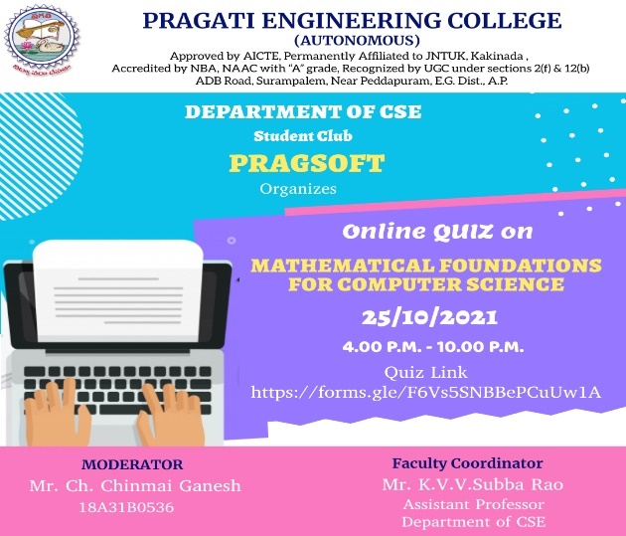

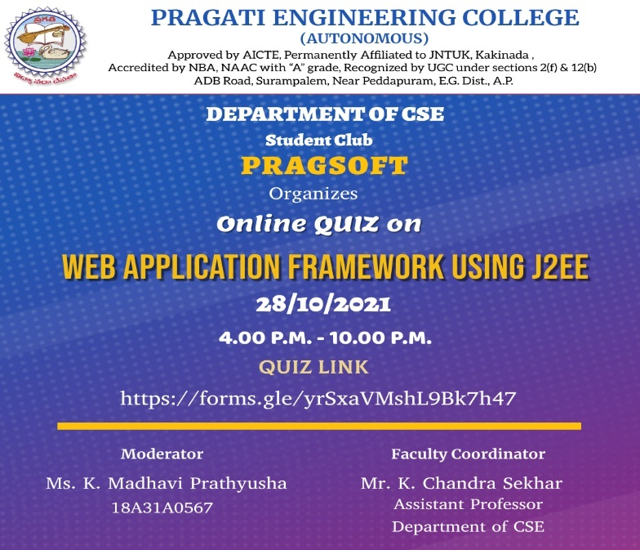

  - Essay Writing :

Date: 15/9/21
Time: 2.00pm - 4.00pm
Event Essay Writing
Topic: The Role of Engineers in an Emerging Nation
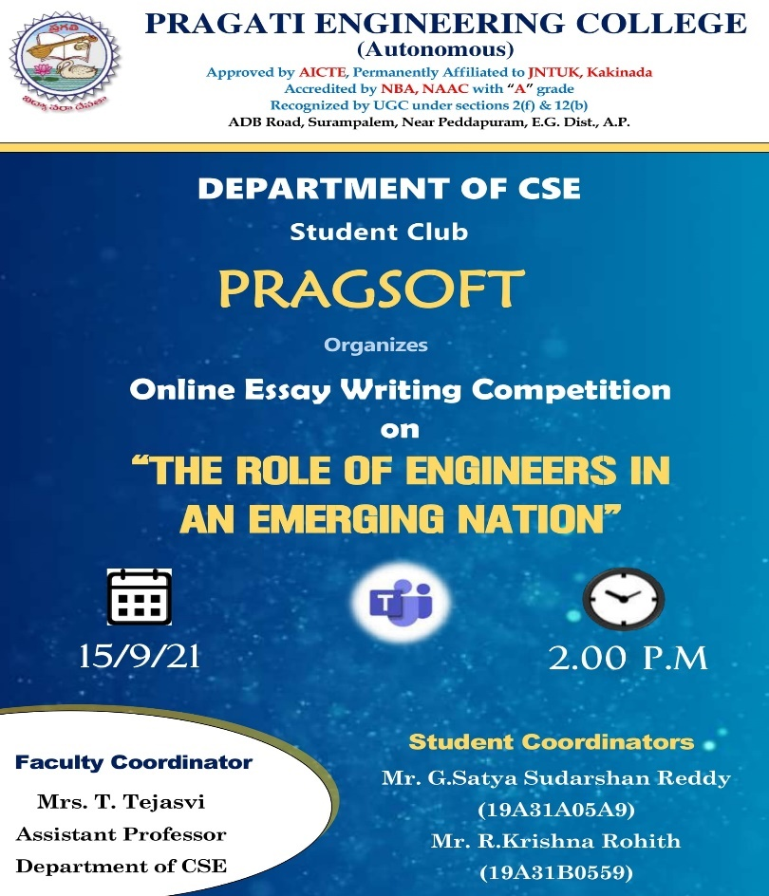

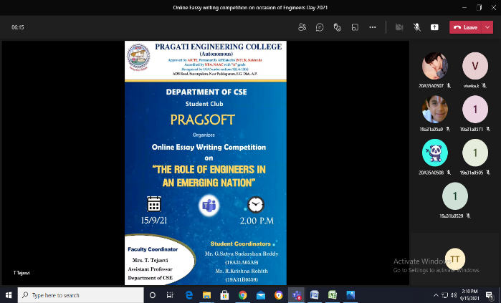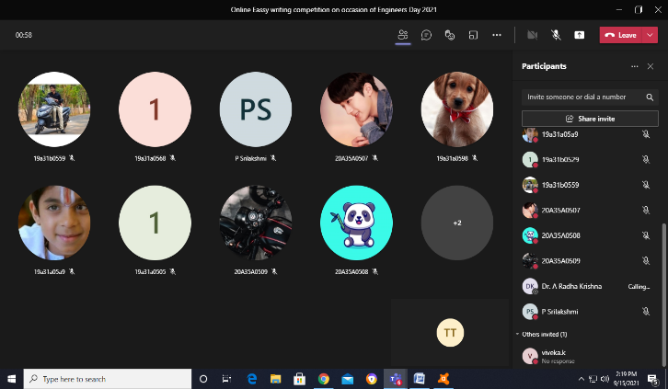

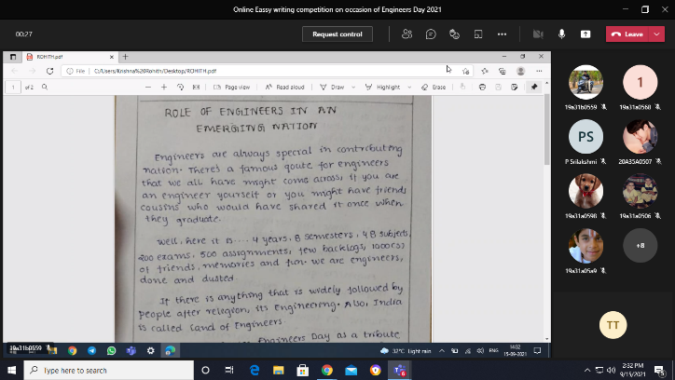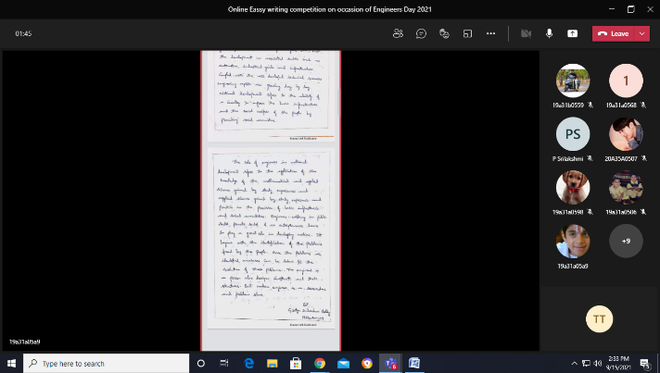

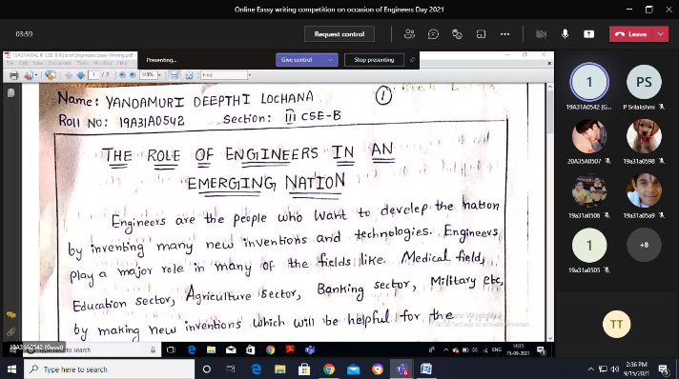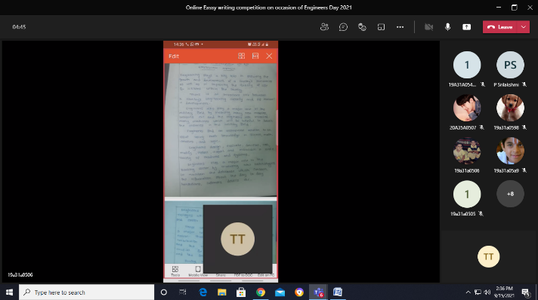

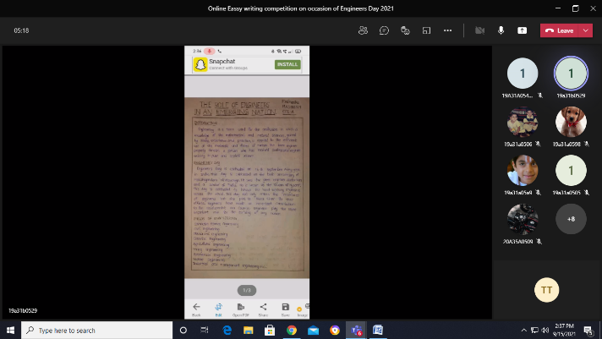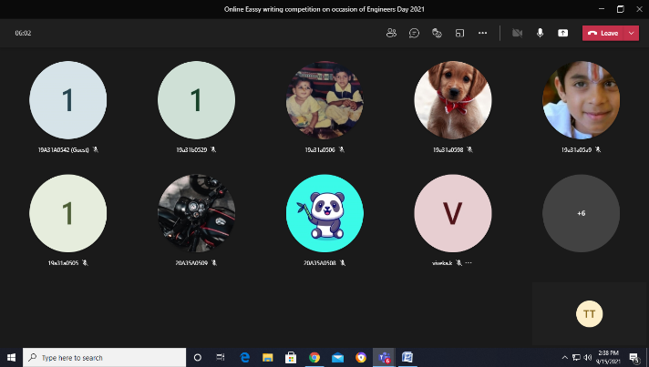

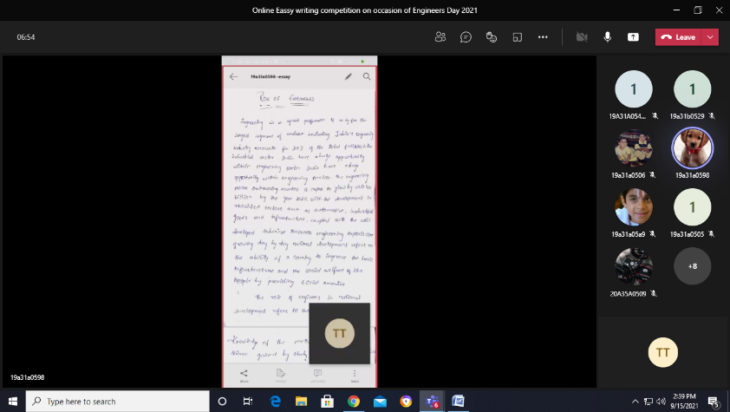

The Following are the Details of III-year students attended for this event

S.NO. | ROLL NUMBER | YEAR | SECTION | NAME OF THE STUDENT
1 | 19A31B0504 | Lll | A | B.N.CH.S.S.HIMA MADHURI
2 | 19A31B0524 | Lll | A | M.URJITHA BALA
3 | 19A31B0528 | Lll | A | P.DURGA PAVANI
4 | 19A31B0529 | lll | A | PITHANI NIHARIKA
5 | 19A31B0515 | lll | A | SHIVA HARIKA KANTUBHUKTHA
6 | 19A31B0559 | lll | A | R.KRISHNA ROHITH
7 | 19A31A0505 | lll | B | B.HARSHITA
8 | 19A31A0524 | lll | B | N.J.L. SWARANAMUKHI
9 | 19A31A0506 | lll | B | CHATRTHI SRI DIVYA GOWRI
10. | 19A31A0518 | lll | B | M.LAKSHMI PRASANNA
11. | 19A31A0542 | lll | B | YANDAMURI DEEPTHI LOCHANA
12. | 19A31A05A9 | lll | C | G.SATYA SUDARSHAN REDDY
13. | 19A31A05B1 | lll | C | K.HARSHA VARDHAN
14. | 19A31A0571 | lll | C | LAHARI
15. | 19A31A0568 | lll | C | LOHITHA
16. | 19A31A0598 | lll | C | GAYATRI PRIYA
17. | 20A35A0507 | lll | C | S.BHUVANESWARI
18. | 20A35A0508 | lll | C | BHAVANA ALEKHYA

