PRAGATI ENGINEERING COLLEGE

ELECTRICAL TIMES
VOL # 31

January to June 2022

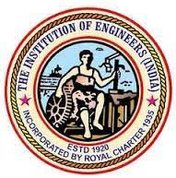
DEPARTMENT OF ELECTRICAL AND ELECTRONICS ENGINEERING
ABOUT THE DEPARTMENT:
T
he Electrical and Electronics Engineering Department of Pragati Engineering College is fully Equipped with state of art laboratories’ and its faculties consists of highly experienced professors, well qualified associate professors and dynamic assistant professors with commitment to give the young minds the very best they deserve.

ABOUT THE DEPARTMENT:
Vision of the Institute:
“To emerge as a Premier Institution for Technical Education in the Country through Academic Excellence and to be recognized as a Centre for Excellence in Research & Development, catering to the needs of our Country.”
Mission of the Institute:
“To realize a strong Institution by consistently maintaining State-of-art-infrastructure and building a cohesive, World Class Team and provide need based Technical Education, Research and Development through enhanced Industry Interaction.”
Vision of the Department:
“To excel in Engineering Education and Research, inculcating professional and social ethics among the students through academic excellence in the field of Electrical & Electronics Engineering.”
Mission of the Department:
M1: To impart quality Technical Education with better infrastructure for students to make them globally competent and technically strong.
M2: To collaborate with industries and academic institutions to enhance creativity and innovation with professional and ethical values.
M3: To motivate faculty and students to do impactful research on societal needs and to build team work among them.
Program Educational Objectives (PEOs):
PEO1
To produce graduates with a strong foundation in the Basic Sciences, Mathematics, Computing and core knowledge in Electrical and Electronics Engineering through high quality Technical Education.
PEO2
To prepare graduates for successful and productive engineering careers, with emphasis on technical competency and with an attention to serve the needs of core and associated sectors by developing novel products and solutions for the real-time problems in a socio-economic way.
PEO3
To inculcate ethical attitude, honing effective communication skills and managerial skills to work in a multidisciplinary environment as a technocrat/administrator/entrepreneur and to acquire the knowledge for pursuing advanced degrees in Engineering, Science, Management, Research and Development.

Program Outcomes (POs):

1. Engineering Knowledge: Apply the knowledge of Mathematics, Science, Engineering fundamentals, and an engineering specialization to the solution of complex engineering problems.

2. Problem Analysis: Identify, formulate, research literature, and analyze complex engineering problems reaching substantiated conclusions using first principles of Mathematics, Natural Sciences, and Engineering Sciences.

3. Design/Development of Solutions: Design solutions for complex engineering problems and design system components or processes that meet the specified needs with appropriate consideration for the public health and safety, and the cultural, societal, and environmental considerations.

4. Conduct Investigations of Complex Problems: Use research-based knowledge and research methods including design of experiments, analysis and interpretation of data, and synthesis of the information to provide valid conclusions.

5. Modern Tool Usage: Create, select, and apply appropriate techniques, resources, and modern engineering and IT tools including prediction and modeling to complex engineering activities with an understanding of the limitations.

6. The Engineer and Society: Apply reasoning informed by the contextual knowledge to assess societal, health, safety, legal and cultural issues and the consequent responsibilities relevant to the professional engineering practice.

7. Environment and Sustainability: Understand the impact of the professional engineering solutions in societal and environmental contexts, and demonstrate the knowledge of, and need for sustainable development.

8. Ethics: Apply ethical principles and commit to professional ethics and responsibilities and norms of the engineering practice.

9. Individual and Team Work: Function effectively as an individual, and as a member or leader in diverse teams, and in multidisciplinary settings.

10. Communication: Communicate effectively on complex engineering activities with the engineering community and with society at large, such as, being able to comprehend and write effective reports and design documentation, make effective presentations, and give and receive clear instructions.

11. Project Management and Finance: Demonstrate knowledge and understanding of the engineering and management principles and apply these to one’s own work, as a member and leader in a team, to manage projects and in multidisciplinary environments.

12. Life-long Learning: Recognize the need for, and have the preparation and ability to engage in independent and life-long learning in the broadest context of technological change.

Program Specific Outcomes (PSOs)

Engineering Students will be able to:

PSO1: Apply the concepts of Power Systems, Power Electronics and utilization of Renewable Energy in implementation of interdisciplinary projects
PSO2: Acquire the knowledge of Electrical and Electronics Engineering to participate in national and international competitive examinations for successful higher studies and employment.

ABOUT THE ELECTRICAL ASSOCIATION:
Association of IE(I) is organizing national level technical event “EXULT”. The national level technical symposium has events like paper presentations, quiz competitions, project model displays and poster presentations from various engineering colleges. We have been organizing “EXULT” for last eleven years. Eminent personalities from various colleges and Universities are invited to act as Judges and made it a grand success.
The main aim of this symposium is to highlight the current status and emerging trends of technology in various topics towards the betterment of industrial research and IT fields. It will be a great opportunity for students to exchange their experiences through innovative ideas and make them acquired with latest technological trends.
LIST OF FACULTY MEMBERS:
- Dr. K. Sathyanarayana M.Tech, Ph.D, MIE, MIEEE, MISTE, C Eng
- Dr. G.Naresh M.Tech, Ph.D, MIEEE, MISTE
- Dr.A.Mohan Durga Kumar M.Tech, Ph.D
- Mrs. K. Sandhya Rani M.Tech
- Mr.S.Ashokreddy M.Tech
- Mr.M.Veera Chandra Kumar M.Tech
- Mr. M. Mani Shankar M.Tech
- Ms.S.Vara Lakshmi M.Tech
- Mr. K.Siva Shankar M.Tech
- Mrs.V.R.V.S.Saivalli M.Tech
- Mrs. G. Durga Devi M.Tech
- Mrs. Ch.V.V.Manga Lakshmi M.Tech
- Mrs.M.Manga Lakshmi M.Tech
- Mr. M.Satya Harish M.Tech
- Mr. Ch.Pavankumar M.Tech
- Mr.K.V. Durga Prasad M.Tech
- Mr.T.Prasanthjayakumar M.Tech
- Mr.B.Veerababu M.Tech
- Ms.P.Sandhya M.Tech
- Mr.K.SreeHarsha M.Tech
- Mr.K.Sriramamurthy M.Tech
- Mr.D.Prakasarao M.Tech
- Mrs S.Sravani M.Tech
- Ms.Triveni M.Tech
- Mr.B.Pradeep Raj Vardhan Visiting Faculty

Faculty Participations:
1) Dr.A.Mohan Durga Kumar appointed as Editorial Board Member of Journal of Electrical and Electronic Engineering, Science Publishing Group, USA on Apr 21, 2022.

- Faculty Development Programme:

1. Dr.A.Mohan Durga Kumar Successfully completed and got Elite in NPTEL 8 week FDP on the topic “Programming, Data structures and Algorithms using python” from Jan to March-2022.

- NPTEL Certification Courses /Short Term Training Programmes:

- Dr.A.Mohan Durga Kumar Successfully completed NPTEL 8 week online Certification course on the topic “Programming, Data structures and Algorithms using python” from Jan to March-2022.
- Dr.A.Mohan Durga Kumar Successfully completed 12days online Certification course on the topic “Master Class on Motor control for EV Application” from 1-1-2022 to 12-1-2022 Organized by APSSDC – SKILAP- Pantech e learning .

PLACEMENTS:

S.No | Roll No | Name of the student | Selected company
1 | 18A31A0203 | Kasilanka Sai Ramyakrishna | Capgemini (Pool Campus)
2 | 18A31A0216 | Vankayala Varshitha
3 | 18A31A0287 | Gandham Sanjay Kumar
4 | 19A35A0202 | Vadaparthi Surya Kiranmai | Avantix
5 | 19A35A0209 | Sivaneni Anand Eswar
6 | 18A31A0240 | Naidani Vamsi | Byjus
7 | 19A35A0207 | Patra Sai Kishore
8 | 18A31A0251 | Velpuri Manideep | HCL
9 | 19A35A0206 | Mudunuru Satya Sriram
10 | 19A35A0203 | Amajala Sri Ram Pavan | KPIT
11 | 18A31A0223 | Chilukuri Vara Prasad
12 | 18A31A0279 | Vonteddu Sri Naga Sai Datha Vimal
13 | 18A31A0207 | Medapati Sujatha | Mindtree
14 | 18A31A0254 | Yejju Vamsi Krishna
15 | 19A35A0209 | Sivaneni Anand Eswar
16 | 19A35A0210 | Vasamsetti Veera Venkata Lokesh
17 | 18A31A0278 | Vommi Prem Kumar | Revature
18 | 18A31A0236 | Kovvuri Chinna Venkata Reddy | Tech Mahindra (Phase-1)
19 | 18A31A0237 | Makineedi Akash
20 | 18A31A0239 | Meenavalli V V Rama Krishna
21 | 18A31A0253 | Yarrapragada Surya Dheeraj
22 | 18A31A0275 | Y Naga Lakshmi Pranathi
23 | 18A31A02A0 | Pakkurthi Eswar
24 | 18A31A0264 | Koyya Monika
25 | 18A31A0250 | Vasamsetty Sri Rama Krishna Chaitanya | Virtusa
26 | 18A31A0211 | Pachhigolla Ramya Sri
27 | 18A31A0253 | Yarrapragada Surya Dheeraj
28 | 18A31A0239 | Meenavalli V V Rama Krishna
29 | 18A31A0206 | Kothapalli Ganga Bhavani | Zensar
30 | 18A31A0260 | Chodisetti Anjani
31 | 19A35A0209 | Sivaneni Anand Eswar
32 | 19A35A0210 | Vasamsetti Veera Venkata Lokesh
33 | 18A31A0204 | Sri Lakshmi Akanksha Kola | Wipro (NTH-2.0)
34 | 18A31A0225 | Rajesh Chitikela
35 | 18A31A0226 | Surya Kumar Desamsetti
36 | 18A31A0236 | Kovvuri Chinna Venkata reddy
37 | 18A31A0240 | Vamsi Naidani
38 | 18A31A0250 | Vasamsetty Sri Rama Krishna Chaitanya
39 | 18A31A0255 | Naga surendra Yeturi
40 | 18A31A0260 | Anjani Chodisetti
41 | 18A31A0262 | Kondruthu Sambhavi kavya nikitha
42 | 18A31A0263 | Ramya Koppisetti
43 | 18A31A0274 | Sai Archana Bhargavi Sambattula
44 | 18A31A0277 | Varshith Sai Bhaskar Chintapalli
45 | 18A31A0286 | Prem Kumar Dasari
46 | 18A31A0289 | Godi Deepak Kumar
47 | 18A31A02A0 | Eswar Pakkurthi
48 | 19A35A0209 | Anand Eswar Sivaneni
49 | 19A35A0210 | Veera Venkata Lokesh Vasamsetti
50 | 19A35A0213 | Jaya Prasanth Kumar Amujuri
51 | 18A31A0213 | Thota Sruthi | Infosys
52 | 18A31A0219 | Ainavelli Satish
53 | 18A31A0222 | Chaganti Janardhan Kamesh
54 | 18A31A0226 | Desamsetti Surya Kumar
55 | 18A31A0228 | Doddi Ram Mohan
56 | 18A31A0232 | Kola Umar Satish Kumar
57 | 18A31A0236 | Kovvuri Chinna Venkata Reddy
58 | 18A31A0251 | Velpuri Manideep
59 | 18A31A0255 | Yeturi Naga Surendra
60 | 18A31A0272 | Ramireddy Vara Lakshmi Devika
61 | 18A31A0278 | Vommi Prem Kumar
62 | 18A31A02A1 | Ramisetti Vera Venkata Satyanarayana
63 | 18A31A02A2 | Reddy Srikanth
64 | 19A35A0204 | Garaga Satish
65 | 19A35A0209 | Sivaneni Anand Eswar

EVENTS

Report on “Exult-2k22” A National Level Technical Symposium Under STRIDES
The Department of Electrical and Electronics Engineering of this college organized a Two-day National Level Technical Symposium “Exult-2k22 Under STRIDES” on 25th & 26th March, 2022. This event was inaugurated by the Chief Guest, Dr.K.Venkatareddy Professor of EEE, Controller of Examinations JNTUK. The Chief Guest emphasized the different sources for energy generation, importance of renewable energy and opportunities offered for electrical engineers in present scenario.
Dr. P. Krishna Rao, Chairman, Pragati Engineering College Participated in this Programme. Speaking on this occasion he stated that the college has been taking all the necessary steps to mould students as future industrialists besides imparting technical education. He advised the students to progress in their life by utilizing the Opportunities and infrastructure provided in the institution, motivated the electrical engineers towards innovation of latest technology for global needs.
Dr. S. Sambhu Prasad, Director Academics of the College emphasized that EXULT-2K22 is an opportunity for Electrical students to explore their innovative ideas and make them acquainted with latest technological trends and motivated the students regarding Entrepreneurship. He extended his wishes for making event successful.
Dr. K. Sathyanarayana, Principal & Professor of EEE, addressed that this Symposium will provide a good exposure to the students to interact with outside world and briefed about the achievements of the department.
Mrs.K.Sandhyarani , HOD-EEE, Pragati Engineering College highlighted the current status & the emerging trends of the technology in various topics.
Ms.S.Varalakshmi & Ms.P.Sandhya, Assistant Professor of EEE, Coordinator of the event played a pivotal role in organizing this programme said that about 956 Entries were Presented in various events like paper Presentation, Poster Presentation, Project Presentation and Technical Quiz, Out of which 56 Paper Presentations, 60 Poster Presentations, 46 Project Presentations and 561 Technical Quiz teams ,20 innovative design ideas and 90 Tricky circuits were selected in the final round from various colleges.
“EXULT-2K22” Souvenir was released by the Chief guests Dr.K.Venkatareddy , Dr. P. Krishna Rao , Dr. S. Sambhu Prasad, Dr.K.Satyanarayana. Dr. A.Mohan kumar, and Mrs K.Sandhyarani HOD-EEE,Pragati Engineering College were the judges for final presentation.
Sri M. V. HarnathBabu, Director (Mgmt), Sri. M. Satish, Vice-President, Dr. S. Sambhu Prasad, Director, Dr. G. Naresh, Vice principal, Dr.P.Sunitha Convenor of STRIDES, Staff, Participants and students were present at the Prize distribution function. Finally the valedictory function was conducted at 2.30 P.M. First and second prize and third winners are awarded with cash prizes and certificates.

PRIZE WINNERS OF THE EVENT:
PAPER PRESENTATION:
FIRST PRIZE: Topic “Wireless technology”
- Ms.Ch.Lakshmi Meghana from Pragati Engineering College, Surampalem.
SECOND PRIZE: Topic “Happie Technology”
- Mr.P.Venkata Balaji
- Ms.K.Revathi
- Ms. S.Divya veeramani from Pragati Engineering College, Surampalem
THIRD PRIZE: Topic “Education System”
- Ms.D.Sri dhanya
- Ms.K.Srilakshmi
- Ms.M.S.S.V.Kusuma
- Ms.S.Sofia sugandhi from Pragati Engineering College, Surampalem.

POSTER PRESENTATION:
FIRST PRIZE: Topic “IOT IN AGRICULTURE”
- Ms. S.Jhansi Divya
- Ms. G.Geetha Venkata Lakshmi from Pragati Engineering College, Surampalem
SECOND PRIZE: Topic “GPS and GSM Based Health Monitoring System”
- Ms.J.Suneetha Devi
- Ms.R.Bandhavya from Pragati Engineering College, Surampalem.

THIRD PRIZE: Picto
- Mr. V Haritha from Aditya Degree College

PROJECT MODEL DISPLAY:
FIRST PRIZE: Topic “Air Quality Monitoring System Using Arduino”
- Ms. P. Sri Rama Aparna
- Ms. A.Kavya
- Ms. Prathibha
- Ms.S.Jhansi from Pragati Engineering College, Surampalem.

SECOND PRIZE: Topic “Smart Card Based Door Lock And Unlock System”
- Mr. Vedula Narayana from Pragati Engineering College, Surampalem.
THIRD PRIZE: Topic “Wireless Power Transmission”
- Mr. G.Ramesh,
- Mr. G.Sai Durga,
- Mr.K.Bharath,
- Mr.M.Dharma Teja,
- Mr.V.Sampath,
- Mr.D.M.Prasad,
- Mr. K.Raghunath from Pragati Engineering College, Surampalem.

TECHNICAL QUIZ:
FIRST PRIZE:
- Ms. Doolla Venkata Padma from Pragati Engineering College, Surampalem

SECOND PRIZE:
1. Ms. Mutyala Pavani Sai from Pragati Engineering College, Surampalem

INNOVATIVE DESIGN IDEAS:
FIRST PRIZE:
1. Mr. P.Krishna Swamy

2. Mr.M.Krishna Praveen from Pragati Engineering College, Surampalem

SECOND PRIZE:
1. Ms. K. Monika Lakshmi from Pragati Engineering College, Surampalem

TRICKEY LOOPS:
FIRST PRIZE: Topic “Air Quality Monitoring System Using Arduino”
- Ms. M Durga Malleswari from Pragati Engineering College, Surampalem.

SECOND PRIZE: Topic “Smart Card Based Door Lock And Unlock System”
- Mr. Ansuri Subash from Pragati Engineering College, Surampalem.

THIRD PRIZE: Topic “Wireless Power Transmission”
- Mr R Surya
- Ms. P Subhasreya from Pragati Engineering College, Surampalem.

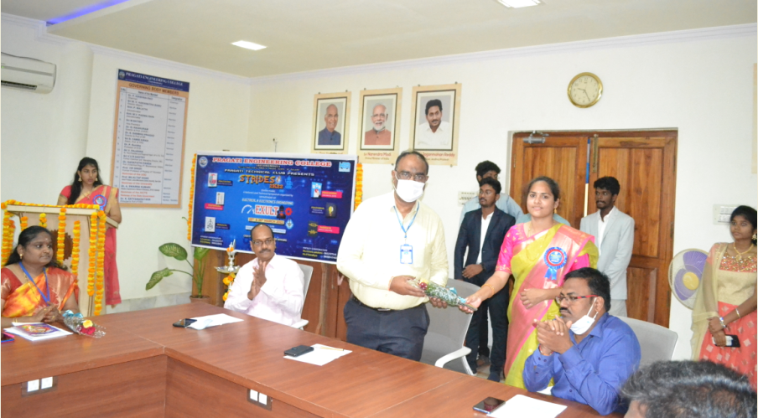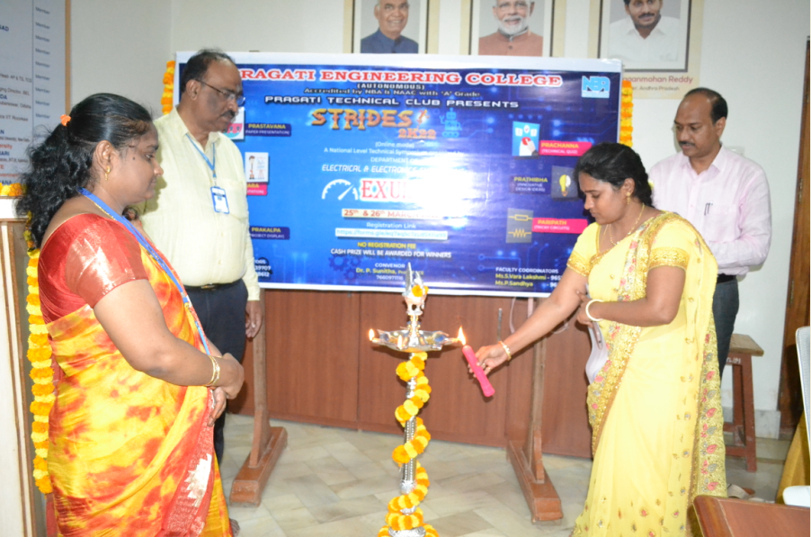
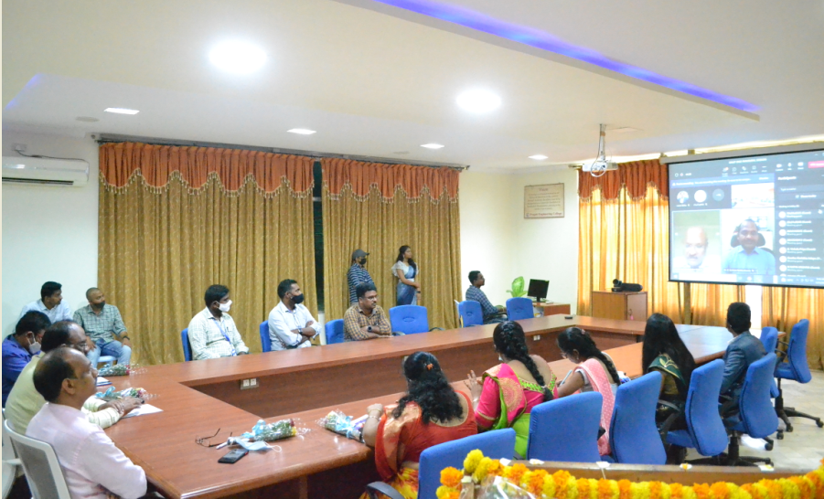

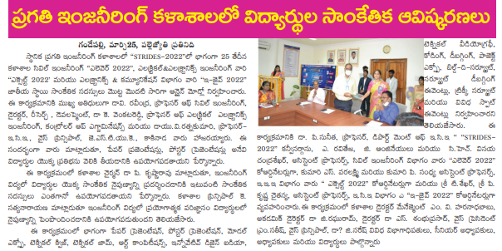
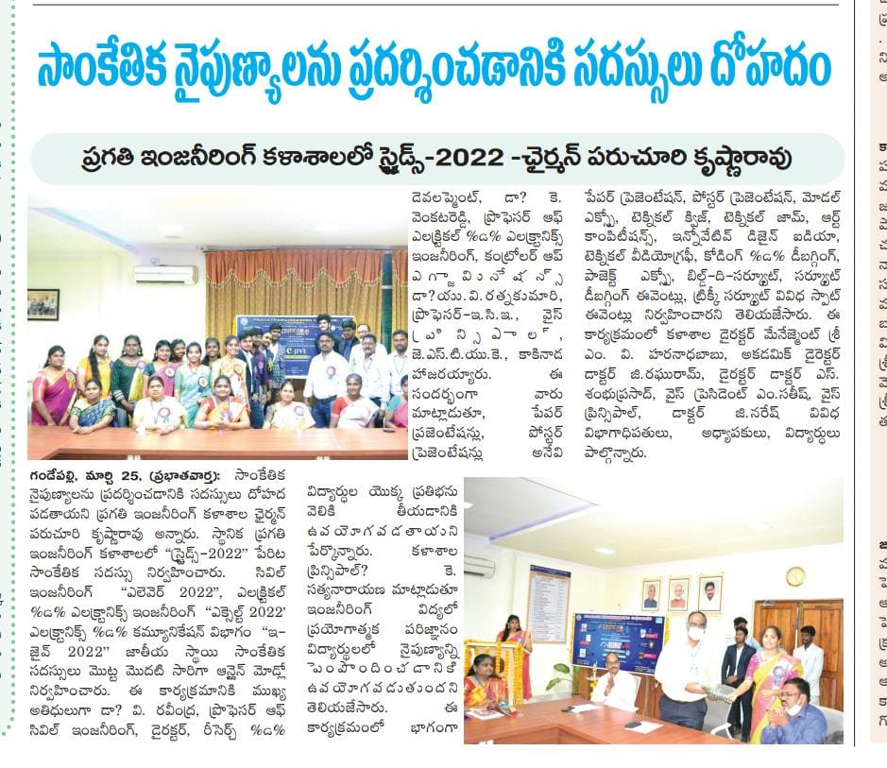

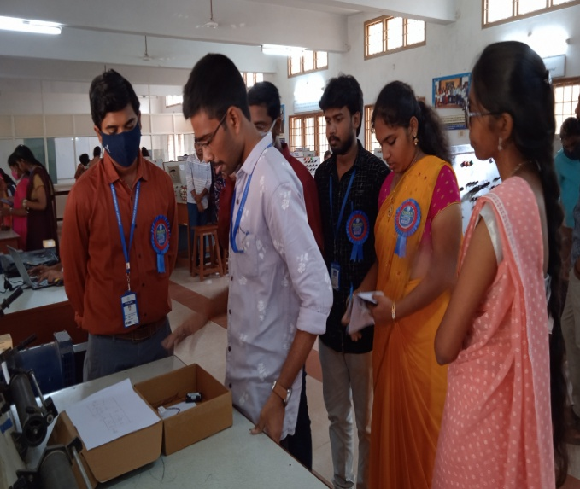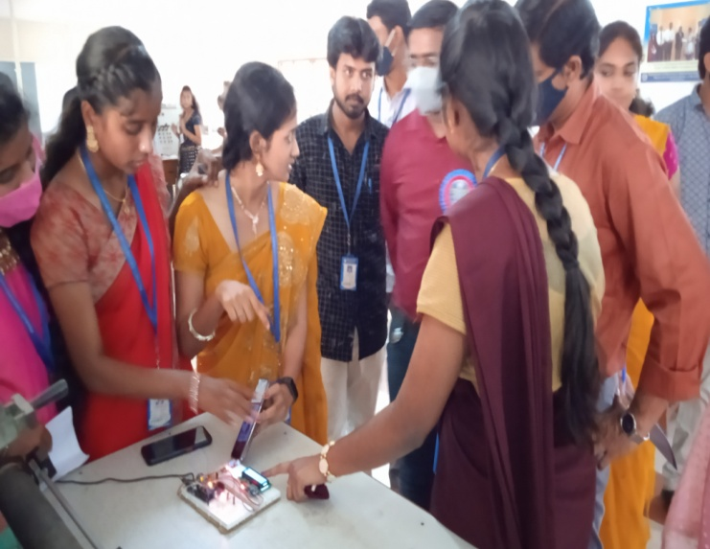
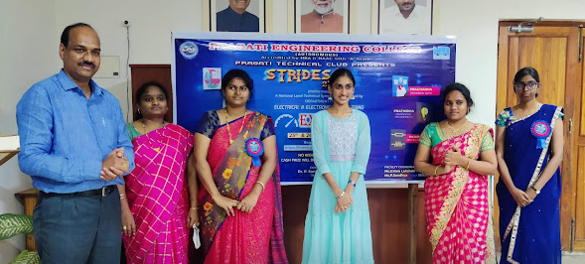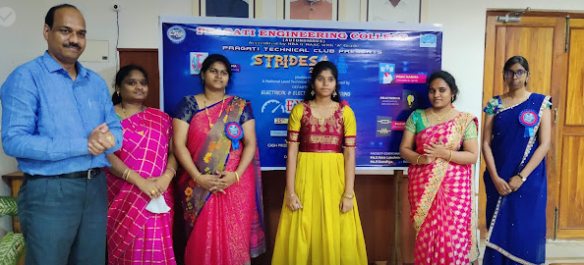

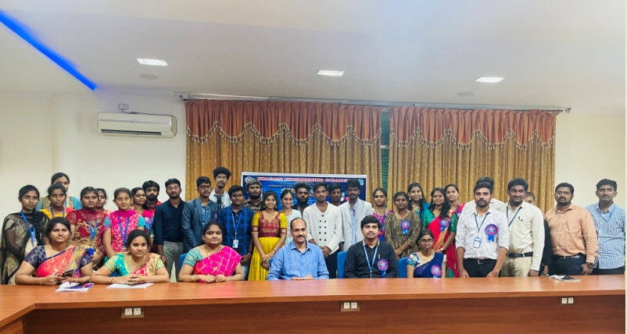

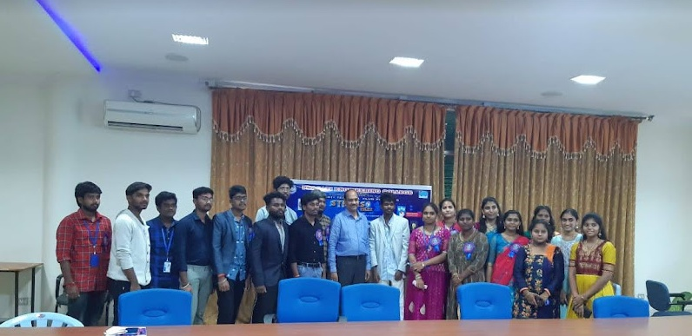

Student Achievements in various activities:
Paper publications:
- Kollapureddy Satya Nukesh, Meenavalli V V Ramakrishna, Kasilanka Sai Ramyakrishna, Upadhyay Sakshee, Visanala Surekha, Pentakota Prasad of IV EEE A published paper entitled with, “Automatic HTTransformer Protection From Fire Hazard”,Published in The International journal of analytical and experimental modal analysis(IJAEMA), Volume XIV, Issue 05, May/2022 ISSN 0886-9367,Impact factor:6.3.

- P. Sai Kishore, K. Naga Durga , S. Anand Eswar ,V.Varshita ,G. Shyam Kumar of IV EEE A published paper entitled with, “Automatic Billing System Using Iot Technology For Smart Cities “Published in Journal of Interdisciplinary Cycle Research (JICR), Volume XIV, Issue-V , ISSN NO: 0022-1945, MAY 2022,impact Factor 6.2.

- Narla Surya Kiran , Mudunuru Satya Sriram, Vasamsetti Veera Venkata Lokesh, Yeturi Naga Surendra, Prasant Kumar Sahu, Dulapalli Chandrasekhar of IV EEE A published paper entitled with, Solar Based Smart Street Lighting System, Published in Journal of Engineering Sciences (JES) Volume 13, Issue 05, E-ISSN 0377-9254 , May-2022, Impact Factor 6.54.

- J. Hari Chandana ,M. Nikitha ,T. Suma,C. V. Reddy,R .Bhargav of IV EEE A published paper entitled with “IOT SMART SWITCH”, Published in International Journal For Advanced Research In Science And Technology(IJARST), Volume 12,Issue 05,May 2022 ISSN 2457-0362,Impact factor:6.428

- P. Ramyasri A.Sri Ram Pavan, M. Akash, A. Uma Nagendra Swaroop, M.Sujatha, of IV EEE A published paper entitled with “Automatic Phase Selector in Power Supply”, Published in The international journal of analytical and experimental modal of analysis, Volume XIV ISSN NO: 0886-9367, MAY 2022, impact factor 6.4.

- Grandhi Venkata Rama Lakshman, Doddi Ram Mohan, Kondapu Madhu, Naidani Vamsi, Pandiri Siva Sai Durga Anil Kumar, Rambothula Kailash, of IV EEE A published paper entitled with “Smart Parking System”, Published in Journal of Interdisciplinary Cycle Research,Volume 14,Issue No.5,E-ISSN 0022-1945,May-2022,Impact Factor 6.2

- Devarakonda Vamsi, Kothapalli Ganga Bhavani, Gubbala Satya Meghana, Changanti Janardhan Kamesh, Chilukuri Vara Prasad, of IV EEE A published paper entitled with “Work Force Safety Monitoring Using IOT”, Published in Journal of Engineering Sciences Page No :446-451 DOI:10.15433.JES.2022.V13I05.43P.62

- Kola Umar Satish Kumar, Yarrapragada Surya Dheeraj, Desamsetti Surya Kumar, Ainavelli Satish, Varasala Tarun Kumar, of IV EEE A published paper entitled with “Internet Controlled Street Lights”, Published in International Journal of Engineering and Advanced Technology (IJEAT), Volume 12, Issue 05, ISSN: 2547-0362, May-2022, Impact Factor 6.428.

- N Durga Santhoshi Mata, Y Vamsi Krishna, K Chinna Venkata Reddy, G Tulasi Swetha, S Venkata Mani Teja, of IV EEE A published paper entitled with “Poly House Monitoring System In Agriculture Using Iot”, Published in The International journal of analytical and experimental modal analysis (IJAEMA),Volume 14,Issue No.5, E-ISSN 0886-9367, MAY 2022, Impact Factor 6.3

- P.Udaya Sree, A. Tarun Sai, V.Surya Kiranmai, B.Bhanu Prakash Reddy, D. Lokesh, of IV EEE A published paper entitled with “Solar Charge:E-Vehicles with IoT”, Published in Journal of Interdisciplinary Cycle Research(JICR), Volume 14,Issue No.5,E-ISSN 0022-1945,MAY 2022,impact Factor 6.2

- T.Sruthi, K.S.L.Akanksha, G.Satish, Ch.Rajesh, P.S.V.Ganesh, of IV EEE A published paper entitled with “IOT Based School Childrentransport System ”,Published in Journal of Engineering Sciences , Volume 13, Issue 05, May/2022 ISSN 0377-9254,Impact factor:6.54

- Kompella Aditya Sri Harsha, Velpuri Manideep, Vasamsetty Sri Rama Krishna Chaitanya, Nakka Sree Lakshmana Ramesh, Seshapu Venkat, of IV EEE A published paper entitled with “Self Protection System Using IOT and GPS “, Published in International Journal For Advanced Research In Science And Technology(IJARST), Volume 12, Issue No.05, ISSN:2457-0362, May-2022.

- Marisetti Radha Lahari, Malladi Ravi Varma, Budhireddy Bhanu Prasad, Madduri Tejaswi, Sayed Yunus, of IV EEE B published paper entitled with “Activity Based Lighting System Using IOT “The international journal of analytical and experimental model analysis (IJAEMA), Volume 14, ISSN NO: 0886-9367 , MAY 2022,impact Factor 6.3.

- Bandaru Satya Akhila, Bathula Yasaswini krishnaSri, Malladi Bhargava Sri Sai Sundar, Mohammad Khamruddin Javeed, Thiparti h S S V Mani Vamsi of IV EEE B published paper entitled with “Aqua Farming System Using Ph Sensor and IOT”, Published in Journal of Interdisciplinary Cycle Research, Volume XIV, Issue V, ISSN NO: 0022-1945, Page number:938-944, May-2022, Impact factor – 6.2.

- A. Durga Satya Sai Kiran Kumar , K. Ramya , Ch. Siva Rama krishna ,K . Sai Venkata Naveen , Arsha Zaheen , of IV EEE B published paper entitled with “Creating Signal Free Traffic For Ambulance”, Published in Journal of Engineering Sciences(JES), Volume 13,Issue No.5, ISSN NO:0377-9254,MAY 2022,impact Factor 6.54

- P. Eswar, r.srikanth , k.venkatesh , m.sanjeev , k.jaswanth of IV EEE B published paper entitled with “Energy Meter Reading Monitoring Through IOT ”, Published in International Journal for Advanced Research in Science and Technology , Volume 12, Issue 5, ISSN NO: 2457-0362, Page number:105-110, May-2022, Impact factor – 6.2.
- Ch.Anjani , P.Sirisha , V.PremKumar , G.S.Sai Manohar , M.Avinash, of IV EEE B published paper entitled with “Accident Spot Identification System” , The International Journal ofAnalytical andExperimentalModalAnalysis,IssueNo:08869367, Volume XIV, Issue V, May/2022
- G.p.d.k. Mahalakshmi, Isukapatla Syam Sundar, Narukula Harika, Kesuboina Subhash, Maka Appanna, of IV EEE B published paper entitled with “IOT Based Agriculture System”, Journal of Interdisciplinary Cycle Research(JICR),Volume 14, ISSN NO: 0022-1945,MAY 2022,Impact factor 6.2

- A.J.Prasanth Kumar, S.S.Archana Bhargavi, K.S.K.Nikitha, V.Durga Rao, G.Sumanth, of IV EEE B published paper entitled with “Internet Of Things Gas Leakage Identification System Using Blynk App ”,Journal of Engineering Science(JRS),Volume 13,Issue No.5,ISSN NO:0377-9254,MAY 2022,Impact Factor-6.54

- Y. Naga Lakshmi Pranathi, P. Swathi, J. Uma Mani Shankar, G. Deepak Kumar, G. Bhagya Vinayaka Yogi, of IV EEE B published paper entitled with “Remote Oil Facilities Monitoring Using Internet Of Things”, Published in International Journal For Advanced Research In Science And Technology (IJARST),Volume 12,Issue No.5,E-ISSN 2457-0362,MAY 2022,impact Factor 6.428

- R.V.L.Devika , S.Sunny, M.Mounika, A.Safru Qureshi, N.Vamsi, of IV EEE B published paper entitled with”RFID Based Billing System”, Published in The International journal of analytical and experimental modal analysis, Volume XIV, Issue V, May/2022, ISSN NO: 0886-9367.

- B.Chandini, D.Omkar, K.Monika, D.Premkumar, V.S.N.S.D.Vimal, of IV EEE B published paper entitled with “Speed and direction control of a DC motor using blynk app”, Journal of Interdisciplinary Cycle Research ,volume 14,Issue no.5,E-ISSN 0022-1945,MAY 2022,impact factor 6.2

- Vedula Sai Shyam, Pulaparthi Purna Latha, Gubbala Kumar Swamy, Pendyala Lasya Priya, Uday Kiran , of IV EEE B published paper entitled with “Smart Farming System Using ZIGBEE” Journal of Engineering Sciences (JES), Volume 13, ISSN NO: 0377-9254 , MAY 2022, Impact factor- 6.54

- Y. Mahima Anjeelina, G. Sanjay Kumar, Y. Yamini Ravali, G. Vijay Sagar, D. Bhavani Shankar , of IV EEE B published paper entitled with “Door Access Control System - RFID”, Published in The international journal of analytical and experimental model analysis (IJAEMA), Volume 14, ISSN NO: 2457-0362 , MAY 2022, impact Factor 6.428.

- A.Satish, K.Samuel, R.Satyanarayana, G.Harish, Ch.V Sai Bhaskar, of IV EEE B published paper entitled with “ Fire Alert Monitoring System In Parking Area Using IOT", Published in The International journal of analytical and experimental modal analysis , Volume XIV, Issue V, May/2022,ISSN NO: 0886-9367
INTERNSHIPS
- Ms.D.Venkata Padma(20A31A0252) Successfully completed 10 Weeks Robotic process Automation (RPA) Virtual Internship during march-may 2022 organized by AICTE, NEAT
- Workshops attended by the students
- Ms.D.S.N.L Priyanka (19A31A0204) of III EEE-A attended two day Workshop on Embedded Systems in National level Technical Symposium Organized by JNTU-GV College of Engineering Vizianagaram from 21st – 22nd April 2022
- Mr.Y.Gowtham (19A31A0256) of III EEE-A attended two day Workshop on Embedded Systems in National level Technical Symposium Organized by JNTU-GV College of Engineering Vizianagaram from 21st – 22nd April 2022
- Mr. A.Sudheer kumar (19A31A0223) of III EEE-A attended two day Workshop on Embedded Systems in National level Technical Symposium Organized by JNTU-GV College of Engineering Vizianagaram from 21st – 22nd April 2022
- Mr. Dadala Ashok Kumar (20A35A0214) of III EEE-A attended two day Workshop on Embedded Systems in National level Technical Symposium Organized by JNTU-GV College of Engineering Vizianagaram from 21st – 22nd April 2022
- Mr. Suresh Annamdevula (20A35A0207) of III EEE-A attended two day Workshop on Embedded Systems in National level Technical Symposium Organized by JNTU-GV College of Engineering Vizianagaram from 21st – 22nd April 2022
- Ms. Inti Sadhvika Jani (19A31A0209) of III EEE-A attended two day Workshop on Embedded Systems in National level Technical Symposium Organized by JNTU-GV College of Engineering Vizianagaram from 21st – 22nd April 2022
- Ms. Karri Syamala Devi (20A35A0202) of III EEE-A attended two day Workshop on Embedded Systems in National level Technical Symposium Organized by JNTU-GV College of Engineering Vizianagaram from 21st – 22nd April 2022
- Ms. Kurra Naga Mahalakshmi Vidyasri (19A31A0215) of III EEE-A attended two day Workshop on Embedded Systems in National level Technical Symposium Organized by JNTU-GV College of Engineering Vizianagaram from 21st – 22nd April 2022
- Ms. Gunnam Bala Veera Nandini (19A31A0207) of III EEE-A attended two day Workshop on Embedded Systems in National level Technical Symposium Organized by JNTU-GV College of Engineering Vizianagaram from 21st – 22nd April 2022
- Mr. Gubbala Ravindra (19A31A0228) of III EEE-A attended two day Workshop on Embedded Systems in National level Technical Symposium Organized by JNTU-GV College of Engineering Vizianagaram from 21st – 22nd April 2022
- Mr. Koppana Jhansi Satya Venkata T (19A31A0214) of III EEE-A attended two day Workshop on Embedded Systems in National level Technical Symposium Organized by JNTU-GV College of Engineering Vizianagaram from 21st – 22nd April 2022
- Mr Sai Krishna Sri Harsha (19A31A0257) of III EEE-A attended two day Workshop on Embedded Systems in National level Technical Symposium Organized by JNTU-GV College of Engineering Vizianagaram from 21st – 22nd April 2022
- Mr Saladi Ishwarya Madhuri (19A31A0220) of III EEE-A attended two day Workshop on Embedded Systems in National level Technical Symposium Organized by JNTU-GV College of Engineering Vizianagaram from 21st – 22nd April 2022
- Mr. Valluri Swaroop (19A31A0253) of III EEE-A attended two day Workshop on Embedded Systems in National level Technical Symposium Organized by JNTU-GV College of Engineering Vizianagaram from 21st – 22nd April 2022
- Mr. Paruchuri Dharma Sai (19A31A0242) of III EEE-A attended two day Workshop on Embedded Systems in National level Technical Symposium Organized by JNTU-GV College of Engineering Vizianagaram from 21st – 22nd April 2022
- Mr. Undurthi Praveen Kumar (19A31A0252) of III EEE-A attended two day Workshop on Embedded Systems in National level Technical Symposium Organized by JNTU-GV College of Engineering Vizianagaram from 21st – 22nd April 2022
- Mr. Ulli Sai Trinadh (19A31A0251) of III EEE-A attended two day Workshop on Embedded Systems in National level Technical Symposium Organized by JNTU-GV College of Engineering Vizianagaram from 21st – 22nd April 2022
- Ms. Sankabathula Lakshmi Alekhaya (19A31A0221) of III EEE-A attended two day Workshop on Embedded Systems in National level Technical Symposium Organized by JNTU-GV College of Engineering Vizianagaram from 21st – 22nd April 2022
- Mr. K.Veerababu (19A31A0231) of III EEE-A attended two day Workshop on Embedded Systems in National level Technical Symposium Organized by JNTU-GV College of Engineering Vizianagaram from 21st – 22nd April 2022
- Ms. Kedarisetti Lakshmi Sahithi (19A31A0213) of III EEE-A attended two day Workshop on Embedded Systems in National level Technical Symposium Organized by JNTU-GV College of Engineering Vizianagaram from 21st – 22nd April 2022
- Mr. P Harsha Veera Nagendra Vara Prasad (19A31A0245) of III EEE-A attended two day Workshop on Embedded Systems in National level Technical Symposium Organized by JNTU-GV College of Engineering Vizianagaram from 21st – 22nd April 2022
- Ms. Palivela Jeevana Sushmitha Rani (20A35A0201) of III EEE-A attended two day Workshop on Embedded Systems in National level Technical Symposium Organized by JNTU-GV College of Engineering Vizianagaram from 21st – 22nd April 2022
- Mr. Seela Gowtham (19A31A0248) of III EEE-A attended two day Workshop on Embedded Systems in National level Technical Symposium Organized by JNTU-GV College of Engineering Vizianagaram from 21st – 22nd April 2022
- Mr. N.Eswar Manikanta (19A31A0241) of III EEE-A attended two day Workshop on Embedded Systems in National level Technical Symposium Organized by JNTU-GV College of Engineering Vizianagaram from 21st – 22nd April 2022
- Mr. Sonteni Aharon (20A35A0210) of III EEE-A attended two day Workshop on Embedded Systems in National level Technical Symposium Organized by JNTU-GV College of Engineering Vizianagaram from 21st – 22nd April 2022
- Mr.Kanigineedy Daya Kiran (19A31A0232) of III EEE-A attended two day Workshop on Embedded Systems in National level Technical Symposium Organized by JNTU-GV College of Engineering Vizianagaram from 21st – 22nd April 2022
- Mr. A.L.N.Prashanth (19A31A0222) of III EEE-A attended two day Workshop on Embedded Systems in National level Technical Symposium Organized by JNTU-GV College of Engineering Vizianagaram from 21st – 22nd April 2022
- Ms. N.Srujana (19A31A0216) of III EEE-A attended two day Workshop on Embedded Systems in National level Technical Symposium Organized by JNTU-GV College of Engineering Vizianagaram from 21st – 22nd April 2022
- Mr. Kornani Bharath (19A31A0236) of III EEE-A attended two day Workshop on Embedded Systems in National level Technical Symposium Organized by JNTU-GV College of Engineering Vizianagaram from 21st – 22nd April 2022
- Ms. G.V.S.Reshma (19A31A0261) of III EEE-B attended two day Workshop on Embedded Systems in National level Technical Symposium Organized by JNTU-GV College of Engineering Vizianagaram from 21st – 22nd April 2022
- Ms. Kadimi Lalitha Devi (19A31A0263) of III EEE-B attended two day Workshop on Embedded Systems in National level Technical Symposium Organized by JNTU-GV College of Engineering Vizianagaram from 21st – 22nd April 2022
- Ms. Kapu Naga Haritha Pravallika (19A31A0264) of III EEE-B attended two day Workshop on Embedded Systems in National level Technical Symposium Organized by JNTU-GV College of Engineering Vizianagaram from 21st – 22nd April 2022
- Ms. Kasimeda Rojamani (19A31A0265) of III EEE-B attended two day Workshop on Embedded Systems in National level Technical Symposium Organized by JNTU-GV College of Engineering Vizianagaram from 21st – 22nd April 2022
- Ms. Mallipudi Durga Malleswari (19A31A0267) of III EEE-B attended two day Workshop on Embedded Systems in National level Technical Symposium Organized by JNTU-GV College of Engineering Vizianagaram from 21st – 22nd April 2022
- Ms. M.I Prathusha (19A31A0268) of III EEE-B attended two day Workshop on Embedded Systems in National level Technical Symposium Organized by JNTU-GV College of Engineering Vizianagaram from 21st – 22nd April 2022
- Ms. Tulli Chamundeswari (19A31A0273) of III EEE-B attended two day Workshop on Embedded Systems in National level Technical Symposium Organized by JNTU-GV College of Engineering Vizianagaram from 21st – 22nd April 2022
- Yerroju Naga Satya Ganga Prane (19A31A0276) of III EEE-B attended two day Workshop on Embedded Systems in National level Technical Symposium Organized by JNTU-GV College of Engineering Vizianagaram from 21st – 22nd April 2022
- Mr. Narla Uma Mahesh (19A31A0297) of III EEE-B attended two day Workshop on Embedded Systems in National level Technical Symposium Organized by JNTU-GV College of Engineering Vizianagaram from 21st – 22nd April 2022
- Mr. John Wind (19A31A0298) of III EEE-B attended two day Workshop on Embedded Systems in National level Technical Symposium Organized by JNTU-GV College of Engineering Vizianagaram from 21st – 22nd April 2022
- Mr. Patamsetti Surya Venkata Manoj (19A31A0299) of III EEE-B attended two day Workshop on Embedded Systems in National level Technical Symposium Organized by JNTU-GV College of Engineering Vizianagaram from 21st – 22nd April 2022
- Ms. Myla Satya Devi Hari Priya (20A35A0215) of III EEE-B attended two day Workshop on Embedded Systems in National level Technical Symposium Organized by JNTU-GV College of Engineering Vizianagaram from 21st – 22nd April 2022
- Mr Kesanakurthi V V S S Bhavani Prasad (20A35A0217) of III EEE-B attended two day Workshop on Embedded Systems in National level Technical Symposium Organized by JNTU-GV College of Engineering Vizianagaram from 21st – 22nd April 2022
- Mr. Ulapalli Sai Srinivas (20A35A0218) of III EEE-B attended two day Workshop on Embedded Systems in National level Technical Symposium Organized by JNTU-GV College of Engineering Vizianagaram from 21st – 22nd April 2022
- Ms.D.S.N.L Priyanka (19A31A0204) of III EEE-A attended two day Workshop on ARDUINO BOOTCAMP in National level Technical Symposium Organized by JNTU-GV College of Engineering Vizianagaram from 21st – 22nd April 2022
- Mr.Y.Gowtham (19A31A0256) of III EEE-A attended two day Workshop on ARDUINO BOOTCAMP in National level Technical Symposium Organized by JNTU-GV College of Engineering Vizianagaram from 21st – 22nd April 2022
- Mr. A.Sudheer kumar (19A31A0223) of III EEE-A attended two day Workshop on ARDUINO BOOTCAMP in National level Technical Symposium Organized by JNTU-GV College of Engineering Vizianagaram from 21st – 22nd April 2022
- Mr. Dadala Ashok Kumar (20A35A0214) of III EEE-A attended two day Workshop on ARDUINO BOOTCAMP in National level Technical Symposium Organized by JNTU-GV College of Engineering Vizianagaram from 21st – 22nd April 2022
- Mr. Suresh Annamdevula (20A35A0207) of III EEE-A attended two day Workshop on ARDUINO BOOTCAMP in National level Technical Symposium Organized by JNTU-GV College of Engineering Vizianagaram from 21st – 22nd April 2022
- Ms. Inti Sadhvika Jani (19A31A0209) of III EEE-A attended two day Workshop on ARDUINO BOOTCAMP in National level Technical Symposium Organized by JNTU-GV College of Engineering Vizianagaram from 21st – 22nd April 2022
- Ms. Karri Syamala Devi (20A35A0202) of III EEE-A attended two day Workshop on ARDUINO BOOTCAMP in National level Technical Symposium Organized by JNTU-GV College of Engineering Vizianagaram from 21st – 22nd April 2022
- Ms. Kurra Naga Mahalakshmi Vidyasri (19A31A0215) of III EEE-A attended two day Workshop on ARDUINO BOOTCAMP in National level Technical Symposium Organized by JNTU-GV College of Engineering Vizianagaram from 21st – 22nd April 2022
- Ms. Gunnam Bala Veera Nandini (19A31A0207) of III EEE-A attended two day Workshop on ARDUINO BOOTCAMP in National level Technical Symposium Organized by JNTU-GV College of Engineering Vizianagaram from 21st – 22nd April 2022
- Mr. Gubbala Ravindra (19A31A0228) of III EEE-A attended two day Workshop on ARDUINO BOOTCAMP in National level Technical Symposium Organized by JNTU-GV College of Engineering Vizianagaram from 21st – 22nd April 2022
- Mr. Koppana Jhansi Satya Venkata T (19A31A0214) of III EEE-A attended two day Workshop on ARDUINO BOOTCAMP in National level Technical Symposium Organized by JNTU-GV College of Engineering Vizianagaram from 21st – 22nd April 2022
- Mr Sai Krishna Sri Harsha (19A31A0257) of III EEE-A attended two day Workshop on ARDUINO BOOTCAMP in National level Technical Symposium Organized by JNTU-GV College of Engineering Vizianagaram from 21st – 22nd April 2022
- Mr Saladi Ishwarya Madhuri (19A31A0220) of III EEE-A attended two day Workshop on ARDUINO BOOTCAMP in National level Technical Symposium Organized by JNTU-GV College of Engineering Vizianagaram from 21st – 22nd April 2022
- Mr. Valluri Swaroop (19A31A0253) of III EEE-A attended two day Workshop on ARDUINO BOOTCAMP in National level Technical Symposium Organized by JNTU-GV College of Engineering Vizianagaram from 21st – 22nd April 2022
- Mr. Paruchuri Dharma Sai (19A31A0242) of III EEE-A attended two day Workshop on ARDUINO BOOTCAMP in National level Technical Symposium Organized by JNTU-GV College of Engineering Vizianagaram from 21st – 22nd April 2022
- Mr. Undurthi Praveen Kumar (19A31A0252) of III EEE-A attended two day Workshop on ARDUINO BOOTCAMP in National level Technical Symposium Organized by JNTU-GV College of Engineering Vizianagaram from 21st – 22nd April 2022
- Mr. Ulli Sai Trinadh (19A31A0251) of III EEE-A attended two day Workshop on ARDUINO BOOTCAMP in National level Technical Symposium Organized by JNTU-GV College of Engineering Vizianagaram from 21st – 22nd April 2022
- Ms. Sankabathula Lakshmi Alekhaya (19A31A0221) of III EEE-A attended two day Workshop on ARDUINO BOOTCAMP in National level Technical Symposium Organized by JNTU-GV College of Engineering Vizianagaram from 21st – 22nd April 2022
- Mr. K.Veerababu (19A31A0231) of III EEE-A attended two day Workshop on ARDUINO BOOTCAMP in National level Technical Symposium Organized by JNTU-GV College of Engineering Vizianagaram from 21st – 22nd April 2022
- Ms. Kedarisetti Lakshmi Sahithi (19A31A0213) of III EEE-A attended two day Workshop on ARDUINO BOOTCAMP in National level Technical Symposium Organized by JNTU-GV College of Engineering Vizianagaram from 21st – 22nd April 2022
- Mr. P Harsha Veera Nagendra Vara Prasad (19A31A0245) of III EEE-A attended two day Workshop on ARDUINO BOOTCAMP in National level Technical Symposium Organized by JNTU-GV College of Engineering Vizianagaram from 21st – 22nd April 2022
- Ms. Palivela Jeevana Sushmitha Rani (20A35A0201) of III EEE-A attended two day Workshop on ARDUINO BOOTCAMP in National level Technical Symposium Organized by JNTU-GV College of Engineering Vizianagaram from 21st – 22nd April 2022
- Mr. Seela Gowtham (19A31A0248) of III EEE-A attended two day Workshop on ARDUINO BOOTCAMP in National level Technical Symposium Organized by JNTU-GV College of Engineering Vizianagaram from 21st – 22nd April 2022
- Mr. N.Eswar Manikanta (19A31A0241) of III EEE-A attended two day Workshop on ARDUINO BOOTCAMP in National level Technical Symposium Organized by JNTU-GV College of Engineering Vizianagaram from 21st – 22nd April 2022
- Mr. Sonteni Aharon (20A35A0210) of III EEE-A attended two day Workshop on ARDUINO BOOTCAMP in National level Technical Symposium Organized by JNTU-GV College of Engineering Vizianagaram from 21st – 22nd April 2022
- Mr.Kanigineedy Daya Kiran (19A31A0232) of III EEE-A attended two day Workshop on ARDUINO BOOTCAMP in National level Technical Symposium Organized by JNTU-GV College of Engineering Vizianagaram from 21st – 22nd April 2022
- Mr. A.L.N.Prashanth (19A31A0222) of III EEE-A attended two day Workshop on ARDUINO BOOTCAMP in National level Technical Symposium Organized by JNTU-GV College of Engineering Vizianagaram from 21st – 22nd April 2022
- Ms. N.Srujana (19A31A0216) of III EEE-A attended two day Workshop on ARDUINO BOOTCAMP in National level Technical Symposium Organized by JNTU-GV College of Engineering Vizianagaram from 21st – 22nd April 2022
- Mr. Kornani Bharath (19A31A0236) of III EEE-A attended two day Workshop on ARDUINO BOOTCAMP in National level Technical Symposium Organized by JNTU-GV College of Engineering Vizianagaram from 21st – 22nd April 2022
- Ms. G.V.S.Reshma (19A31A0261) of III EEE-B attended two day Workshop on ARDUINO BOOTCAMP in National level Technical Symposium Organized by JNTU-GV College of Engineering Vizianagaram from 21st – 22nd April 2022
- Ms. Kadimi Lalitha Devi (19A31A0263) of III EEE-B attended two day Workshop on ARDUINO BOOTCAMP in National level Technical Symposium Organized by JNTU-GV College of Engineering Vizianagaram from 21st – 22nd April 2022
- Ms. Kapu Naga Haritha Pravallika (19A31A0264) of III EEE-B attended two day Workshop on ARDUINO BOOTCAMP in National level Technical Symposium Organized by JNTU-GV College of Engineering Vizianagaram from 21st – 22nd April 2022
- Ms. Kasimeda Rojamani (19A31A0265) of III EEE-B attended two day Workshop on ARDUINO BOOTCAMP in National level Technical Symposium Organized by JNTU-GV College of Engineering Vizianagaram from 21st – 22nd April 2022
- Ms. Mallipudi Durga Malleswari (19A31A0267) of III EEE-B attended two day Workshop on ARDUINO BOOTCAMP in National level Technical Symposium Organized by JNTU-GV College of Engineering Vizianagaram from 21st – 22nd April 2022
- Ms. M.I Prathusha (19A31A0268) of III EEE-B attended two day Workshop on ARDUINO BOOTCAMP in National level Technical Symposium Organized by JNTU-GV College of Engineering Vizianagaram from 21st – 22nd April 2022
- Ms. Tulli Chamundeswari (19A31A0273) of III EEE-B attended two day Workshop on ARDUINO BOOTCAMP in National level Technical Symposium Organized by JNTU-GV College of Engineering Vizianagaram from 21st – 22nd April 2022
- Yerroju Naga Satya Ganga Prane (19A31A0276) of III EEE-B attended two day Workshop on ARDUINO BOOTCAMP in National level Technical Symposium Organized by JNTU-GV College of Engineering Vizianagaram from 21st – 22nd April 2022
- Mr. Narla Uma Mahesh (19A31A0297) of III EEE-B attended two day Workshop on ARDUINO BOOTCAMP in National level Technical Symposium Organized by JNTU-GV College of Engineering Vizianagaram from 21st – 22nd April 2022
- Mr. John Wind (19A31A0298) of III EEE-B attended two day Workshop on ARDUINO BOOTCAMP in National level Technical Symposium Organized by JNTU-GV College of Engineering Vizianagaram from 21st – 22nd April 2022
- Mr. Patamsetti Surya Venkata Manoj (19A31A0299) of III EEE-B attended two day Workshop on ARDUINO BOOTCAMP in National level Technical Symposium Organized by JNTU-GV College of Engineering Vizianagaram from 21st – 22nd April 2022
- Ms. Myla Satya Devi Hari Priya (20A35A0215) of III EEE-B attended two day Workshop on ARDUINO BOOTCAMP in National level Technical Symposium Organized by JNTU-GV College of Engineering Vizianagaram from 21st – 22nd April 2022
- Mr Kesanakurthi V V S S Bhavani Prasad (20A35A0217) of III EEE-B attended two day Workshop on ARDUINO BOOTCAMP in National level Technical Symposium Organized by JNTU-GV College of Engineering Vizianagaram from 21st – 22nd April 2022
- Mr. Ulapalli Sai Srinivas (20A35A0218) of III EEE-B attended two day Workshop on ARDUINO BOOTCAMP in National level Technical Symposium Organized by JNTU-GV College of Engineering Vizianagaram from 21st – 22nd April 2022
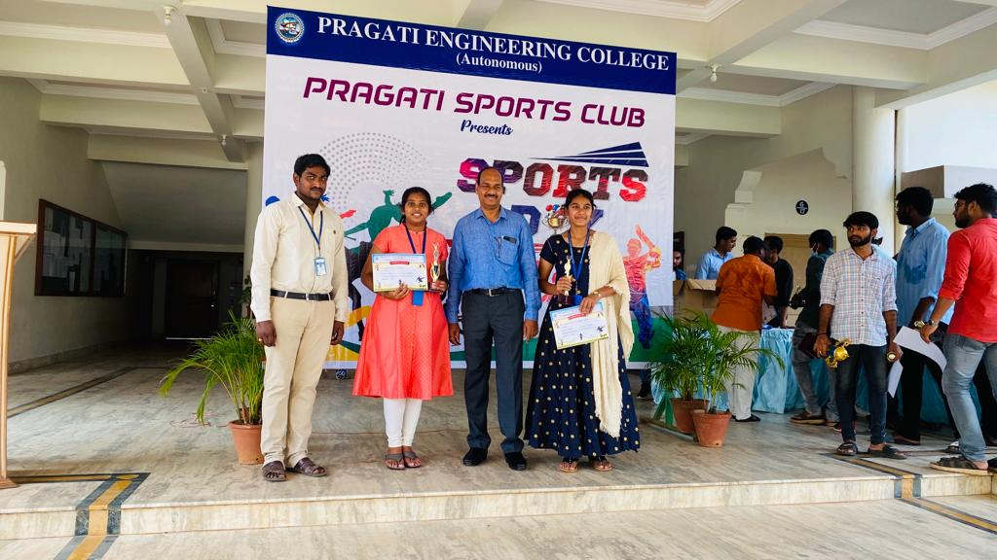
Sports day celebrations
1. volleyball winners
18A31A0284 | Dara Omkar
18A31A0218 | A U Swaroop
18A31A0281 | Akana Satish
18A31A0253 | Y Surya Dheeraj
18A31A0223 | Ch Vara Prasad
18A31A0245 | P S Venkata Ganesh
2. tennicoit winners
1. J.Divya
2. N.Ananthalakshmi

Editorial BOARD committeE:
Staff Students:
- Mrs.K.Sandhyarani,Assistant professor - Incharge HOD-EEE
S. Gowtham (III EEE-248)
D.S.N.L Priyanka (III EEE-204)

- Ms. S. Varalakshmi, Assistant Professor

