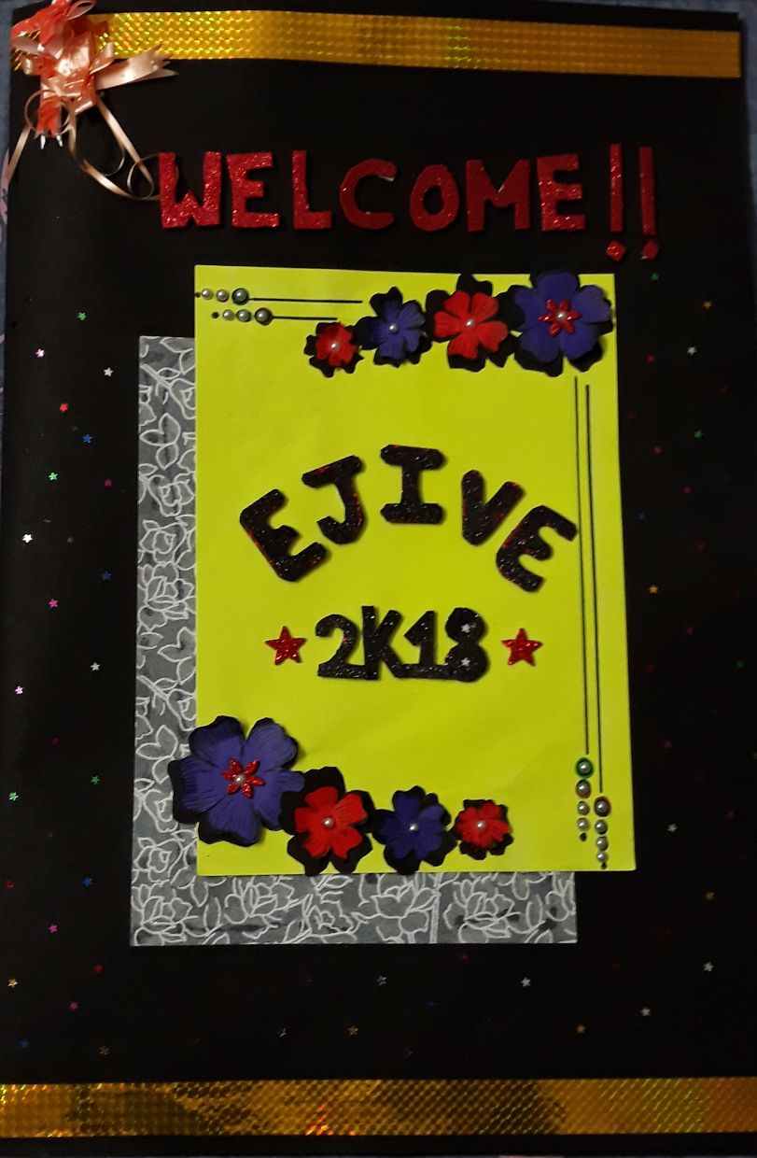
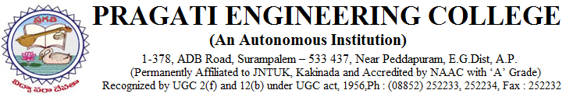
DEPARTMENT OF ELECTRONICS AND COMMUNICATION ENGINEERING

Date : 06-03-2018
Event : Inauguration of ejive 2k18
Agenda
09 : 30AM : Welcome Gathering
- : 35AM : Inviting Guests on to the dais
- Dr. K. Siva Kumara Swamy, HOD ECE
- Ch. Vasantha Lakshmi, Assoc. Prof, Mech Dept(Strides college Coordinator)
- Dr. S. Sambhu Prasad, Principal
- Dr. P. Krishnarao ,Chairman
- Dr .K.Padma Raju, Prof at JNTUK, Member of APPSC
09 : 40AM : Prayer song by Tushara, Jhanavi
09 : 45AM : lightening the lamp by chief guest
09 : 50AM : Welcome Note by Kalyani, Kowsalya
09 : 55AM : Addressing by HOD-ECE
10 : 00AM : Speech by Ch. Vasantha Lakshmi
10 : 05AM : Speech by Principal
10: 10AM : Speech by Chairman
10: 15AM : Introduction about Chief Guest
10: 20AM : Addressing by Chief Guest
10: 30AM : Souvenir Release
10: 35AM : Memento Presentation to Chief Guest by Chairman, Principal, Raghuram
Sir
10: 40AM : Vote of Thanks

DEPARTMENT OF ELECTRONICS AND COMMUNICATION ENGINEERING
VALEDICTORY FUNCTION:

Date : 05-03-2018
Event : ejive 2k18 (Valedictory Function)
Agenda
03: 30PM : Welcome Note
03: 35PM : Inviting Dignitaries on to the dais
- Dr.K.Sivakumar Swamy, HOD ECE dept
- Dr. V. Sailaja, Professor, ECE dept
03: 40PM : Closing remarks by judges
03: 45PM : Feedback from students
03: 50PM : Prize Distribution
- Projects
- Paper Presentation
- Poster Presentation
- Quiz
- Contraption
- Logo Design
04: 00PM : Memento Presentation to the judges
04: 05PM : Vote of Thanks

PRAGATI ENGINEERING COLLEGE
(Autonomous)
Suprampalem.
ELECRONICS AND COMMUNICATION DEPARTMENT
Association.
REPORT ON”EJIVE-2K18” UNDER STRIDES
A NATIONAL LEVEL TECHNICAL SYMPOSIUM.

A Eleventh National Level Technical Symposium “STRIDES – E-JIVE 2K18” was inaugurated by the Department of Electronics and Communication Engineering on 05-03-2018 at PRAGATI ENGINEERING COLLEGE.

The programme was inaugurated by the Chief guest K.Padma Raju . Dr. K. Padma Raju lighted the inaugural jyothi and also spoke a few words on the occasion. Madam Vasantha Lakshmi covener of STRIDES2K18 MECH gave a warm welcome to the chief guest Dr. K. Padma Raju , Dr. P.Krishna Rao, Chairman of Pragati Engineering College, Principle , Vice President , Directors, Head of The Department, Staff , Participants and students to grace the inauguration. As a part of first day of Strides 2k18 Activities, EJIVE2K18 was organized by the Department of Electronic and Communication Engineering.

Dr. P Krishna Rao, Chairman of the college in inaugural note expressed his happiness that college is progressing in modeling the students as Industrialists beside academics. Dr. K. Padma Raju, Chief guest , in his message conveyed that exposure to technical symposium will refine the ideas for innovative thinking and innovation in engineering.
Dr. S Sambhu Prasad, Principle of the College Marked that national Symposium is a platform to exhibit inmate skills for “MAKE IN INDIA” and extend his wishes for making event successful.

Dr. G Raghuram, Director Academics started Technical Symposium is to bring awareness in the emerging trends in Electronics and Communization streams.
Conveners of EJIVE2K18, Smt Prassana Kumari and Sunitha Asst Professors in ECE Played a pivotal role in organizing the programme.

They informed that about 400 students attented from various colleges out of which 359 entries were registered for events like paper presentation, poster presentation, project presentation and technical quiz, various spot events were conducted as part of strides.

New events such as Logo designing , Contraptions and communication expo were also introduced to bring out the talents of the students. Each and everyone executed and brought their inner talents to the brim.
The non technical events also contain more than ten spot events and online events like INSTAJIVE AND MANIQUINE which were conducted. There was also a special event called the Treasure hunt and Evolution(Electronics and Communication Expo) under the part of strides.

The strides has become the best platform and good opportunity to excel their knowledge.

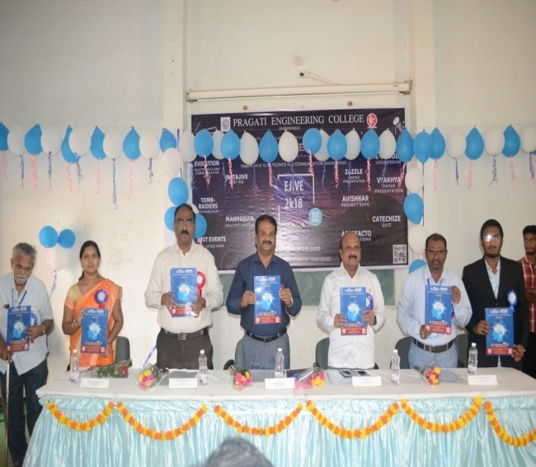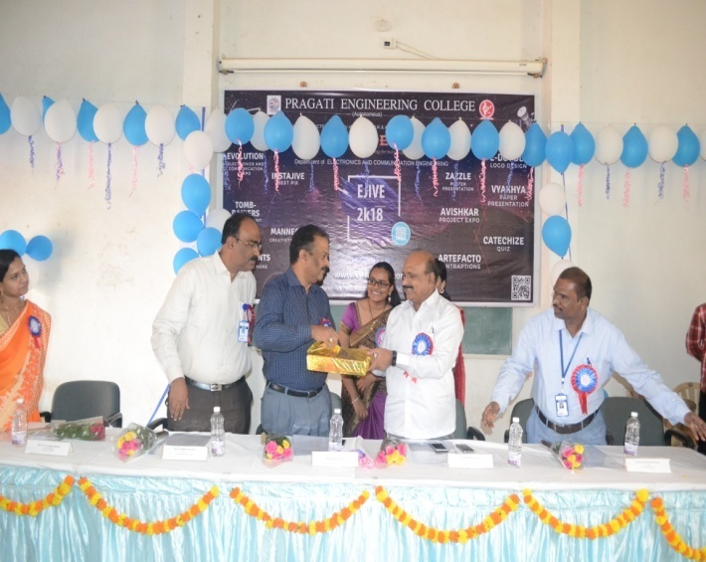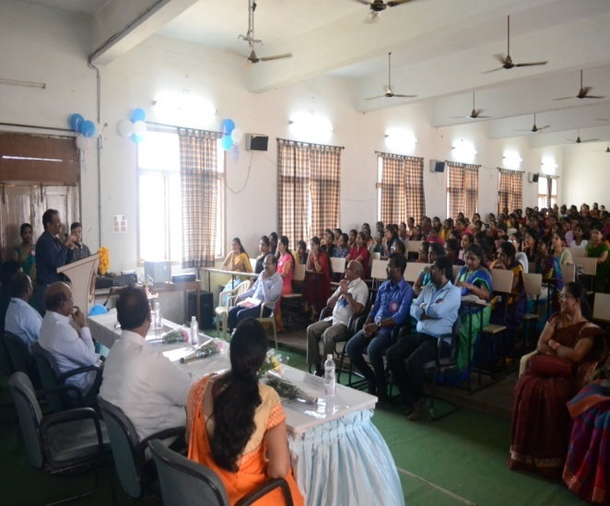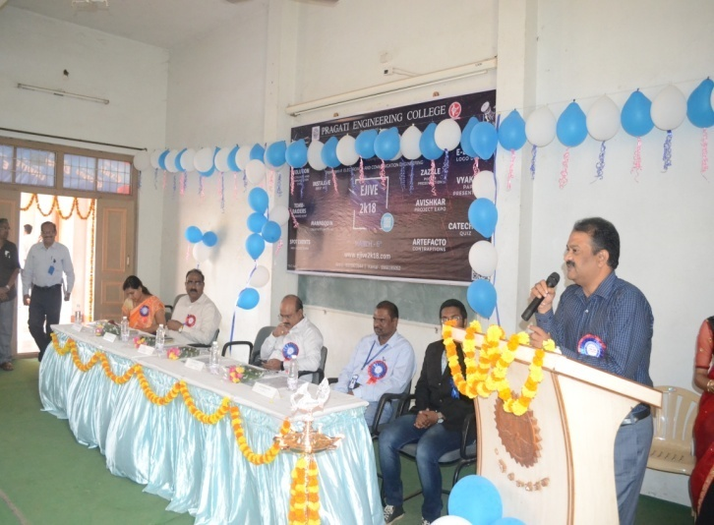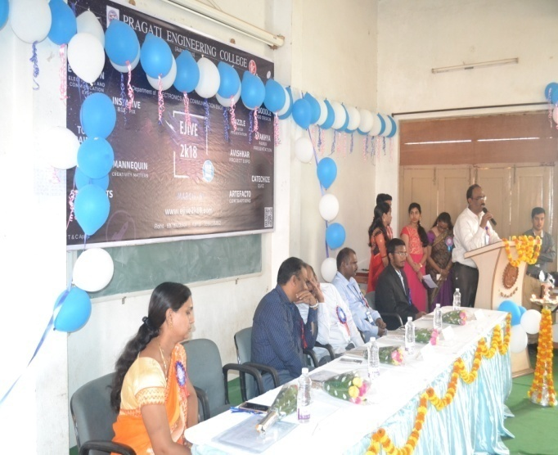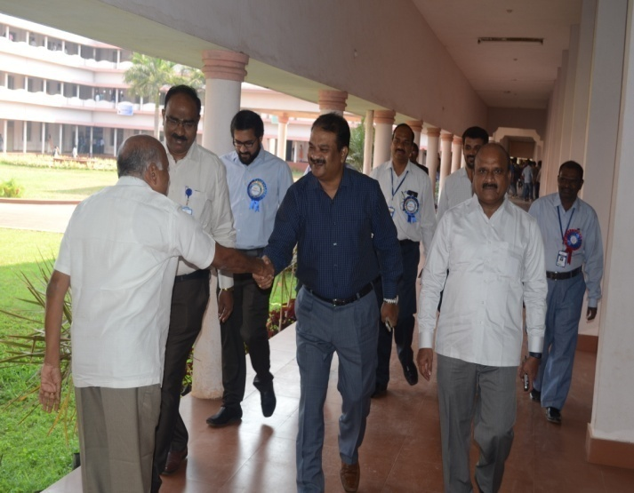

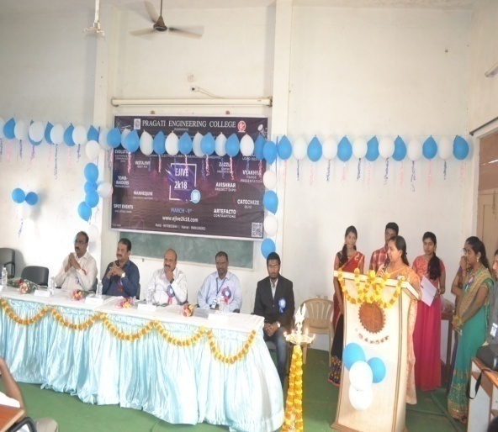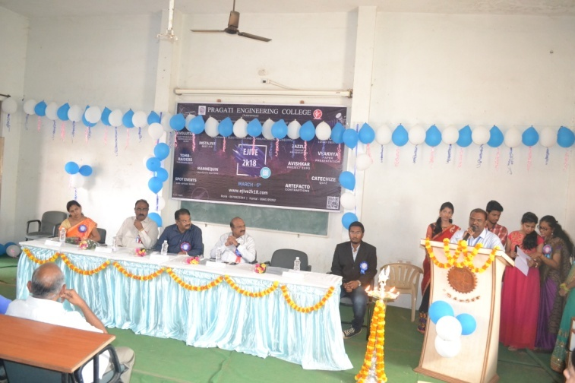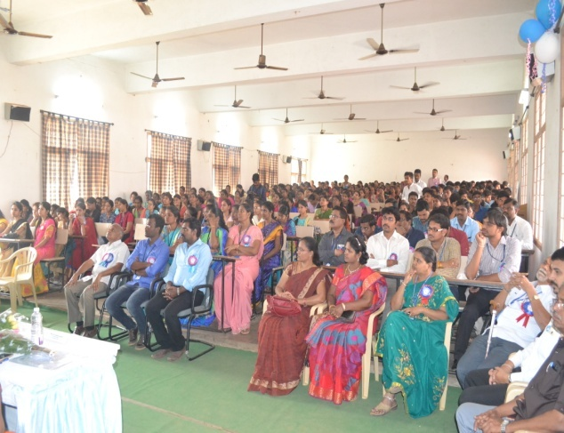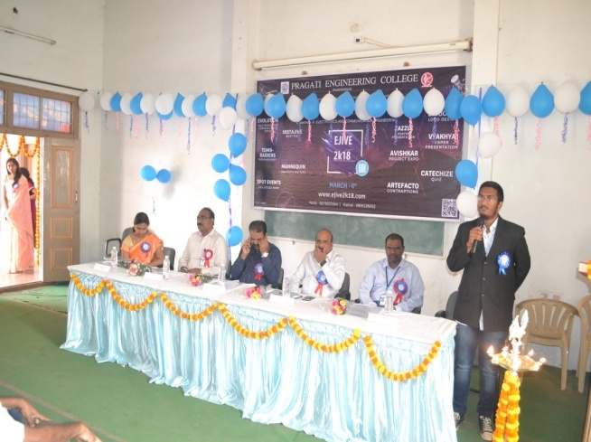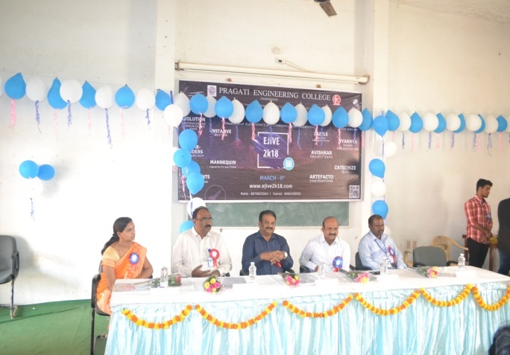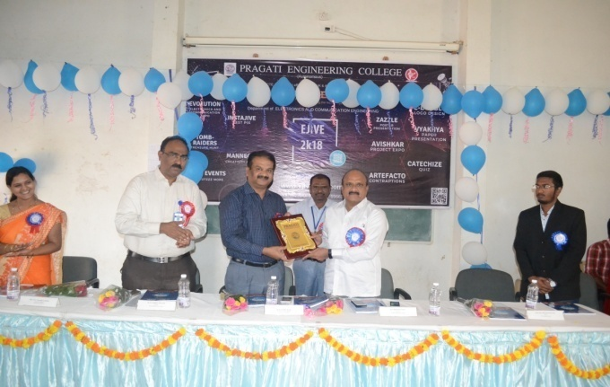

FACULTY COORDINATORS:
- K. SURYA KUMARI asst.prof
- P.SUNITHA asst.prof
- P.PRASANNA KUMARI asst.prof
STUDENT COORDINATORS:
- G.SAHITHI (E)
- T.EESHA SRI (D)
- CH.ROHIT (C)
- D.VIHAR (E)
- A. SAI KAMAL (E)
- NARAYANA (A)
- K.KOWSALYA (E)
- P.PADMAKALA (A)
- K.BHASKAR (B)
10.SUSHMA (A)

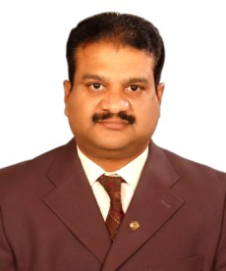
Curriculum Vitae of Dr. K. PADMA RAJU (Born: 27th August, 1967)
Professor, Electronics and Communication Engg. Department
Director, Industry Institute Interaction Placements & Training
Jawaharlal Nehru Technological University Kakinada
KAKINADA - 533 003, INDIA
e-mail: padmaraju_k@yahoo.com Mobile: 0091 96185 22555

1. Qualifications
- B.Tech in Electronics and Communication Engg., Bapatla Engineering College, Nagarjuna University, 1989 – First Class.
- M.Tech in Electronic Instrumentation, Regional Engineering College, Warangal, 1992 – First Class.
- Ph.D in Slot Array Antennas, Andhra University, 2005.
- Post Doctoral Fellowship at Hoseo University, South Korea, 2007
2. Professional Experience
- Worked as DSP Engineer during May 1992 – October 1992 in Signion Systems Pvt.) Ltd., Hyderabad.
- Assistant Professor/Lecturer, JNTUCE Kakinada, October 1992 – October 2002.
- Associate Professor (CAS) JNTUCE Kakinada, October 2002 – 01 August 2006.
- Professor, JNTUCE Anantapur, 02 August 2006 – 20 January 2009.
- Visiting Professor, Hoseo University, South Korea, April 2006 – March 2007.
- Professor, UCE, JNTU Kakinada, Kakinada, 21 January 2009 – till date.
3. Administrative Experience
- Officer-in-charge of Examinations in the Nodal Center, JNTU College of Engineering, Kakinada for 2 ½ Years.
- Officer-in-charge of Hostels JNTU College of Engineering, Kakinada during 1999 – 2001.
- Deputy Warden for various Hostels JNTU College of Engineering, Kakinada for over 6 years.
- Director, Industry Institute Interaction Placements & Training, JNTU Kakinada, 31 January 2009 – 26 April, 2012
- Chief, University Employment Information & Guidance Bureau, JNTU Kakinada, 23 November 2010 – till date
- Principal, University College of Engineering (Autonomous), JNTUK, from April 26, 2012 – till date
4. Research Experience
- Awarded Ph.D.s- 01 No
- Submitted Ph.D.s- 01 No
- Presently guiding 12 research scholars.
- M.Tech Theses guided: 55 Nos. and M.Tech Theses evaluated: 45 Nos.
- Ph. D. thesis evaluated: 03 Nos.
- Post Doctoral Fellowship at Hoseo University, South Korea, 2007.
- Research Professor at Hoseo Unversity, South Korea, 2006-2007.
5. Research Publications
- Research Publications:
  - International Journal - 31 No.(Journal of Korea Electromagnetic Engg. Society)
  - National Journals - 04 Nos. (IETE & SEMCE Research Journals)
  - International Conferences - 30 Nos.
  - National Conference/workshops - 30 (15+15) Nos.

6. Membership in Professional Bodies
- Fellow Institute of Engineers, Fellow IETE, Member SEMCE(I) and MISTE,MIEEE.
7. Awards
- State Best Teacher Award 2014, awarded by the State Government.
- Awarded “Best Teacher Award” in Electronics and Communication Engineering Department based on student evaluation for the year 2004.
- Awarded “Best Teacher Award” in Electronics and Communication Engineering Department based on student evaluation for the year 2012

BUDGET.
INCOME:
NO OF STUDENTS PAID : 847
AMOUNT FOR STRIDES : 300/-
TOTAL AMOUNT RECEIVED: 2,54,100/-
AMOUNT DEPOSITED TO COLLEGE: 2,02,200/-

REGISTRATION AMOUNT GENERATED:
PPT : 15,2000/-
POSTER PRESENTATION : 6,800/-
PROJECTS EXPO : 13.800/-
CONTRAPTIONS: 3000/-
LOGO DESIGN: 2,800/-
TECHNICAL QUIZ: 4,800/-

EXPENDITURE:
DECORATIOIN :11,000/-
SAVOUNIER BOOKS: 6,400/-
NOTEPADS: 6,600/-
FOLDERS & PENS: 10,200/-
CERTIFICATES AND BADGES : 12,120/-
COMMUNICATION EXPO: 2,468/-

PRIZE MONEY:
PPT:
1ST = 3000/-
2ND = 2000/-
POSTER PRESENTATION
1ST = 3000/-
2ND = 2000/-
PROJECTS EXPO:
1ST = 5000/-
2ND = 3000/-
3RD = 2000/-
CONTRAPTIONS:
1ST = 3000/-
2ND = 2000/-
LOGO DESING:
1ST = 1200/-
2ND = 800/-
TECHNICAL QUIZ:
1ST – 2000/-
2ND = 1000/-
INSTAJIVE: 1000/-
MANNEQUIN:
1ST = 1500/-
2ND = 1,200/-
FOOD: 1,15,000

DEPARTMENT OF ELECTRONICS AND COMMUNICATION ENGINEERING
S.NO | EVENT NAME | FACULTY COORDINATOR
1 | Poster | P. Krishna Chaitanya
 |  | T. Vishnu murthy
2 | Powerpoint Presentation | P. Vijay Gopal
 |  | G. Srilakshmi
3 | Project | P. Sunitha
 |  | A.S.Amruthavarshini
4 | Quiz | Rubhiya Tasneem,  M.DhanaLakshmi
5 | Contraption | Ch. Lakshmi Narayana  B. Sudheer
6 | ECE EXHIBITION | M.Srinivas
 |  | P.Ramya Krishna
 |  | K.Surya Kumari
7 | Food | P.Sitaram
 |  | G.S. Siva Kumar
8 | Decoration | K. Deepthi
9 | Help Desk | K.Sowjanya
10 | Invitation | U.S. Alekhya
 |  | Y. Ananthasatya
11 | Discipline | Ch. Venkateswarlu
 |  | D.Nataraj
 |  | K. Raghu ram
12 | Transportation | T. Vishnu Murthy
13 | Hospitality | T. ManiKumar
14 | Money Coordinatoor | M.ravikumar
15 | Spot Event 1  (Mind boggling) | G. Durgaprasad
16 | Spot Event 2  (Step in the Tech Fortune) | k.p.rao
17 | Spot Event 3  (Tech Pic-O-mania) | K.Ajay Kiriti
18 | Spot Event 4  (Separation anxiety) | K. Chaitanya sri
19 | Spot Event 5  (Bread board kings) | K.V.R.Vara prasad
20 | Poster Design | P.prasanna kumari
21 | Certificates | B.Prakruthi  M. Priyanka

22 | Logo design | D.V.V Lakshmi  P. Prasanna Kumari

S.NO | EVENT NAME | STUDENT COORDINATOR | FACULTY COORDINATOR
1 | PPT  (Power point presentation) | A.Sneha Alekhya[a]  K.Sai Ram[b]  Javad Rouhollah[d]  G.Kalyani[d]  M.Saranya[c]  B.Harika[e]  Hema sri[e]  Sasikanth[a]  Y.Mounika[b]  T.Geetha Lakshmi[d]  N.Pravallika[c] | P. Vijay Gopal  (8121722452)  G. Sri Lakshmi  (95154213641)
2 | POSTER | S.T.Nikhil[a]  Y.Srilekha[b]  P.Viraja[c]  B.Divya[d]  M.Sudheer[a]  M.prabhuteja[b]  M.Akhil KUMAR Reddy[c]  Ch.Lalitha[d]  M.R.N.Nikhil[c]  M.Varalakshmi[e]  P.Vineesha[e] | P. Krishna Chaitanya  (9515268475)  T. Vishnu Murthy  (7075072633)
3 | PROJECT | P.Alekhya[a]  P.Sandeep Reddy[b]  P.Sai kumar[c]  K.Raja[d]  B.Vamsi[e]  M.lalitha[e]  ABSRK.Manikanta[a]  M.Surya Sai[b]  P.Jhanavi[c]  K.Chandana[d] | P. Sunitha  (7660971116)  A.S. Amrutha Varshini  (9603119889)
4 | QUIZ | Rishitha Reddy[a]  P.Keerthy[a]  Y.D.Rohith[a]  P.Satya Supriya[a]  P.Samhitha[a]  T.Atchiveni[b]  M.Maneesha[b]  S.Malleshwari[b]  M.Aruna[b]  K.V.Kalyan[d]  V.Sri Ram[d]  G.Sowmya sree[e]  A.Anantha[e]  K.Aparanjith[c] | RubiaTasneem  (9618266245)  M. Dhana Lakshmi  (9642536109)
5 | CONTRAPTION | Shaik Simran[a]  M.vignesh[b]  K.Priyanka[c]  R.Sravya[d]  K.Deva[e]  G.Nandini[e]  P.Neerja[a]  T.Tejashwar[b]  M.Gowtham[c]  M.Azizunnisa[d]  M.Bindu[a] | Ch. LakshmiNarayana  (8523045062)  B. Sudheer  (9505486426)
6 | LOGO DESIGNING | A.Bhuchakra Kumar[a]  G.Vijaya Lakshmi[b]  L.Ruchita[c]  K.Y.Krishna Priya[d]  G.Sahithi[e]  B.Kavya[a]  V.Sowjanya[a]  K.Vishwesh[b]  T.Manjusha[c]  I.Lavanya[d]  Nishan Jain[e] | D.V.V. Lakshmi  (9492141122)  P. Prasanna Kumari  (9493172980)
S.NO | EVENT NAME | STUDENT COORDINATOR | FACULTY COORDINATOR
7 | FOOD | T.M.Lalitha[a]  Prabhavati[a]  M.Vamsi[a]  Rama Rao[a]  Sameer[a]  Vamsi[b]  Bhanu kiranmai[b]  Sandeep vanga[b]  Venkateshwari[b]  Chandrakanth[b]  Santhiswaroop[b]  D.lalitha[b]  Roshini[d]  E.lalitha[d]  G.Tanusri[d]  M.Jemima[d]  Danesh Murthy[d]  Rishi Bayisetty[d]  P.Manoj[d]  A.Vineela[c]  D.Likitha[c]  Anitha[c]  N.Divya[c]  Pranayani[c]  Muthu[c]  Venky[e]  Sidhu[e]  Hari Shankar[e]  Eswar[e] | P. Sitaram  (8099977789)  G. S. Siva Kumar  (9949811979)
8 | DECORATION | P.Sravani[a]  S.Uma[a]  P.Indu[a]  P.Pavani[a]  T.Maniharika[b]  P.Harshini[b]  Surekha[d]  Karuna[d]  j.bhavana[e]  P.Hema sri[e]  V.Ramya[e]  P.Sowmya[c]  V.Maheshwari[c]  Varun[c]  G.Niharika[c]  G.Sudha[c]  G.Akhil[c]  C.Shankar[c]  Sravanthi[c] | K. Deepthi  (9492953416)
9 | HELP DESK | Surendra[a]  D.Mounica[a]  M.Dileep[c]  Satish[c]  G.lavanya[a]  P.Mohanamsi[b]  K.Mounica[b]  S.Anusha[d]  K.Jyothi[d]  B.Sri Harika[e]  Hema sri[e] | K. Sowjanya  (9550290768)
10 | INVITATION | K.Ramya[a]  B.Ashiritha[a]  Y.Dhatri[a]  V.Sravani[a]  B.Manohar[a]  Ch.Bharadwaja[a]  P.Nirupama[a]  Kanksha[a]  Hema[e] | U.S. Alekhya  (7288888026)  Y. AnanthaSatya  (9542723280)
S.NO | EVENT NAME | STUDENT COORDINATOR | FACULTY COORDINATOR
11 | DISCIPLINE | Akhilesh[b]  Vijay Kumar[b]  Ravi teja[d]  Prasanna kumar[d]  Harish[d]  Venky[e]  Siddhu[e]  Venkat[e]  Hari Shankar[e]  G.Venkata Krishna[c]  Ch.Mahesh[c]  P.Durga Prasad[c]  Poorna Sai Teja[a] | Ch. Venkteswarlu  (9391384324)  D. Natraj  (9494362444)  K. Raghuram  (9676743338)
12 | TRANSPORTATION | Naryana reddy[b]  Rabbani[d]  M.Umesh[c]  K.V.Durga Prasad[e]  R.SriRam[c] | T.Vishnu Murthy  (7075072633)
13 | HOSPITALITY | M.Meghana[b]  A.Anusaandhya[b]  B.Suchitra[b]  K.Hema Mounika[d]  Ashwini[d]  Hema[e]  P.Vyshnavi[c]  K.Karuna[c] | T. Mani Kumar  (9398848173)
14 | MONEY COORDINATOOR | D.Vihar | M. Ravi Kumar  (9030533306)
S.NO | EVENT NAME | STUDENT COORDINATOR | FACULTY COORDINATOR
15 | SPOT EVENT 1 | Deepthi Ahuja[a]  Manoj[a]  Y.Madhurya[b]  V.Sahithi[b]  Anjali[c]  D.Sivani[d]  Sai ram teja[e]  Ganga vikas[e]  Balaram(d)  Maheswari(c) | G. Durga prasad  (9912433972)
16 | SPOT EVENT 2 | T.Madhuri[a]  Gowri[a]  p.sowmya[b]  alekhya(c)  Ch. Haritha(b)  A.charitha[e]  k. sai babu(c)  Babilal[c]  Pavan[d]  Ranjith[d]  v.L bhavya(b) | K.P. Rao  (9494985984)
17 | SPOT EVENT 3 | M.Reena Sri[a]  N.Shruti[a]  M.Ravi[c]  i.Vinay[c]  s. srujan(c)  ch.Venky(c)  Ch.Jahnavi[d]  y.Rasagna[e]  P. Akhil[e] | K. Ajay Kiriti  (9441315344)
18 | SPOT EVENT 4 | R.K.Chaitanya[a]  T.N.L.Lalitha[a]  Nikitha[b]  S.Bharathi[e]  M. vara Lakshmi[e]  P.Vineesha[e]  K.Sravani[b]  E.Mrudula[b] | K. Chaitanya Sri  (7382041063)
19 | SPOT EVENT 5 | V.Saketh[a]  P.Ravi Teja[a]  K.Satya Lakshmi[d]  G. sravani(d)  B.anantha[e]  g.sowmya sree[e]  sidhu[e]  venkat[e]  hari Shankar(e)  Manikanta[c]  Y.teja sree(e) | K.V.R. VaraPrasad  (9182625033)
20 | POSTER/BANNER DESIGN | Dasari Chaitanya[b]  Sandeep[E]  Mvs kiran[b] | P. Prasanna Kumari  (9493172980)
21 | CERTIFICATES | M.Sravanthi[c]  ashraf(b)  vivek(b)  T.Sushmitha[c]  M.Sravya[c]  G.Smitha[d]  A.B.S.Sri Ram[d]  Vijaya Gopal[a]  B.Ramya[a]  S.Uma[a]  D.vihar[e] | B. Prakruthi  (9704717250)  M. Priyanka  (7036600898)

POWER POINT PRESENTAT ION (PPT).
VYAKHYA
On the event of EJIVE held on 6th march 2018 the third year students organized an named POSTER PRESENTATION. The event revealed the inner talents and the presentations skils of all those who took part in it.

FACULTY COORDINATORS:
1). P.VIJAY GOPAL asst.proof
2). G.SRI LAKSHMI asst.prof
STUDENT COORDINATORS:
1). A.SNEHA ALEKHYA (A)
2). K.SAIRAM (B)
3). G.KALYANI (D)
4). N.PRAVALLIKA (C)
5). T.GEETHA LAKSHMI (D)
6). JAVAD ROUHOLLAH (D)
JUDGES:
1) DR. K.RAMA DEVI, assoc .prof JNTUK.
2). DR. K.RAJAMANI, asst. prof JNTUK.
INFO:
Total no of abstracts recevid: 100
No of abstracts selected: 76
No of abstracts from other colleges: 27
No of abstracts from our college: 49
Maximum no of participants per team: 2
Registrationa amount: 200/-
Total Amount: 15,200/-
Venue : ECE block
Colleges attended: BVC, VISHNU, ADITYA, ANITS, KIET (W), MVCR,IDEAL, VSM.
Presentations are evaluated on the following criteria:
Neat presentation, advanced innovation, speaking and comunication skills.
Total marks: 50
FINALISTS | PARTICIPANTS |  | COLLEGE | PRIZE MONEY
1ST PRIZE |  | Room1:  K.SIVA SANKAR  Room2:  K.SATWICK RAM  D.SRINIVAS | MVGR  PEC | 1500/-  1500/-
2ND PRIZE |  | Room1:  K.NAVEENA  M.MOUNICA  Room2:  V.RAJESH NAIDU  MD.AFSRUDDIN | PEC  ANITS | 1000/-  1000/-

PRATICIPANTS LIST :l
COLLEGE PEC:
S.NO | NAME | TOPIC | COLLEGE
1 | A.Aishwarya | Drones | PEC
2 | K.GEETHIKA | SMART POWER GENERATION FROM WASTE | PEC
 | P.KEERTHI | HEAT BY THERMOELECTRIC GENERATOR
3 | CH.MADHU SREE | BIO BATTERY | PEC
 | B.AKHILA
4 | K.KALYANI | HAPTIC TECHNOLOGY | PEC
 | V.ANUSHA
5 | P.JYOTSNA DEEPIKA | LI-FI | PEC
 | V.V. SIREESHA PAVANI
6 | K.SAI GANESH | VIRTUAL,MERGED, AUGMENTED REALITY | PEC
7 | Y.HARIKA | WIRELESS CHARGING OF MOBILE PHONES | PEC
 | V.JYOTHI | USING MICROWAVES
8 | S.PRASANNA | NIGHT VISION TECHNOLOGY | PEC
 | CH.KEERTHI
9 | K.GEETHA NAVEENA | AUTOMATIC ENGINE LOCKING SYSTEM THROUGH | PEC
 | K.LAKSHMI MOUNIKA | ALCOHOL DETECTON
10 | R.V.S.SWAROOPA | BLUE BRAIN TECHNOLOGY | PEC
 | R.JYOSTHNA
11 | M.ROHITHA | PAPER BATTERY | PEC
 | K.BHAVANA
12 | K.AJAY | STEGNOGRAPHY | PEC
 | A.DHANA SEKHAR
13 | P.LIKITHA | PILL CAMERA | PEC
 | V.LAKSHMI NANDINI
14 | Ch.Manikanta | 5g technology | PEC
15 | V.ANUSHA | SMART ANTENNAS IN MOBILE | PEC
 | M.SATYA SWETHA | COMMUNICATION
16 | S.KRISHNA MANOJ | SIXTH SENSE TECHNOLOGY | PEC
 | CH.SAI SUBASH
17 | J.SHIVA KISHORE REDDY | EYE GAZE COMMUNICATION | PEC
 | A.P.S.KRISHNA
18 | K.BAVESH | ACCIDENT DETECTION SYSTEM | PEC
 | D.SATYA | (USING MOBILES)
19 | CH.GEETHA SRI | NANO TECHNOLOGY USING WIRELESS | PEC
 | V.SAI SREE | DEVICES
20 | P.JANAKI RAMYA | ADVANCES IN MOBILE TECHNOLOGY | PEC
 | P.SAI CHAKRA VIDHYA MOUNIKA
21 | N.BHUVANA SREE | BLUE EYES TECHNOLOGY | PEC
 | Y.SRI SATYA
22 | A.ARAVIND | TOUCH LESS SCREEN USER INTERFACE | PEC
 | K.ARUNA KUMAR
23 | P.V.M.G.Bhavani | SNIFFER FOR MOBILE PHONES | PEC
 | P.Vennala
24 | K.PRAVALLIKA | TONGUE MOTION CONTROLLED WHEEL | PEC
 | K.DURGA TEJASWINI | CHAIR
25 | V.SUVARNA JYOTHI | ARTIFICIAL VISION TECHNOLOGY | PEC
 | P.MEGHANA MAHESWARI
26 | Akanksha Mishra | Rescue Operations at Sea | PEC
 | Amritha Chandra Shekar
27 | P.ANJANI RATNA | ULTRA WIDEBAND TECHNOLOGY | PEC
 | I.MOUNIKA
28 | S.GANGA BHAVANI | UNDERWATER WIRELESS COMMUNICATION | PEC
 | S.MALLESWARI
29 | Y.RASAGNA | AUTOMATIC HEADLIGHT DIMMER | PEC
 | A.JAGAN MOHAN SAI ANVESH
30 | Srujuna | Solar Plant | PEC
 | Pravallika
31 | T.S.S.TEJASWINI | QUANTUM COMMUNICATION | PEC
 | CH.NIRCHITHA
32 | P.Anjaneya Varma | Advanced Wireless Communications | PEC
 | N.Vivek kumar
33 | K.SAI CHANDRA HAS | TRANSPARENT ELECTRONICS | PEC
 | J.SIVA TEJA
34 | Y.YOGITHA CHOWDARY | SKINPUT TECHNOLOGY | PEC
 | P.CHANDRIKA
35 | D.S.RAVI TEJA | ELECTRONIC SKIN | PEC
 | K.SATHWIK RAM
36 | V.Sandeep | Ardino Technology | PEC
 | A.Viswesh
37 | K.A.S.SMounika | Artificial Intelligence in robotics | PEC
 | S.K Basheeramma
38 | K.SWATHI SAMEERA | HOLOGRAPHIC DATA STRUCTURES | PEC
 | K.L.PAVANI
39 | M.Manikanta | Neural Networks | PEC
 | Supriya
40 | K.Sai siva prabhu teja | Digital image processing | PEC
 | M.Surya Sai
41 | R.K.CHAITANYA | MICROSOFT HOLOLENS-FUTURE IN PRESENT | PEC
 | DEEPTHI AHUJA
42 | S.VIVEK | TOUCH SCREEN TECHNOLOGY | PEC
 | M.AKHIL KUMAR
43 | G.Akhil |  | PEC
 | N.Divya
44 | K.H.H.GANESH SAI SINGH | NUCLEAR BATTERIES | PEC
 | R.SRI SAI ANUSHA
45 | S.N.Anusha | Applications of digital image processing | PEC
 | G.Vijaya Lakshmi
46 | R.S.KIRAN PRAMODA | MILITARY RADAR | PEC
 | MD.MOBEEN RUKSANA
47 | T.SAI MADHURI | TRANSLATOR-A COMMUNICATION INTERFACE | PEC
 | M.REENA SREE
48 | K.V.S Narayana reddy | Coupling al with human mind | PEC
 | M.T.M.Vignesh
49 | Ch.Samyuktha | Spintronics | PEC
 | K.Syamala

OTHER COLLEGES LIST :
Sl.no | Name | Topic | College
1 | Rachana | Network Traffic Management | Aditya
2 | Pavan | Plasmonics | BVC(odalarevu)
3 | N.Deepthi | Smart Irrigation Using IOT | BVC(RJY)
 | V.Sruthi
4 | V.L.C.Sai Srujuna | Nuclear Power | Aditya
 | B.Sharmila Devu
5 | J.Swathi | Roll Top Laptop | BVC
 | K.Suvarna Rekha
6 | V.Jagadeeshwari | Cryptography | Vishnu
 | P.Swathi
7 | B.Sri Ajay | Smart Antenna System | Aditya
 | P.M.V.P.Sai ram
8 | J.Surya Teja | Artificial Passanger | Vishnu
 | S.Pravallika
9 | K.Venusri | Inter Vechile Communication | VSM
 | K.Akhila
10 | D.V.N.S.K.Sindhu | Ultrasonic Blind Walking Stick | BVC
 | P.Bhuvaneshwari
11 | P.Chandralekha | Eye Detective Wheel Chair | BVC
 | V.L.V.Chandrakala
12 | K.Shiva Shankar | Finger Print Recognition | MVGR
13 | D.Durga Bhavani | Light Emitting Polymers | BVC
 | B.Uma Maheshwari
14 | M.Sandhya Rani | Automatic Analysis Boxes in | Aditya
 | T.U.N.S L .Vyshnavi | Aeroplanes and Automobiles
15 | K.Niranjan Sai | Enzyme Activity for Cancer Cure | GMRIT
16 | P.Govinda Raju | Flexible OLED's | Aditya
17 | K.Deepika | Blue Brain | Vishnu
 | N.Tejaswi Ramani
18 | S.B.Naga Alekhya | Nano Electonics Devices in | Aditya
 | S.Madhav | Solar Panels
19 | S.Swetha | Eye gaze Communication | Vishnu
 | U.Chandini
20 | U.Venkata sai lakshmi | Changes of Data and Machine | Aditya
 | O.Keerthi | Using Solar System
21 | M.Vikash | Air touch and it's applications | ANITS
 | P.Harsha Aditya
22 | Ch.Bharadwaj | Nano Technology | Ideal
 | P.Deelip
23 | Md.Afsaruddin | Face Detection using image | ANITS
 | U.Rajesh Naidu | Processing
24 | K.Sravani | VLSI and Nano technology | Aditya
 | K.Anusha
25 | S.Devi sumalatha | Womens safety using IOT Kiet womens
26 | K.Devi | Global system Mobile | Kiet Womens
 |  | Communication
27 | G.Sandhya Rani | E-Textiles | Vishnu
 | D.evanjilin
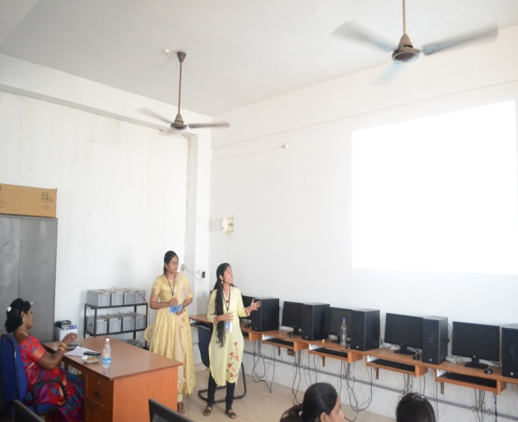
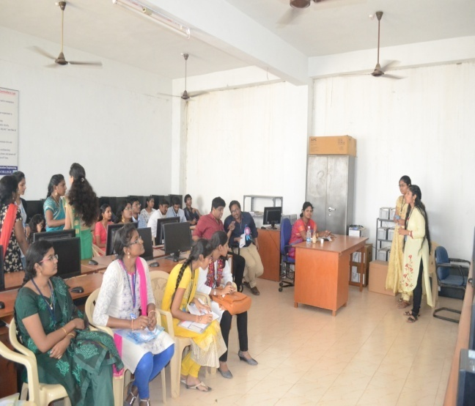
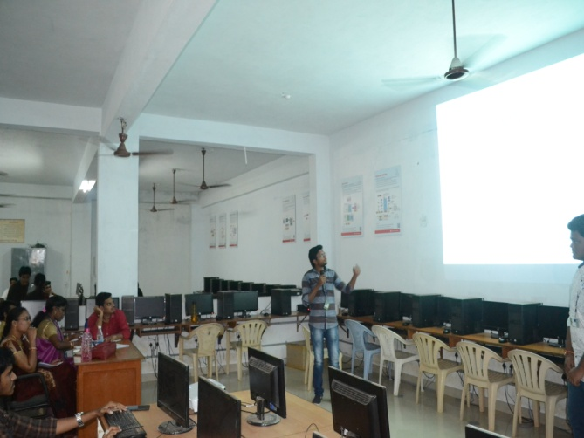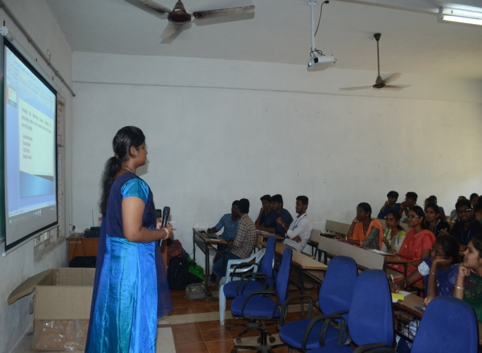
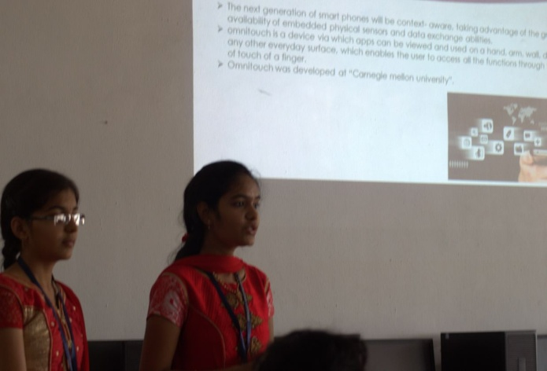
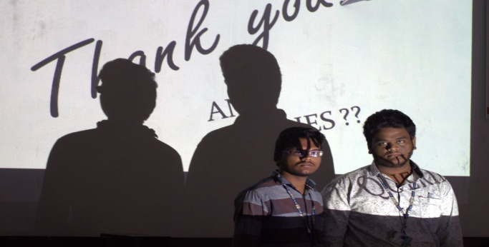
PROJECTS EXPO
AVISHKAR
On the event of EJIVE held on 6th march 2018 the third year students organized an named PROJECTS PRESENTATION. The event revealed the inner talents and the presentations skils of all those who took part in it.
FACULTY COORDINATORS:
1. P.SINITHA asst.prof
2. A.S.AMRUTHA VARSHINI asst.prof
STUDENT COORDINATORS:
1). P.ALEKHYA (A)
2). P. SANDEEP REDDY (B)
3). K.RAJA (D)
4). M.LIKITHA (E)
5). M.SURYA SAI (B)
6). K. CHANADANA (D)
JUDGES:
1). V. PRASHANTHA asst.prof
2). DR. G. RAGHURAM prof
INFO:
Total no of abstracts recevid: 60
No of abstracts selected: 46
No of abstracts from other colleges: 12
No of abstracts from our college: 34
Maximum no of participants per team: 4
Registration amount: 300
Total Amount: 13,800
Venue : ECE block
Colleges attended: BVC, ADITYA, VISHNU, SASI, ANITS
Presentations are evaluated on the following criteria:
Neat presentation, advanced innovation, speaking skills and best output.\
Total marks: 50
FINALISTS | PARTICIPANTS | COLLEGE | PRIZE MONEY
1st prize | 1.T.Durga ram Prasad  2.V.V.V.D.satyanarayana  3.T.Vishnumurthy  4.U.Rajendra | Aditya | 5000/-
2nd prize | 1.M.Vikash  2.R.Harsha Aditya  3.M.Saibabu  4.N.Sandeep | Anits | 3000/-
3rd prize | K.Nookaraju  2.k.sai sandeep  3.P.Surya  4.V.Naveenkumar | Aditya | 2000/-

PARTICIPANTS:
SLOTS | PROJECT’S NAME | COLLEGE | CANDIDATES DETAILS
01 | Portable mobile charger | Pragati Engineering College | P. Mallika  G.Pavani  N.saraswathi  L.Swathi
02 | Anti Terrorist Robot (ATR) | Aditya Engineering College | K.Nookaraju  V.Naveen kumar  K.Sai Sandeep  p.surya
03 | Density Based Traffic Signal Systemo | Shri Vishnu Engineering College For Women | S.Swetha  U.Chandini  N.Naveena  k.surya pranaya
04 | Patient Identifier And Saviour In Emergency | BVC Engineering College | B.Sai Kalyan  D.appalaraju  p.praveen  N.swaroop
05 | Arduino Based Plant Watering System Using Amoisture Sensor | Pragati Engineering College | S.Mukesh Krishna Reddy  V.Saty Naveen  K.Satish nadiu  B.Satish
06 | Distance Sensing With Arduino And Ultrasonic Sensor | Aditya Engineering College | M.Uma  Ch.Swarneswari  P.Prema Leela  S.Sashi Gayathri
07 | Light Sensor Based Wheel Chair | Pragati Engineering College | P. Jahnavi  A.Vineela  m.pranayani  p.j.s.s.kalyani
08 | Air Touch And Its Applications | Anil Neerukonda Institute ofTechnology, Sangivalasa | M.Vikash  R.Harsha Aditya  M.Sai Babu  N Sandeep
09 | Smart Street Lighting System | Aditya Engineering College | K.Shalini  R.Lakshmi Narayana  B.Tejaswini  K.S.K.Vamsi
10 | Application Developing kit using 555 IC | Aditya Engineering College | T.Durga Ram Prasad.  U.v.v.D.Satyanarayana  T.vishnu murthi  U.Rajendra Kumar.
11 | Hexapod Robot | Sasi Eng College Tadepalligudem | T.Pavan Kumar  M.Naga rani  T.Manipreet  v.v.chiranjeva mohan kumar
12 | Temperature Based  Motor Speed Control Using PIC | Pragati Engineering College | S.Baskara Padma  T.Bindu Rajya Lakshmi  A.Lakshmi Prasanna
13 | Heart-Beat Monitoring System(MC) | Pragati Engineering College | M.S.S.Veerraju  T.S.R.C.Sekhar  K.Siva Teja  G.S.Chandra Kiran
14 | Automatic Intelligent Plant Watering System Using Aurdino | Aditya Engineering College | N.Ramya  G.Lalitha  P.Naresh  A.Lalitha
15 | Laser Light Security Alarm System* | Pragati Engineering College | Ch.Veera Kinnera  J.Mani madhuri  K.Reshma sri  R.Rohitha jyothi
16 | Detection Of Carbon Monoxide By Using Sensor | Pragati Engineering College | Madhu Jain  k.Raja  P.Manisundar  P.V.S.S.Surekha
17 | Auto washbasin Water Flow Control | Pragati Engineering College | K.Swathi Sameera  k.L.Pavani  Bhuvana sri  Y.sri sodya
18 | Fire Fighting Robot | Pragati Engineering College | A. S. R. K. Prakash  C. Phani Chandra  V.K.M.Vijayalakshmi  K.Aparna
19 | Laser Alarm Security System* | Pragati Engineering College | P.Meghana  k.sowmya  p.vishala  v.s.k.srija
20 | Parking Slot Availability Using Arduino | Pragati Engineering College | K.Janani  I.S.Likhitha  T.V.V.Ratna
21 | Project On Obstracle Avoiding Using Arduino | Pragati Engineering College | P.Ch.S.V.N.Padmakar  N.Rakesh
22 | Fruits Condition Checker* | Pragati  Engineering College | M. S. Suma Sridevi  K.Prasanna  B.Sharonaishawarya  G.Mahadevi
23 | Overhead Tank Water Alarm* | Pragati Engineering College | M.S.S.Sridevi  G.Tejaswi  D.Sowjanya  G.Sujana
24 | GSM Based Home Security System Using Arduino PIR Sensor | Pragati Engineering College | N.V.V.Chakravathi  N.subhash  D.Sai Sandeep  y.j.krishna veni
25 | Controlling Computer With Hand Gestures Using Arduino | Pragati Engineering College | V. Siva Sankar Vara Prasad  I.Pooja  T.Sai Veerendra  Y.Durga bhavya sri
26 | Solar Tracker | Pragati Engineering College | G.Srinivasarao  G.Harshit Prasad  v.sai ganesh  k.p.s.d.s.r.prasad
27 | IR Based 3rd Eye Implementation For Industrial Safety | Pragati Engineering College | M.Kranthi  k.sathvik ram  v.ravi rama Krishna  G.anil sai Krishna
28 | Line Following Vehicle Using In Agriculture | SHRI VISHNU Engineering College For Womens | K.Deepika  T.L.N.D.Pranitha  T.Ramya  M.Tejaswi ramani
29 | Computer Numerical Control Machine  (Cnc) | Pragati Engineering College | G.Praveen Kalyan  P.Sri Devi  D.Srinivas Raviteja  Nagendra
30 | Auto Sensible Cars | Pragati Engineering College | K.H.H. Ganesh Sai Singh  D.N.V.S .VAMSI  Billal mohammed  P.Sri sai anusha
31 | Air Cooler | Pragati Engineering College | G.Bhanu Sravani  B.krishna priya  B.Anjani  s.v.v.s.s.madhuri devi
32 | Gesture Control Robot | Pragati Engineering College | M.V.S.S.Anil  S.S.S.Chandu  Ch.R.V.Srinidhi  P.Mohan Sai
33 | Propeller Clock By Using Arduino | Pragati Engineering College | B.Samhitha  G.josh  T.ankith  v.sobhana akhil
34 | Wireless Communication Using Rf Circuit | Pragati Engineering College | Anantha Lakshmi  Vijaya Durga  v.durga bhavani  N.L.prasanna
35 | SPEAKING PLANT | ADITYA ENGINEERING  COLLEGE | S.Yogesh  I.srihari Srinivas  P.Yogeswara reddy  k.Lokesh Chandra
36 | FIRE ALARM | Pragati Engineering College | K.Naveena chowdary  k.bhavana  m.rohitha  m.mounika
37 | Burglar Alarm Using IR | Pragati Engineering College | S.Satya Rachana  p.jyothsna deepika  p.keerthi madhuri  p.ramji asish
38 | Visual Radar Using Arduino | Pragati Engineering College | V. Abhilash  V.V. Shanmukesh  G.V.V.Rahul  K. Parimala Devi
39 | Automatic fish feeder | Pragati Engineering College | P.Prasanna  p.sai deepika  s.uma maheswari  k.sharmila jayasri
40 | OBJECT DETECTION USING  IMAG E PROCESSING | ANITS | Md.AFSARUDDIN  N.Naveen  T.Avinash  D.Chakri
41 | Operating Home Appliances With Android Mobile | Pragati Engineering College | G.Veera Prabhakarv.  M.V Santhosh Kumar  K.Satish  D.G.Prasad
42 | Auto Irrigation Development | Pragati Engineering College | V. Neeharika  k.lakshmi prasanthi  m.tejaswi  v.lakshmi nandini
43 | Ultra Sonic Blind Walking Stick | Pragati Engineering College | Ch.Samyuktha  k.symala  R.V.S.S.Swaroopa  R.Jyothsna
44 | Automatic car parking | Pragati Engineering College | M.Prabhu  G.Chandrakanth  M.AKHILESH  S.tejeswar
45 | Multi Rhythm Led Flashlight Using Microphone | Pragati Engineering College | N.Aditya Harsha Vardhini  A.gowri palllavi  K.Kalyani  f.suneela
46 | Remote Controlling Of Home Appliances Using  Mobile Telephony | Pragati Engineering College | R.Kanksha Sulekha  k.sai nirupama  P.Pavani  B.Parvathi satya gowri

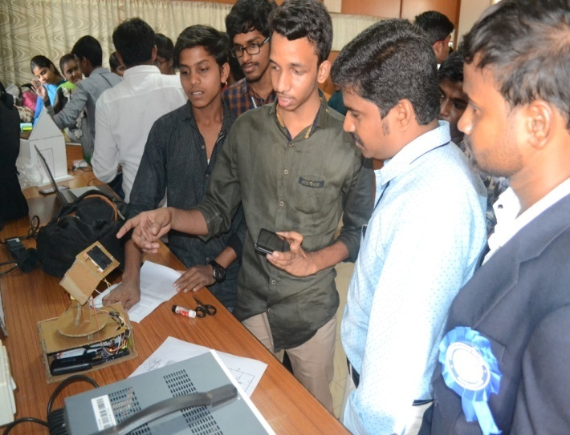
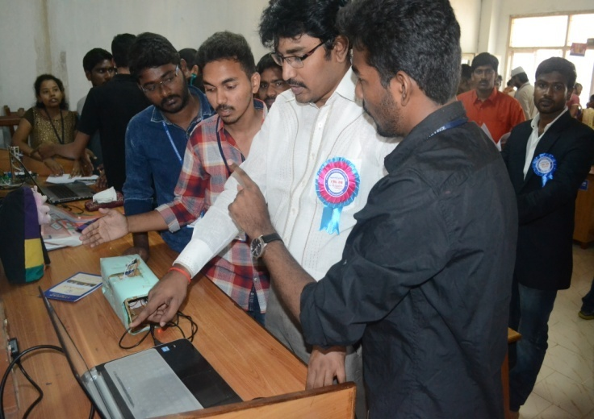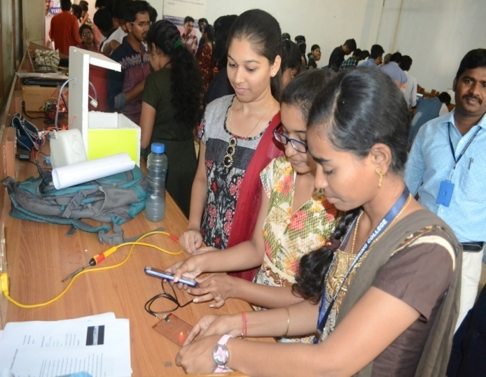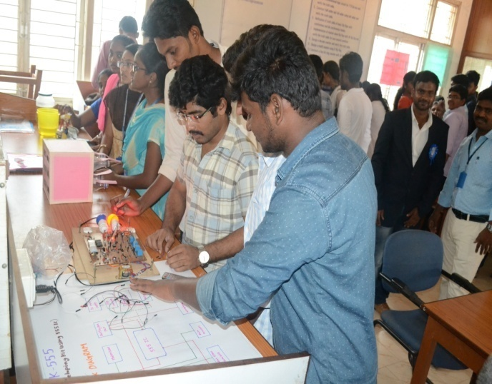

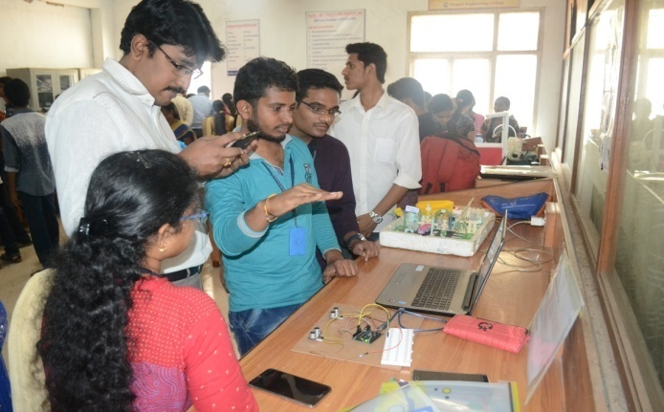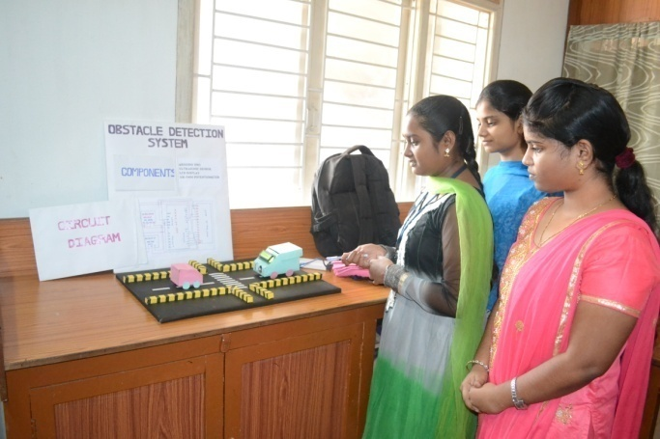
POSTER PRESENTATION.
ZAZZLE
On the event of EJIVE held on 6th march 2018 the third year students organized an named POSTER PRESENTATION. The event revealed the inner talents and the presentations skils of all those who took part in it.
FACULTY COORDINATORS:
1). K.KRISHNA CHAITHANYA asst.prof
2). T.VISHNU MURTHY asst.prof
STUDENT COORDINATORS:
1). S.T.NIKHIL (A)
2). B.DIVYA (D)
3). M.SUDHEER (A)
4). Y.SRILEKHA (B)
5). CH.LIKITHA (D)
6). M.PRABHUKUMAR (B)(
JUDGES:
1). Dr. V. SAILAJA prof
2). SURYA KUMARI asst.prof

INFO:
Total no of abstracts recevid: 40
No of abstracts selected: 34
No of abstracts from other colleges: 5
No of abstracts from our college: 29
Maximum no of participants per team: 2
Registration amount: 200/-
Total Amount: 6800/-
Venue : ECE block

Presentations are evaluated on the following criteria:
Neat presentation, advanced innovation, speaking and comunication skills.
Total marks: 50

FINALISTS | PARTICIPANTS | COLLEGE | PRIZE MONEY
1ST PRIZE | K.DEEPIKA  N.TEJASWI RAMANI | VISHNU | 3000/-
2ND PRIZE | T.ASHWINI  M.HEMA MOUNIKA | PEC | 2000/-

PARTICIPANTS:
S.NO | NAME | TOPIC | COLLEGE
1 | K.PRAVALLIKA | TONGUE MOTION CONTROLLED WHEEL CHAIR | PRAGATI ENGINEERING COLLEGE
 | K.DURGA TEJASWINI
2 | P.J.S.S.KALYANI  N.MOUNAJA | OPTICAL COMMUNICATION | PRAGATI ENGINEERING COLLEGE
3 | M.SIVA POOJITHA  B.BHUVANESWARI | STEALTH TECHNOLOGY | PRAGATI ENGINEERING COLLEGE
 |  |  | PRAGATI ENGINEERING COLLEGE
4 | K.DEEPIKA  N.TEJASWI RAMANI | BLUE BRAIN | PRAGATI ENGINEERING COLLEGE
 |  |  | PRAGATI ENGINEERING COLLEGE
5 | NAVYA VADLAMURI  KIRAN SINDHU GODE | BIONIC EYES | PRAGATI ENGINEERING COLLEGE
 |  |  | PRAGATI ENGINEERING COLLEGE
6 | P.SANTHOSH KUMAR  A.SRI SOWMYA TEJASWINI | WHY TO BE HANDICAPPED | PRAGATI ENGINEERING COLLEGE
 |  |  | PRAGATI ENGINEERING COLLEGE
7 | B.RAM SWAROOP YADAV  D.SRAVANI LAKSHMI | AUDIO SPOT LIGHTING | PRAGATI ENGINEERING COLLEGE
 |  |  | PRAGATI ENGINEERING COLLEGE
8 | R.V.S.SWAROOPA  R.JYOTHSNA | GREEN ENERGY FROM FISH SCALES | PRAGATI ENGINEERING COLLEGE
 |  |  | PRAGATI ENGINEERING COLLEGE
9 | P.ANIL KUMAR  Y.VENKATESH | OPTOGENTIC | PRAGATI ENGINEERING COLLEGE
 |  |  | PRAGATI ENGINEERING COLLEGE
10 | T.S.R.C.SEKHAR  M.S.S.VEERRAJU | HAPTIC TECHNOLOGY | PRAGATI ENGINEERING COLLEGE
 |  |  | PRAGATI ENGINEERING COLLEGE
11 | R.ROHITA JYOTHI  K.RESHMA SRI | NANOTECHNOLOGY | PRAGATI ENGINEERING COLLEGE
 |  |  | PRAGATI ENGINEERING COLLEGE
12 | T.ASHWINI  M.HEMA MOUNIKA | NIGHT VISION DEVICES | PRAGATI ENGINEERING COLLEGE
 |  |  | PRAGATI ENGINEERING COLLEGE
13 | K.AJAY  K.SIVA TEJA | I-RAM | PRAGATI ENGINEERING COLLEGE
 |  |  | PRAGATI ENGINEERING COLLEGE
14 | C.PHANI CHANDRA  S.RITHVIK KRISHNA | AUGMENTED REALITY | PRAGATI ENGINEERING COLLEGE
 |  |  | PRAGATI ENGINEERING COLLEGE
15 | I.NAVYA REETHIKA  N.M.P.ALEKHYA | BRAIN CHIPS TECHNOLOGY | PRAGATI ENGINEERING COLLEGE
 |  |  | PRAGATI ENGINEERING COLLEGE
16 | N.KEERTHIKA  P.SIREESHA | LI-FI TECHNOLOGY | PRAGATI ENGINEERING COLLEGE
 |  |  | PRAGATI ENGINEERING COLLEGE
17 | G.SIRI CHANDANA  K.TEJASWINI | BLUE EYES TECHNOLOGY | PRAGATI ENGINEERING COLLEGE
 |  |  | PRAGATI ENGINEERING COLLEGE
18 | B.MANI HARIKA  K.V.DURGA BHAVANI | BIT COINS | PRAGATI ENGINEERING COLLEGE
 |  |  | PRAGATI ENGINEERING COLLEGE
19 | S.SRI LAKSHMI PRASANNA  S.SRAVANI | A FILTERING APPROCH FOR HUMAN DETECTION IN BIONIC EYE | PRAGATI ENGINEERING COLLEGE
 |  |  | PRAGATI ENGINEERING COLLEGE
20 | NELAPARTHI SIRISHA | WIRELESS COMMUNICATION TECHNOLOGY | PRAGATI ENGINEERING COLLEGE
 |  |  | PRAGATI ENGINEERING COLLEGE
21 | D.SHIVANI  K.JYOTHI | ARTIFICAL INTELLEGENCE | PRAGATI ENGINEERING COLLEGE
 |  |  | PRAGATI ENGINEERING COLLEGE
22 | VUDATHU PRIYANKA  PRATYUSHA MUDUNURI | 5 PEN PC TECHNOLOGY | PRAGATI ENGINEERING COLLEGE
 |  |  | PRAGATI ENGINEERING COLLEGE
23 | N.VIJAYA LAKSHMI  T.NAGA SRUJANA | FREE SPACE OPTICAL COMMUNICATION | PRAGATI ENGINEERING COLLEGE
 |  |  | PRAGATI ENGINEERING COLLEGE
24 | KELLA LOKESH CHANDRA  ALLU SUMA SAI | VIRTAUAL ABILITY TO COUNTER DISABILITY | PRAGATI ENGINEERING COLLEGE
 |  |  | PRAGATI ENGINEERING COLLEGE
25 | T.PAVAN KUMAR  CH.MAHESH | INTERNET OF THINGS | PRAGATI ENGINEERING COLLEGE
 |  |  | PRAGATI ENGINEERING COLLEGE
26 | B.MALLESWARI  P.DEVI PRIYA | TECHNOLOGY IN OUR DAY TO DAY LIFE | PRAGATI ENGINEERING COLLEGE
 |  |  | PRAGATI ENGINEERING COLLEGE
27 | S.GANGA BHAVANI  S.MALLESWARI | UNDER WATER WIRELESS COMMUNICATION | PRAGATI ENGINEERING COLLEGE
 |  |  | PRAGATI ENGINEERING COLLEGE
28 | N.L.DEVI PRASANNA  K.S.JAYA SRI | BRAIN COMPUTER INTERFACE | PRAGATI ENGINEERING COLLEGE
 |  |  | PRAGATI ENGINEERING COLLEGE
29 | SYAM EBENEZER  PRAJEETH | 5G TECHNOLOGY | PRAGATI ENGINEERING COLLEGE
 |  |  | PRAGATI ENGINEERING COLLEGE
30 | SAI YOGESH SEERAPU  VOLETI AVINASH | EMBEDDED SYSTEMS IN IR SENSORS | PRAGATI ENGINEERING COLLEGE
 |  |  | PRAGATI ENGINEERING COLLEGE
31 | V.SUVARNA JYOTHI  P.MEGHANA MAHESHWARI | ARTIFICAL VISION TECHNOLOGY | PRAGATI ENGINEERING COLLEGE
 |  |  | PRAGATI ENGINEERING COLLEGE
32 | P.GOVINDARAJU | FLEXABLE OLED’S | PRAGATI ENGINEERING COLLEGE
 |  |  | PRAGATI ENGINEERING COLLEGE
33 | D.PRIYANKA  K.D.SRAVANI | PILL CAMERA | PRAGATI ENGINEERING COLLEGE
 |  |  | PRAGATI ENGINEERING COLLEGE
34 | M.VAHNIKA  M.HEMA CHARAN | CLOUD COMPUTING | PRAGATI ENGINEERING COLLEGE
 |  |  | PRAGATI ENGINEERING COLLEGE
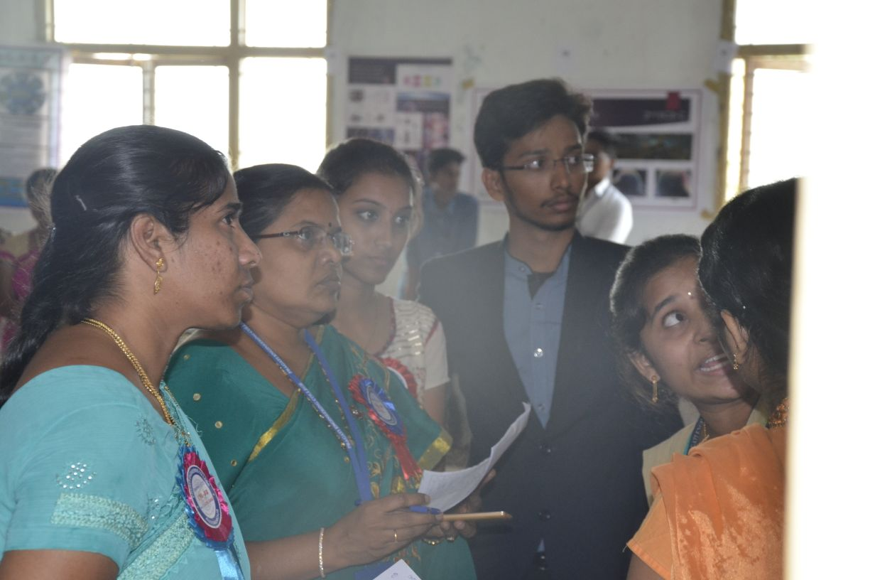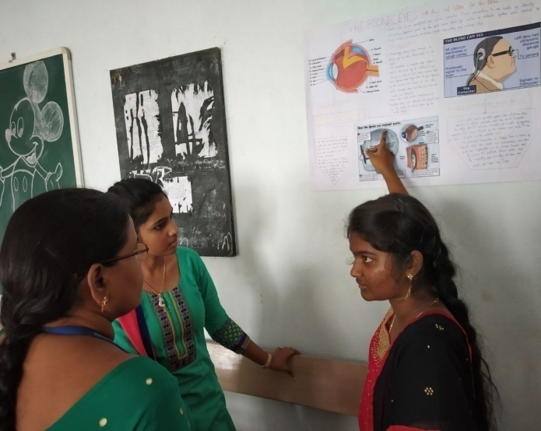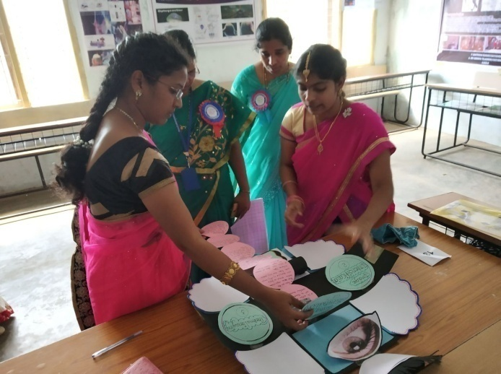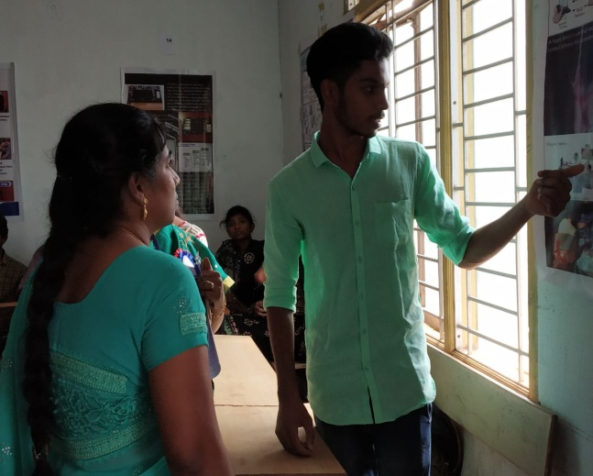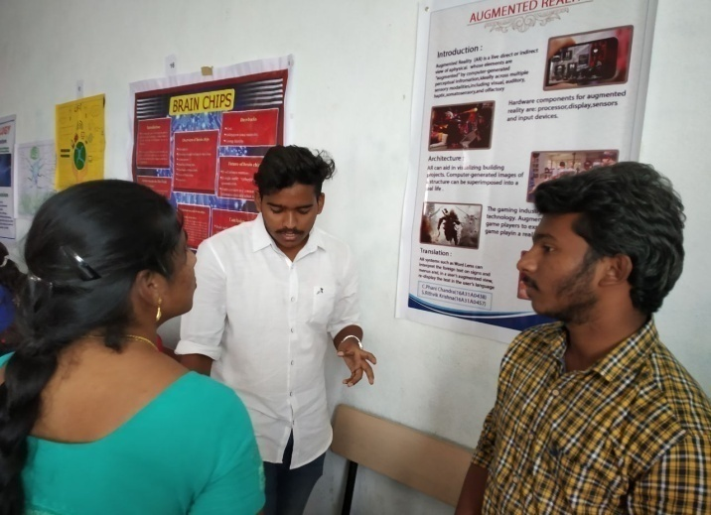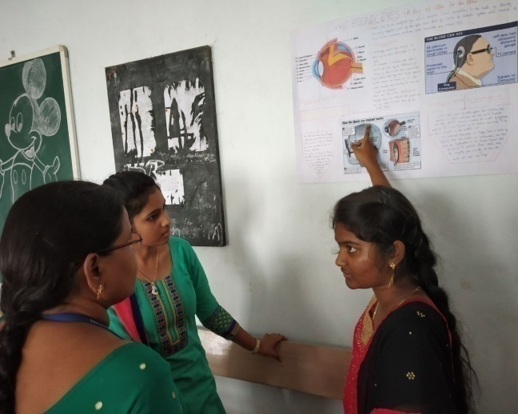
CONTRAPTIONS
ARTEFACTO
On the event of EJIVE held on 6th march 2018 the third year students organized an named CONTRAPTIONS. The event revealed the inner talents and the presentations skils of all those who took part in it.
FACULTY COORDINATORS:
1. Mr. CH. LAKSHMI NARAYANA asst.prof
2. MR. B. SUDHEER asst.prof
STUDENT COORDINATORS:
- R.SRAVYA (D)
2. K.DEVA (E)
3. SHAIK SIMRAN (A)
4. K.PRIYANKA (C)
5. M.AZIZUNNISA (D)
6. SHAIK ASHRAF (B)
JUDGES:
1. Mr . K. RAGHURAM asst.prof
2. MR. SITHARAM asst.prof
INFO:
Total no of abstracts recevid: 11
No of abstracts selected: 10
Maximum no of participants per team: 5
Registration amount: 300/-
Total Amount: 3000/-
Venue : ECE block

Presentations are evaluated on the following criteria:
Neat presentation, advanced innovation, least no of touchs and best output.
Total marks: 50

FINALISTS | PARTICIPANTS | COLLEGE | PRICE MONEY
1ST PRIZE | I SOWMYA LIKITHA  T.V.V.RATNA  D.DEVIKA KALYANI  M.PAVANI  K.JANANI | PEC | 3OOO/-
2ND PRIZE | D.SAI PRIYANKA  CH.MOHANA  P.SAMITHA  T.L.TEJASWI  K.CHANDRIKA | PEC | 2000/-

PARTICIPANTS:
CONTRAPTIONS 2K18
TEAMS | S.NO | NAMES |  |  | SEC | COLLEGE
1 | 1 | A.VASUDHA |  |  | ECE-D
 | 2 | M.SWATHI PRIYA |  |  | ECE-D | PEC
 | 3 | CH.T.SRAVYU |  |  | ECE-D
 | 4 | CH.L.PRIYANKA |  |  | ECE-D
 |  | D.N.V.S.S.SAHITHI |  |  | ECE-D
2 | 1 | P.SAI PRANEETH |  |  | ECE-E
 | 2 | P.PRABHAKAR |  |  | ECE-E | PEC
 | 3 | A.DURGA PRASAD |  |  | ECE-E
 | 4 | P.ARAVIND SWAMY |  |  | ECE-E
 | 5
3 | 1 | P.SIVAKUMAR |  |  | ECE-D
 | 2 | B.RAVITEJA |  |  | ECE-D
 | 3 | E.SRUSTI |  |  | ECE-D | PEC
 | 4 | K.SANDEEP |  |  | ECE-D
 | 5 | S.MANIKANTA KUMAR |  |  | ECE-D
4 | 1 | I.SOWMYA LIKHITHA |  |  | ECE-E
 | 2 | T.V.V.RATNA |  |  | ECE-E | PEC
 | 3 | D.DEVIKA KALYANI |  |  | ECE-E
 | 4 | M.PAVANI |  |  | ECE-E
 | 5 | K.JANANI |  |  | ECE-E
5 | 1 | V.V.S.D.K.M.VINOD.Y |  |  | ME-B
 | 2 | YUVRAJ SHEKHAR.K |  |  | ME-B | PEC
 | 3 | ARAVIND.T |  |  | ME-B
 | 4
 | 5
6 | 1 | KAMIDI HAVILA |  |  | ECE-E
 | 2 | MEDISETTY SONALI |  |  | ECE-E
 | 3 | POTTA PRIYA MADHURI |  |  | ECE-E | PEC
 | 4 | K.L.S.S.V.RAMYA |  |  | ECE-E
 | 5 | B.SOWMYASRI LIKHITHA |  |  | ECE-E
7 | 1 | V.K.M.VIJAYA LAKSHMI |  |  | ECE
 | 2 | D.VARSHITHA |  |  | CIVIL
 | 3 | K.VISWASREE |  |  | CSE | PEC
 | 4 | CH.DEEPIKA |  |  | ECE
 | 5 | G.TEJASWI |  |  | ECE
8 | 1 | D.YESWANTH SAI |  |  | ECE
 | 2 | T.SAI UMA SHANKAR |  |  | ECE | PEC
 | 3 | K.DURGA PRASAD |  |  | ECE
 | 4 | K.SRI VENKATESH |  |  | ECE
 | 5 | S.C.M.S.KOWNDINYA |  |  | ECE
9 | 1 | D.SAI PRIYANKA |  |  | ECE-E
 | 2 | CH.MOHANA |  |  | ECE-E
 | 3 | P.SAMHITH |  |  | ECE-E | PEC
 | 4 | T.L.TEJASWI |  |  | ECE-E
 | 5 | K.CHANDRIKA |  |  | ECE-E
10 | 1 | BILAL MOHAMMED |  |  | ECE
 | 2 | R.ANUSHA |  |  | ECE | PEC
 | 3 | K.GANESH SAI SINGH |  |  | ECE
 | 4 | G.PRAVEEN KALYAN |  |  | ECE
 | 5 | V.S.AKHIL |  |  | ECE

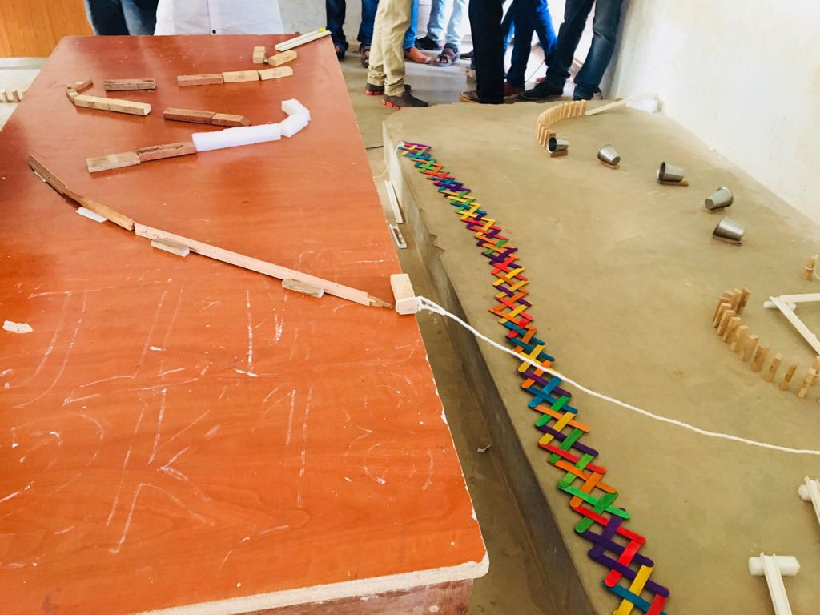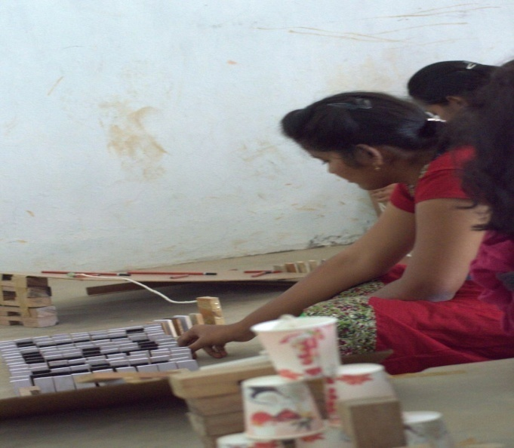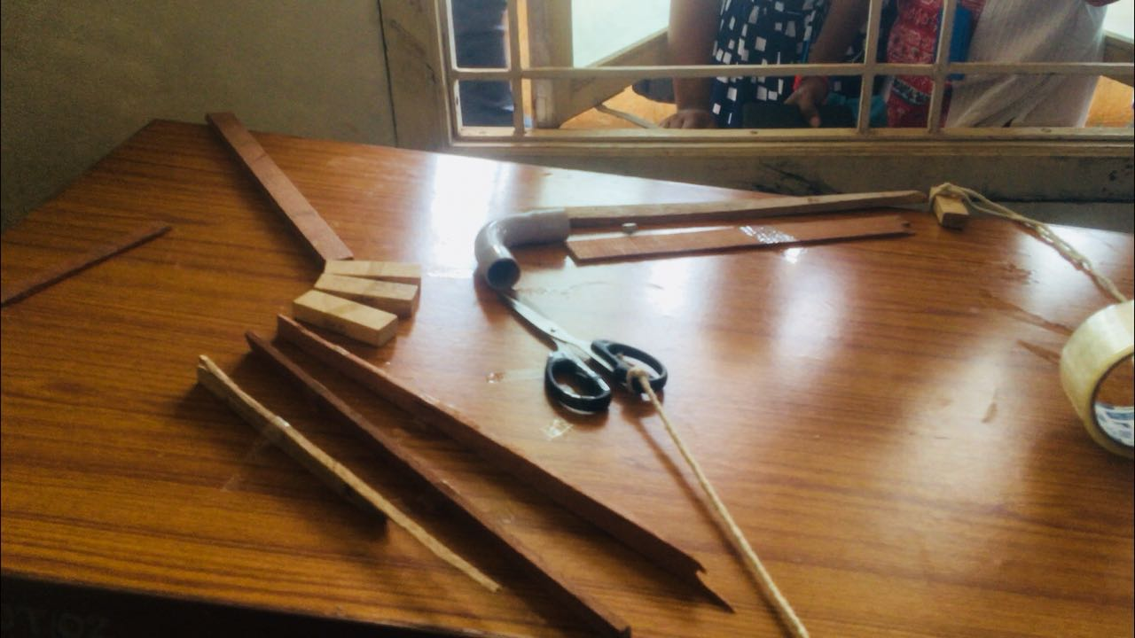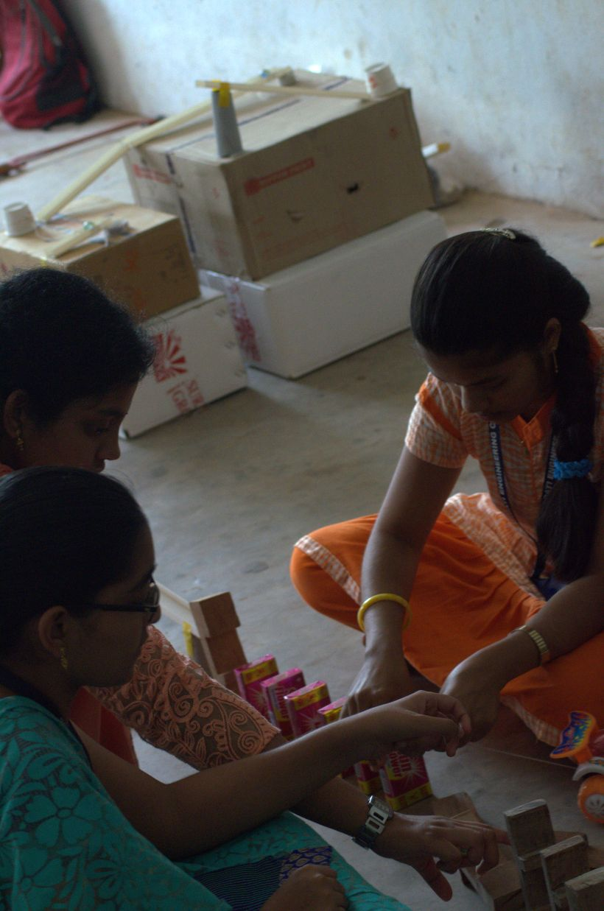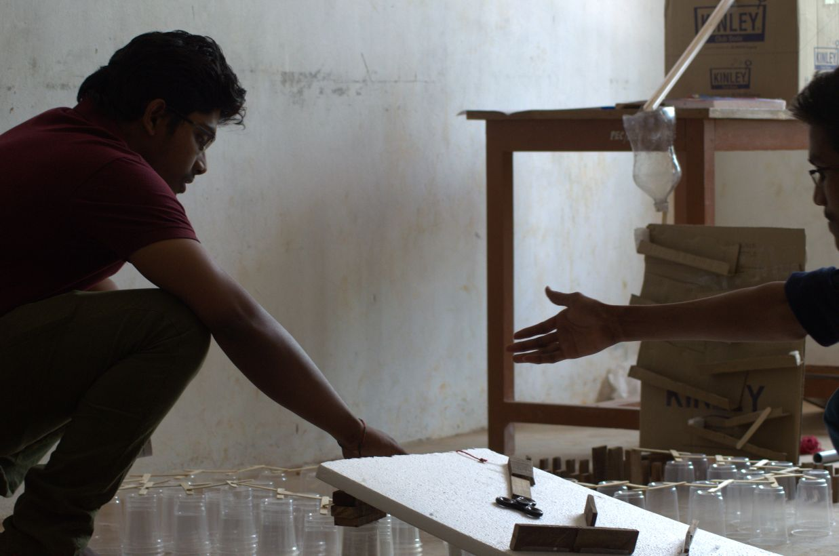
LOGO DESIGN.
E-DOODLE
On the event of EJIVE held on 6th march 2018 the third year students organized an named LOGO DESIGN. The event revealed the inner talents and the presentations skils of all those who took part in it.
FACULTY COORDINATORS:
1). D.V.V.LAKSHMI asst.prof
2). P.PRASANNA KUMARI asst.prof
STUDENT COORDINATORS:
1). L.RICHITHA (C)
2). M MOUNIKA (C)
3). A.BHUCHAKRA KUMAR (A)
4). K.Y.KRISHNA PRIYA (D)
5). G.SAHITHI (B)
6). T.MANJUSHA (C)
JUDGES:
1). NATRAJ SIR asst.prof
2). B.SUDHEER asst.prof

INFO:
Total no of abstracts recevid: 28
No of abstracts selected: 28
Maximum no of participants per team: 2
Registration amount : 100
Total Amount: 2800
Venue : ECE block

Presentations are evaluated on the following criteria:
Neat presentation, advanced innovation , speaking skills.
Total marks: 50

finalists | PARTICIPANTS | COLLEGE | PRIZE MONEY
1st prize | VINITHA JAIN | ADITYA | 1200/-
2nd prize | D.LIKITHA RAJESWARI  CH.TUSHARA | PEC | 800/-

PARTICIPANTS LIST:
Team.No | Name of students | College | Toipc
1 | V.Keerthika | PEC | Rescue polar
 | G.Shivani
2 | S.Sai Sowmya | PEC | Road safety
 | K.Sowjanya
3 | P.Anitha | PEC | Army
 | K.Saranya
4 | Vinitha Jain | Aditya | Pharmacy
5 | A.Sri Sowmya Tejaswini | PEC | Smart city
 | P.Santosh Kumar
6 | P.Govinda Raju | Aditya | IOT
7 | P.Pravallika | PEC | Environment protection
 | Ch.Rajnanjali
8 | G.Bhanu Sravani | PEC | Ardino with transistor
 | N.Sirisha
9 | G.K.S.Pawan Uttej | PEC | Save the Syria
 | P.Revanth
10 | G.Tanu sri | PEC | Communication
 | Krishna Priya
11 | S.K.M.ABDVS Subhan Ali | PEC | Chaos theory
 | V.S.R.Karthik
12 | K.Rachanmayee | PEC | Engineers mind
 | N.Praneetha
13 | B.Anjani | PEC | Smart city
 | P.J.Ramya
14 | P.V.S.Sahithi Raj | PEC | 3R cycle
 | V.Sai Ramya
15 | Anantha lakshmi | PEC | Technology
 | Bhavani
16 | V.Sai Sree | PEC | Road safety
 | P.Likitha
17 | K.Sai Chandana | PEC | Electronics
 | Md.Atitmunisa
18 | Ch.Geeta sri | PEC | ECE
 | R.S.Kiran Pramoda
19 | G.Gowtham Sai | PEC | Make it Home
 | V.Supraja
20 | Ch.Veera Kinnera | PEC | Youth Go
 | J.Mani Madhuri
21 | A.L.Prassana | PEC | Pragati logo
 | K.Alekya
22 | K.V.S.Manju sree | PEC | Syria
 | A.N.V.S.Harsha devi
23 | M.Pallavi | PEC | Don't drink and drive
 | M.Pratyusha
24 | D.Sai Abishek | PEC | Environment
25 | K.Bala Tripura Sundari | PEC | Traditions and culture
 | G.Maha Lakshmi
26 | CH.Reshma | PEC | Micro controllers
 | N.Deepika Mani
27 | D.Likitha Rajeswari | PEC | India
 | CH.Sai Tushara
28 | P.Jyoshna Deepika | PEC | Impacts of social media
 | K.Madhavi

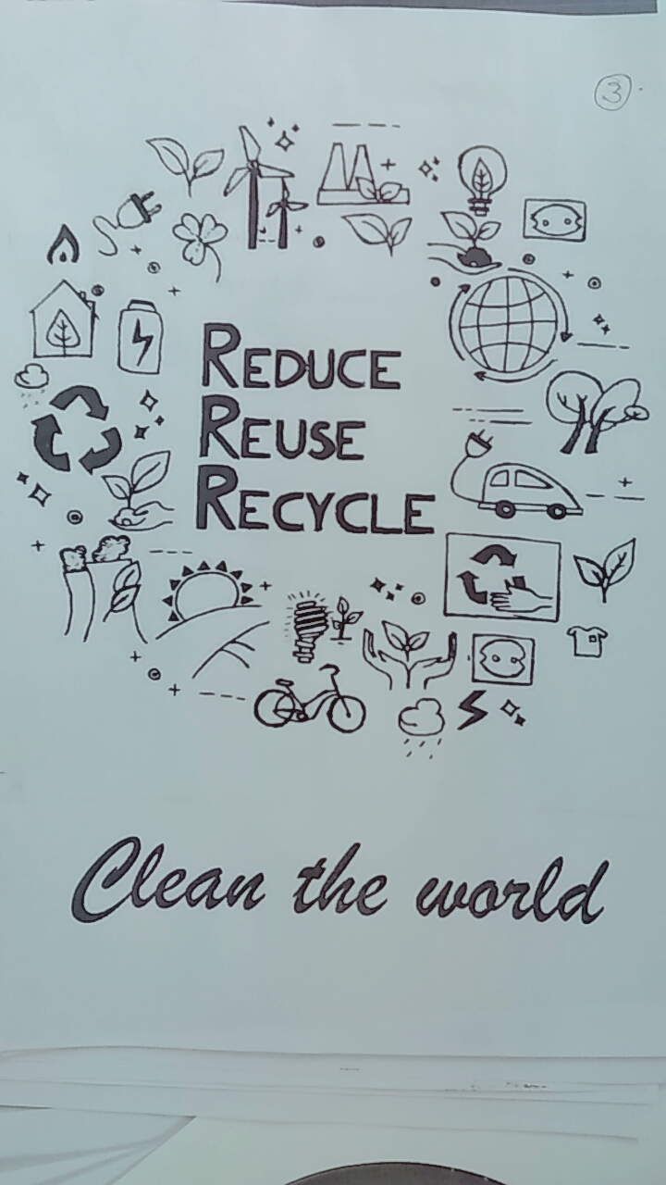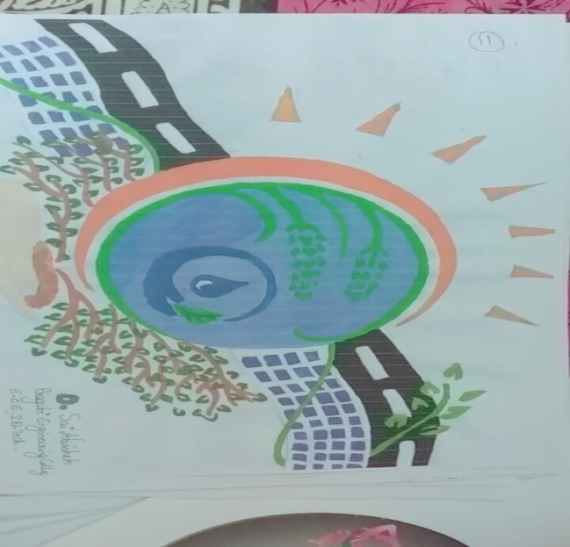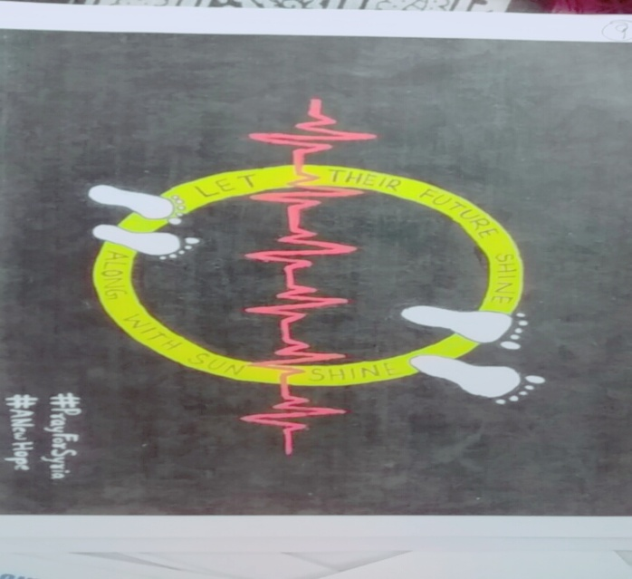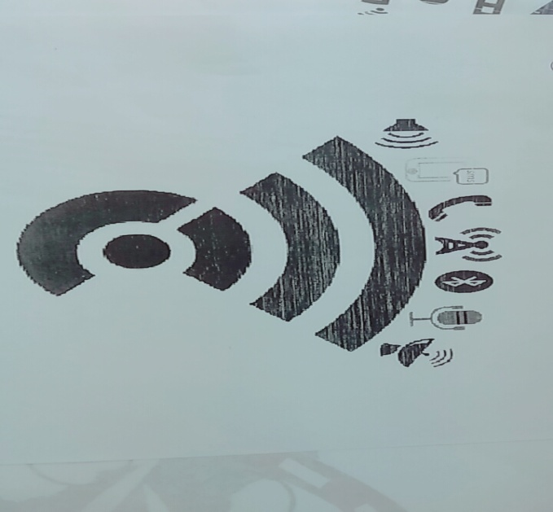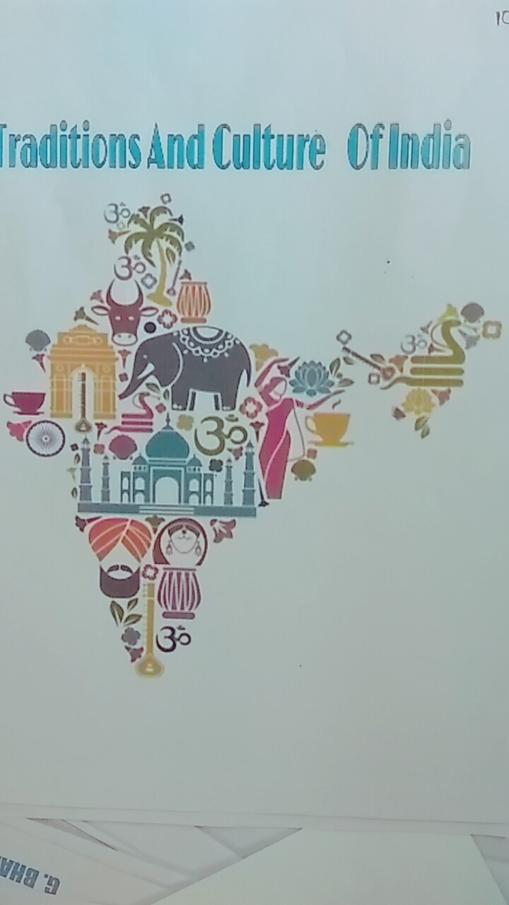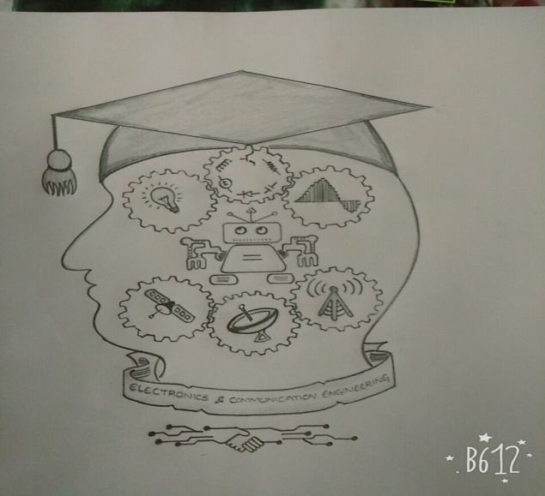

TECHNICAL QUIZ.
CATECHIZE
On the event of EJIVE held on 6th march 2018 the third year students organized an named POSTER PRESENTATION. The event revealed the inner talents and the presentations skils of all those who took part in it.
FACULTY COORDINATORS:
1). RUBIA TASNEEM asst proof
2). M.DHANA LAKSHMI asst.prof
STUDENT COORDINATORS:
1). RISHITHA REDDY (A)
2). Y.D. ROHITH (A)
3). P.SATYA SUPRIYA (A)
4). T .ATCHIVENI (b)
5). M.MANEESHA (B)
6). S.MALLESHWARI /(B)
JUDGES:
1). RUBIA TASNEEM asst proof
2). M.DHANA LAKSHMI asst.prof

INFO:
Total no of TEAMS: 32
Maximum no of participants per team: 3
No of TEAMS from other colleges: 2
No of TEAMS from our college: 30
Registration amount: 150/-
Total Amount: 4800/-
Venue : ECE block
Colleges attended: BVC, IDEAL
Presentations are evaluated on the following criteria:
Total no of teams in 1st round : 32
Total no of teams in 2nd round : 16
Total no of teams in 3rd round : 8
Total no of teams in 4th round : 4
Total no of teams in 5th round : 3
Total marks: 50

FINALISTS | PARTICIPANTS | COLLEGE | PRIZE MONEY
1ST PRIZE |  | PEC | 2000/-
2ND PRIZE |  | IDEAL | 1000/-

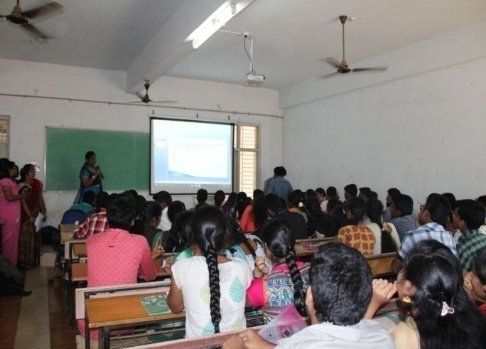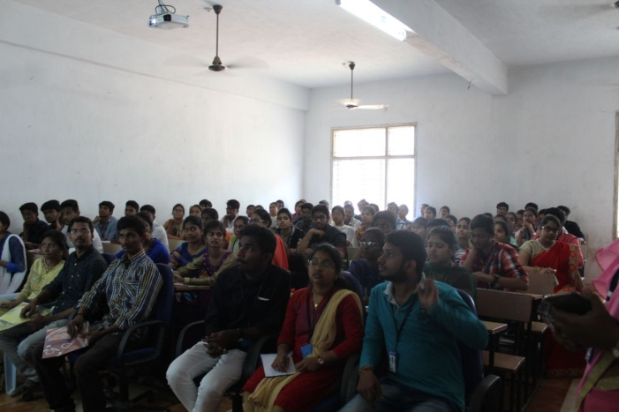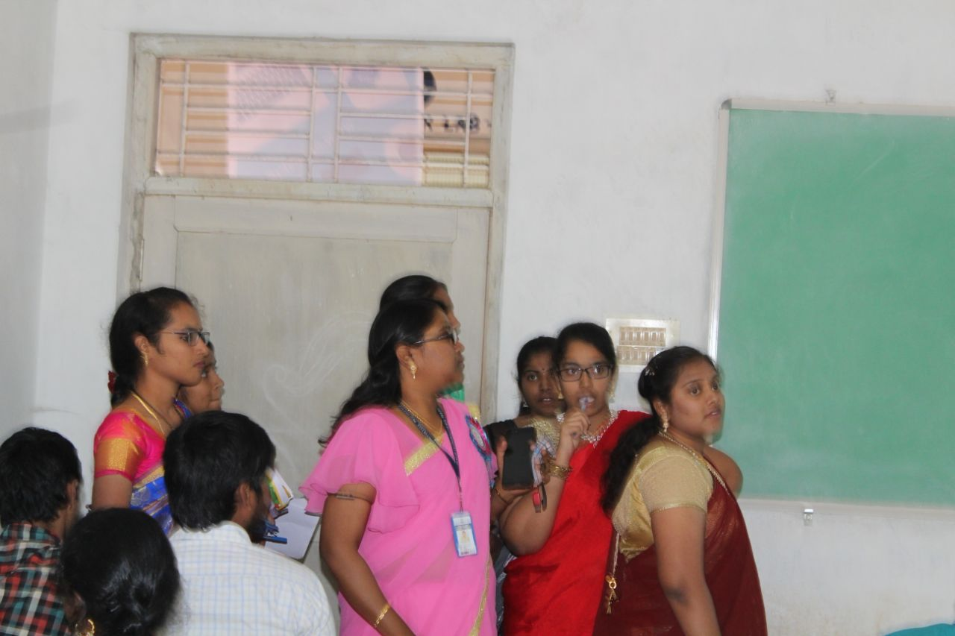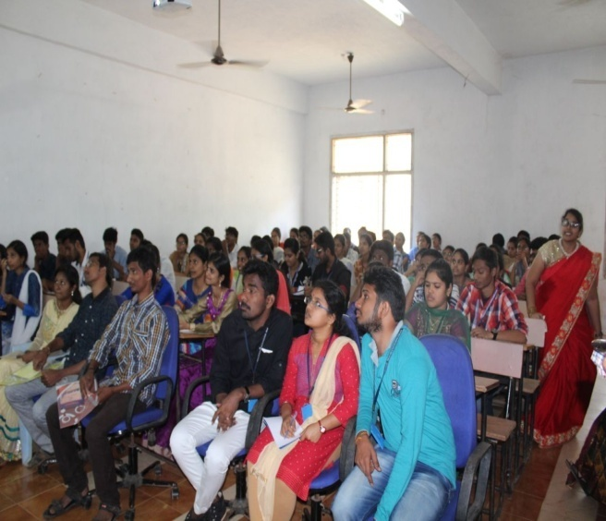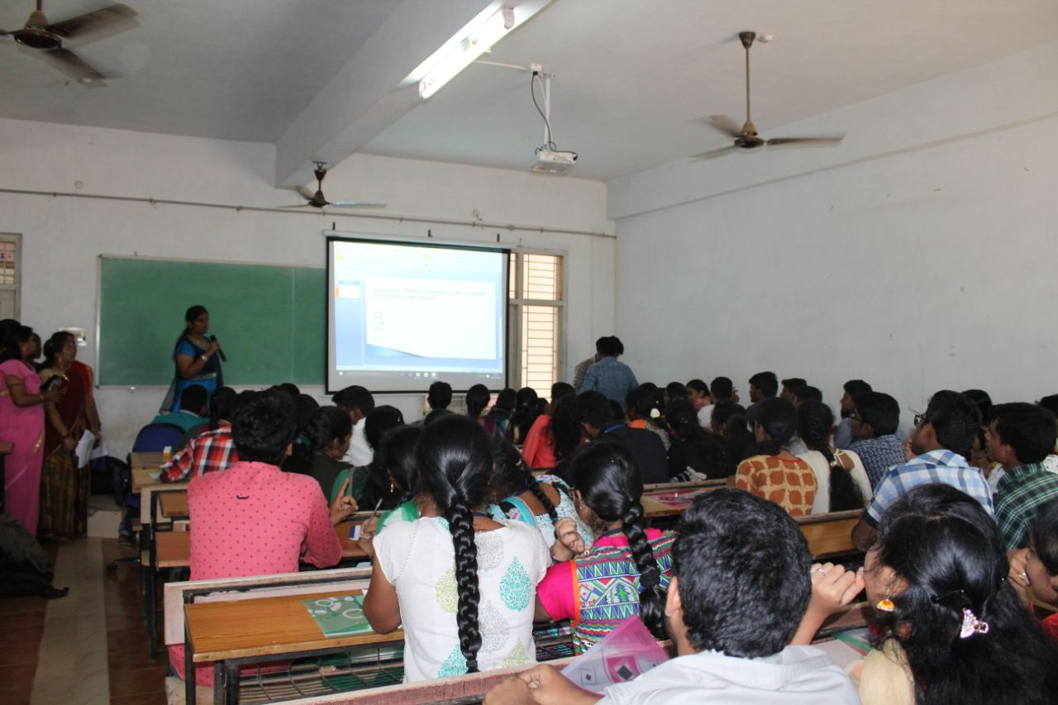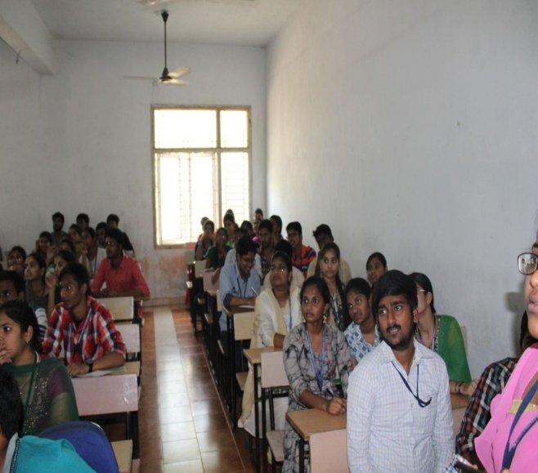

COMM UNICATION EXPO
On the event of EJIVE held on 6th march 2018 the third year students organized an named COMMUNICATION EXPO. The event revealed the inner talents and the presentations skils of all those who took part in it.
FACULTY COORDINATORS:
1. Mr. M.SRINIVAS asst.prof
2. RAMYA KRISHNA asst.prof
STUDENT COORDINATORS:
1. SRAVANTHI (C)
2. SAI ANVESH (C)
AMOUNT SPENT : 2,468/-

ABOUT:
This event is newly introduced by ECE this year . It is all about the evolution of communication. Where it is originated from, sinces basics like basic electroni components . it’s an exhibition of electronics and communications. The students has exhibited the components like resistors,capacipors,diodes and many other basics components.
Next they showed and explained about the transformation of television. How telivisions changed Since the 1st tv invented till now. The evolution of television took part in our lives
Now comes the COMPUTER transformation. Couldn’t imagine our lives without computers. Our students has effectively explained about the transformation of computers they provoked our thoughts.
Students also created a ROBOT using sensors. Which speaks when we stand before it. It performed so well which it became the attraction of the event.
Each and everyone excuted and brought their inner talents to the brim.
The strides has become the best platform and good opportunity to excel their knowledge.
Dr. .K.HARINATH BABU , Has visited the expo , he went though all the things happned in th expo . sir felt really amazed and appreciated all the students who worked thought out. N many students and facualty members has visited the event..

FEEDBACK FROM STUDENT COORDINATORS:

FEEDBACK FROM PARTICPANTS:

Report prepared by.. FACULTY INCHARGE HOD-- ECE
N,PRAVALLIKA K.ARUNVEER DR.K. SIVAKUMAR SWAMY
1531A04D5 (asst.prof)

