
ACADEMIC TOPPERS III B Tech EEE-A II SEM 2015 ADMITTED BATCH
1 | 16A35A0209 | VANKADARI PRAVEEN | 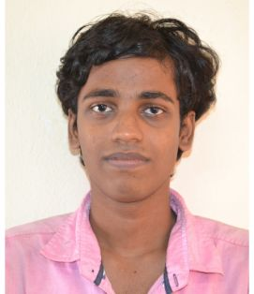 | 88.53
2 | 15A31A0248 | SANKURATHRI HAREEN | 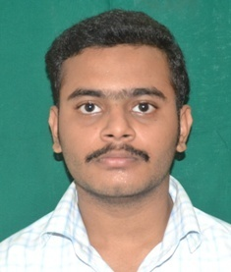 | 81.33
3 | 15A31A0253 | SURATH SIVA KUMAR | 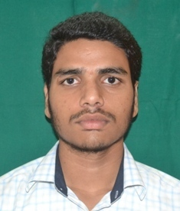 | 80.40
4 | 16A35A0206 | KONTHETI SAI PRAKASH | 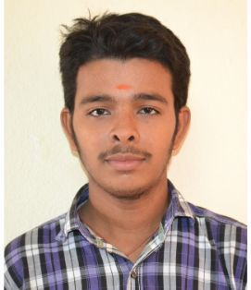 | 80.00
5 | 16A35A0201 | SIMHADRI VIJAYA DURGA | 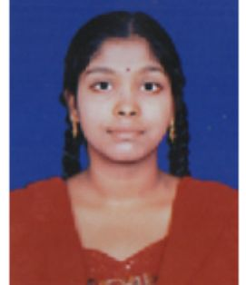 | 78.40
6 | 15A31A0204 | CHILAKAMARRI SREE ANDAL VYSHNAVI | 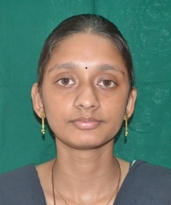 | 76.13
7 | 15A31A0216 | SATHI DEVI PRIYA | 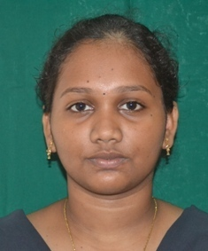 | 75.87
8 | 15A31A0208 | KONDRA PURNIMA RAMYA | 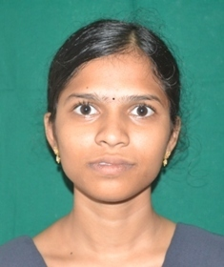 | 75.47
9 | 15A31A0207 | KEERTHI SRI TARANI |  | 74.67
10 | 15A31A0214 | PEPAKAYALA VARALAKSHMI | 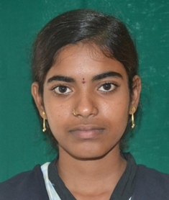 | 74.00

Copy to:
- Principal
- Notice Board
- Dept.File

ACADEMIC TOPPERS III B Tech EEE-B II SEM 2015 ADMITTED BATCH
1 | 15A31A0272 | TEEGALA PRASANNA LAKSHMI | 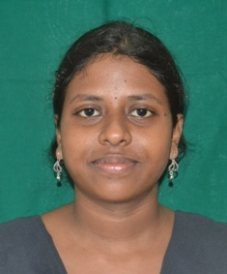 | 84.80
2 | 15MD1A0249 | V KEERTHI |  | 83.47
2 | 16A35A0212 | MADDALA SRIDEVI | 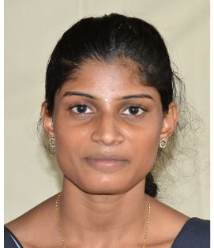 | 83.47
3 | 15A31A0285 | KANAKALA ROHITH SAI SWAROOP | 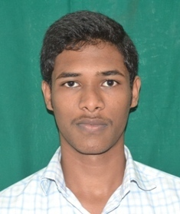 | 80.67
4 | 16A35A0220 | KALAVALA VENKATA GANESH | 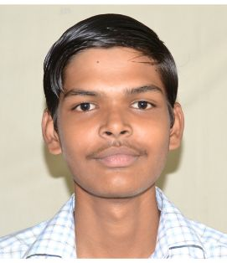 | 80.00
5 | 15A31A02A3 | SANGADI KAMESH | 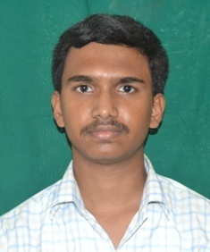 | 78.93
6 | 15A31A0284 | KALYAN GODA | 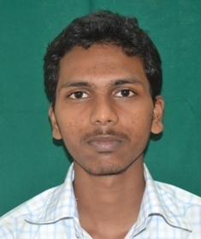 | 78.80
7 | 16A35A0217 | CHODISETTI SWAMY SAIKIRAN | 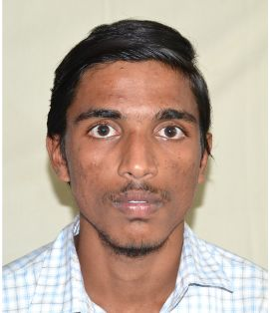 | 77.07
8 | 16A35A0211 | GANJA REKHA DEVI | 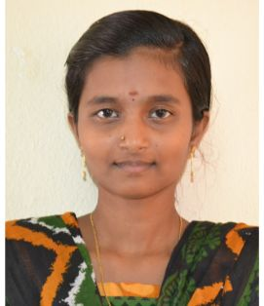 | 76.13
9 | 16A35A0214 | VASAMSETTY SIVASAI VENKATALAKSHMI SOWMYA | 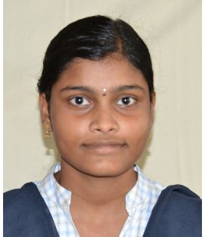 | 75.60
10 | 15A31A0275 | V SATYA DEVI | 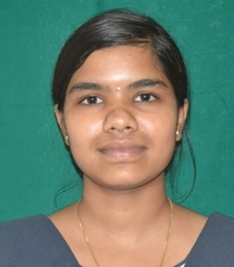 | 75.33

Copy to:
- Principal
- Notice Board
- Dept.File

