
ACADEMIC TOPPERS IV B Tech EEE-A II SEM 2014 ADMITTED BATCH
1 | 14A31A0242 | NARAVA SAI KUMAR | 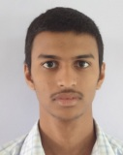 | 86.83
2 | 14A31A0225 | GOOTURU GOVINDA RAJA | 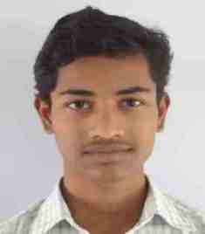 | 83.67
3 | 15A35A0209 | KOMMOJU VASU | 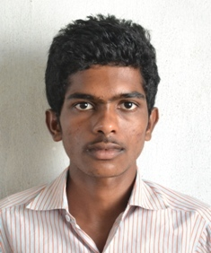 | 82.17
4 | 14A31A0202 | AYYALASOMAYAJULA SIREESHA | 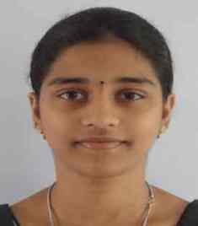 | 81.83
4 | 15A35A0201 | KOTTIYADA BINDHU MOUNIKA | 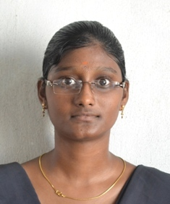 | 81.83
5 | 15A35A0206 | DUVVURI VENKATA SAI SUBHANAND | 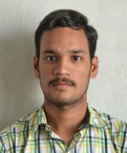 | 81.17
6 | 14A31A0213 | VADAGA SAI DIVYA | 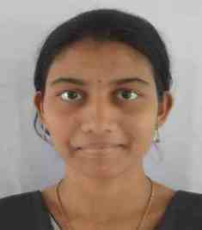 | 79.17
7 | 14A31A0218 | CHADARAM VENKATA VARADURGA LAKSHMIPRASANTH | 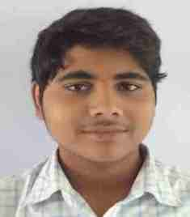 | 78.50
8 | 14A31A0250 | SALA KOTESWARA RAO | 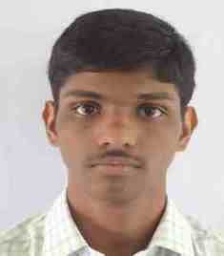 | 78.17
9 | 15A35A0202 | LANKA SIREESHA | 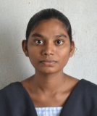 | 77.67
10 | 15A35A0208 | JAGARAPU KIRAN | 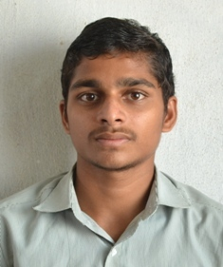 | 77.50

Copy to:
- Principal
- Notice Board
- Dept.File

ACADEMIC TOPPERS IV B Tech EEE-B II SEM 2014 ADMITTED BATCH
1 | 14A31A0261 | GADAMSETTY SATYA NANDINI | 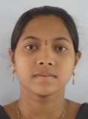 | 83.00
2 | 14A31A0277 | GEDDADA JYOTHI KIRAN |  | 80.50
3 | 14A31A0288 | KUNDALA YASHAS CHANDRA | 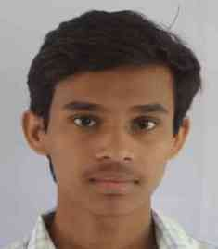 | 79.67
4 | 14A31A0299 | NAMEPULLETIKURTHI SAI VEERA ANUDEEP | 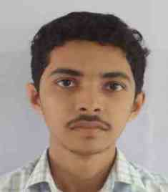 | 78.17
4 | 14A31A02A9 | TUNGALA UMAMAHESWARA RAO | 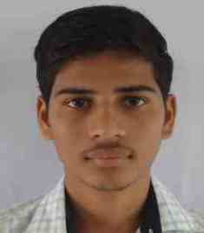 | 78.17
5 | 14A31A0268 | TALAPANTI PAVANI | 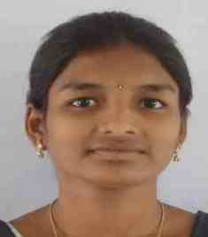 | 77.50
6 | 15A35A0230 | PATHI SATYA VEERA NAGA SRINIVAS | 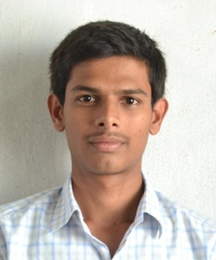 | 76.83
7 | 14A31A02A8 | SUNKARA SRISARAN | 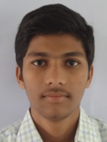 | 76.00
8 | 15A35A0221 | CHODAVARAPU DORABABU | 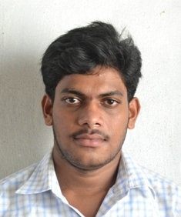 | 75.67
9 | 14A31A0264 | MADDUKURI PRASANTHI | 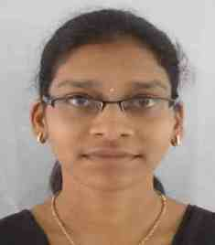 | 75.17
9 | 14A31A0273 | CHIKKAM HARI SRI | 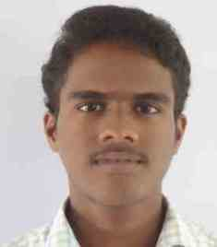 | 75.17
9 | 15A35A0218 | BAVISETTY NAGA SARVANI | 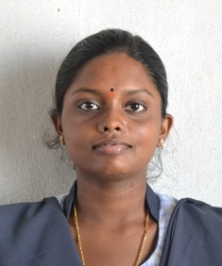 | 75.17
10 | 14A31A0295 | PACHIPALA VEERA VENKATA SATYA JAGADEESH | 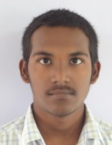 | 75.00
Copy to:
- Principal
- Notice Board
- Dept.File

