Students from Pragati of Engineering College, Kakinada receive TCS Best Student and TCS Best Student Project Awards

TCS award for the Best Student of 2016-17 batch was given away to Chandrabatla Hymavathi Annapoorna from the Department of Civil Engineering, Pragati College of Engineering, Kakinada. The award comprises a gold medal, a certificate and a cash price.
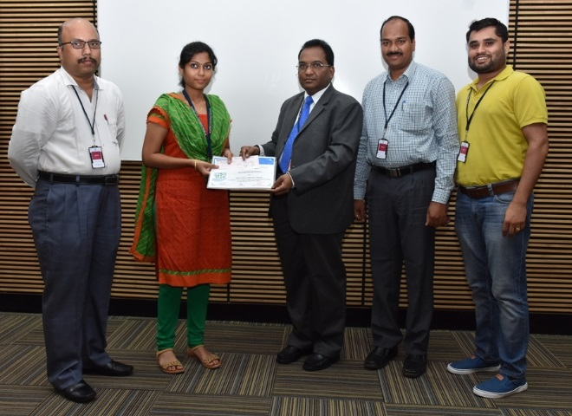
Chandrabatla Hymavathi Annapoorna receiving Best Student Award from V Rajanna, Vice President & Regional Head, TCS Hyderabad
TCS award for the Best Student Project of 2016-17 batch was given away to Sala Yasaswini Shirisha, Karnatakapu Vamsi Krishna, Lakshmi Pravallika Yanamandra, Kotani Srinivas, D V V Varma, and K Nikhileswar for the project entitled Design and Implementation of Solar Powered Robot for Agriculture Applications. The project is done by students from the Department of Electrical and Electronics Engineering, Pragati College of Engineering, Kakinada. The award comprises a gold medal, a certificate and a cash prize.
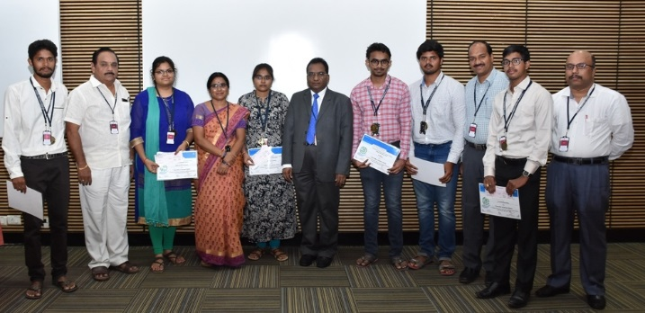
Sala Yasaswini Shirisha, Karnatakapu Vamsi Krishna, Lakshmi Pravallika Yanamandra, Kotani Srinivas, D V V Varma, and K Nikhileswar receiving Best Student Project Award from V Rajanna, Vice President & Regional Head, TCS Hyderabad
These awards are presented to the best student and best project as nominated by the college from each of the colleges with which TCS has signed MoU. These awards aims to promote creativity and socially useful projects.

