Report on Industrial Visit to Achampeta 220/132/33 KV Sub-Station

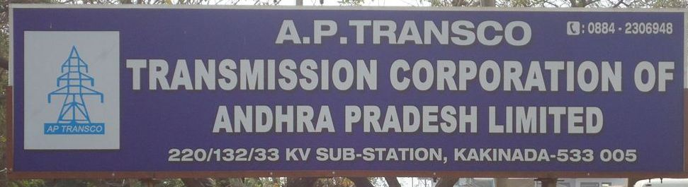

No.of days of Visit : one day
Date of Visit : 7th September,2017
Faculty In-charges : 4 Members
- Mr.S.Ashokreddy , Asst.Prof
- Mr. I.Srinu, Asst. Prof.
- Mr. I.Murali krishna, Asst. Prof.
- Mr. P.Krishna Chaitanya,Asst. Prof.
Student Co-Ordinator(s) : K.Sai (CR) EEE-A
: J. Karthik Reddy (CR) EEE-B

No.of Students : First Batch 68 Students (2015 admitted batch)
: Second Batch 70 Students (2015 admitted batch)
Reporting Time : 10:00A.M, 7th September,2017 (Batch-1)
Session closing Time : 12:30P.M, 7th September,2017 (Batch-1)
Reporting Time : 02:30P.M, 7th September,2017 (Batch-2)
Session closing Time : 04:30P.M, 7th September,2017 (Batch-2)
APTRANSCO Achampeta 220/132/33 KV Sub-Station authorities gave the permission for 2015 admitted batch of III year students to visit the Sub-Station on 7th September, 2017 and accordingly we proceeded to visit the Sub-Station on 07.09.2017 forenoon from our college at 9:15 A.M along with 68 students of III B.Tech Isem EEE-A as first batch accompanying with two Assistant Professors of EEE Department Mr. S.Ashokreddy and Mr. I.Srinu, reached Sub-Station by 10:00 A.M and met the Divisional Engineer.
The Divisional Engineer permitted us at 10:15 A.M and provided two Assistant Engineers for explaining the overview of working of Sub-Station and Switch-yard Equipments and their functionality. We were divided into two groups facilitated by two Assistant Engineers. They explained about all the essential components of the 220KV substation. Also, they explained about SCADA and various programming done in the control room i.e., PLC control. Finally we checked out at 12:30 P.M after through observation of the Sub-Station and we came back to college at 1:30 P.M.
AN OVER VIEW OF THE SUBSTATION:
The following details were observed during the visit. The first thing which we observe in the substation is “Protection of different systems” i.e., Circuit breakers, Transformers, Protective relays, Lightening arresters, Load break switches, Electrical contacts. Due to the unique properties of SF6, it is used for 132KV & 220KV lines protection and vacuum for 33KV & 11KV. In SF6-Circuit Breakers we use SF6 gas because it is an excellent gaseous dielectric for high voltage power applications. It has been used extensively in high voltage circuit breakers and other switch gears employed by the power industry applications for SF6 include gas insulated transmission lines and gas insulated power distributions. The combined electrical, physical, chemical and thermal properties offer many advantages when used in power switchgears.
Lightening arresters are provided in order to discharge the high voltages, lightening surges coming at the fault conditions due to lightening. It acts as main protective device for feeder. After the Lightening arresters it is followed by “Capacitance Voltage Transformer – CVT” which together with the Wave trapper acts as LC circuit. Wave trapper is used as power line carrier communication. In this substation they uses CVT’s in the place of PT’s because it easily passes high frequency signals. The next device followed by CVT’s is “Current Transformers – CT’s”. CT’s are used for measuring the current and used for protection purpose. In this substation the 2 pole isolators are provided for minimum ground clearance.
Transformers are provided with many types of protections like differential protection, trip coil protection, trouble alarm protection, oil protection, PRV protection, OLTC protection, winding temperature protection, on-load tap changing, over flux, under voltage, HV/LV, E/F protection etc.Relay is used to sense the signals and these signals are send to Circuit Breaker at faulty condition. Relays used in the substation of Distance relays, Buchholz relay etc. Distance Relays are provided for distance protection at feeders. Buchholz relays are present in between the transformer main tank and the conservator tank. These relays are used for transformer protection.
The bushing is a hollow insulator, allowing a conductor to pass along its Centre and connect at both ends to other equipment. Bushings are often made of wet-process fired porcelain, and may be coated with a semi-conducting glaze to assist in equalizing the electrical stresses along the length of the bushing. The inside of the bushing may contain paper insulation and the bushing is often filled with oil to provide additional insulation. Bushings for medium-voltage and low-voltage apparatus may be made of resins reinforced with paper. The use of polymer bushings for high voltage applications is becoming more common. The largest high voltage bushings made are usually associated with high voltage direct current converters. A bus bar may either be supported on insulators, or else insulation may completely surround it. Bus bars are protected from accidental contact either by a metal earthed enclosure or by elevation out of normal reach.
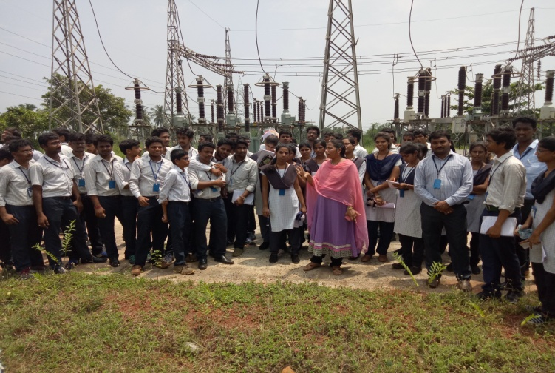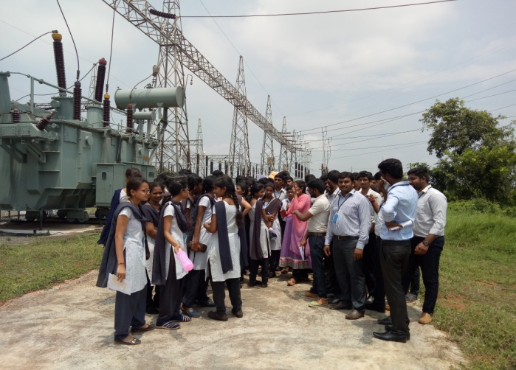
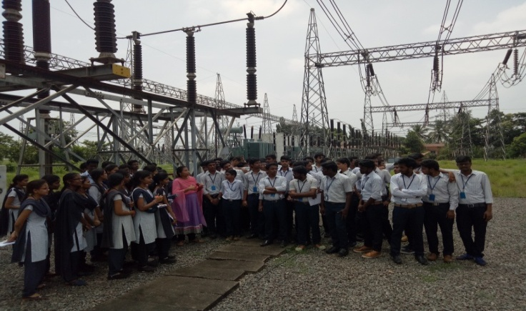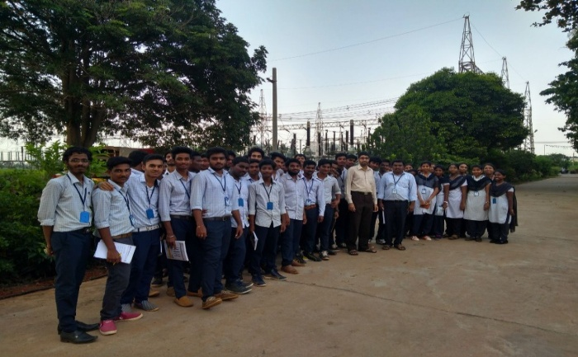
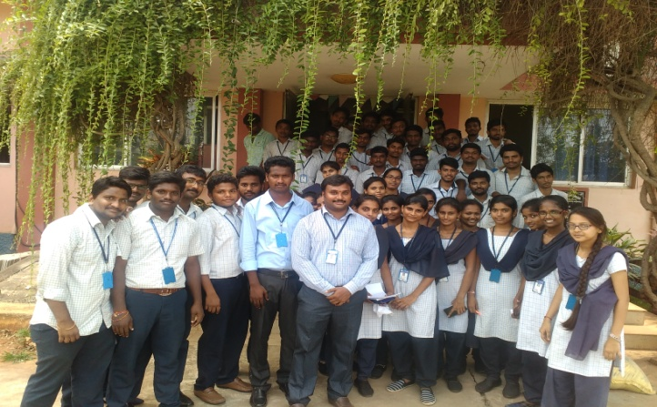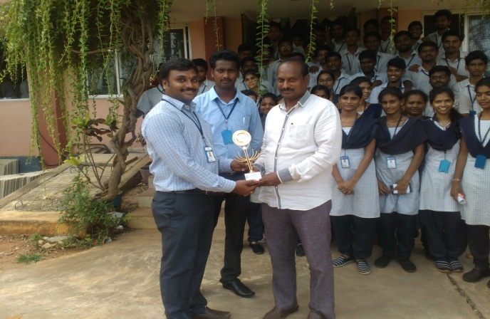
In the afternoon session from our college at 1:30 P.M ,along with 70 students from III B.tech Isem EEE-B as Second batch accompanying with two Assistant Professors of EEE Department Mr. I.Murali Krishna and Mr.P.Krishna Chaitanya, reached Sub-Station by 2:30 P.M and met the Divisional Engineer
The Divisional Engineer permitted us at 02:45 P.M and provided two Assistant Engineers for explaining the overview of working of Sub-Station and Switch-yard Equipments and their functionality. We were divided into two groups facilitated by two Assistant Engineers. They explained about all the essentials and components of the 220KV substation. Also, they explained about SCADA and various programming done in the control room i.e., PLC control. Finally we checked out at 4:30 P.M after thorough observation.
Co-ordinator HOD-EEE

